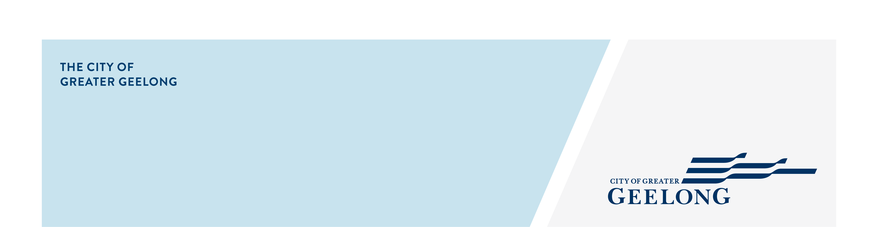
minutes

caos network meeting

15 july 2026, 10:00am-12:00pm, wurriki nyal civic precinct, geelong

Attendees
Lisa Sitlington (chair), Eleisha Casanas, Simon Crase, Carly Rose-Smith, Lauren O’Callaghan, Darren Riggon, Alison Smith, Maricon Embanecido, Amy Coates, Nav Kour, Marie Petersohn, Chris Walters, Felicity Ballard

Apologies
Nina Ditterich, Bronwyn Johnson, Erica Thompson, Sam Radu
- Welcome
Lisa Sitlington welcomed Amanda Glasson and she completed her Acknowledgement of Country.

- Manda Mae – The Lived Experience Workshop
Amanda Glasson facilitated the 1-hour Lived Experience Workshop, an interactive and fun learning experience. The workshop creates to give people a deeper understanding of what a person experiences living with co-morbidity and intersectionality. In groups of 5-7, participants were given resources and a set of rules to follow during the activity. These simulate a disability, a mental health condition or diverse group. We completed the guided activity and then opened for discussions.

For more information: https://mandamae.com.au/

- Around the Room Discussion
Darren Riggon – Clinical Services Manager – Geelong Medicare Mental Health Care
- Free service for everyone, open 7 days a week.
- Self-referral, no appointment required to get support.
- Experienced clinical staff and peer support workers.
- Drop-in facilities
Feel free to reach out Darren.riggon@neaminational.org.au
Visit website for more information: https://www.neaminational.org.au/services/geelong-medicare-mental-health-centre/

Eleisha Casanas –KU Children Services / Friends for Good / Parent Thread
- Working as the Community Liaison Officer at KU Children’s Services at Biyala Community Hub Armstrong Creek.
- There are space available to hire for programs, activities and events with a particular focus on children and families.
- Friends for Good is seeking volunteers for national phone service to “chat to anyone in the community”. This is not a crisis service; it’s about having a chat to reduce loneliness.
- Friendship Alliance is a network of organisations across Australia working to raise awareness about loneliness and social isolation. To find out more: https://friendshipalliance.org.au/
- Bloom & Connect, a 6-week gathering for expectant mums. Sundays 1:00pm-3:00pm at Torquay Community House
- Reach out with any queries: eleisha@friendsforgood.org.au

Simon Crase –Prevention and Community Engagement Officer – Barwon Community Legal
- The Changing Mind & Positive Ageing Expo – October 23^{rd,} 10.30-2.30pm at City of Geelong Bowls Club, 7-9 Ballarat Road – Free Event
  - 4 guest speakers
  - 40 local services
- No Victorian left without Photo ID – advocacy campaign
  - Leading an advocacy campaign to ensure people retain photo ID after surrendering their driver’s licence for a medical reason.
  - Asking the State Government to introduce a pre-licence surrender safeguard within the Medical Review Process.
  - It will ensure people are aware of what happens when they lose their driver’s licence/photo ID and how to apply for a Victorian Proof of Age Card.
  - If you would like to support this campaign, please contact BCLS Prevention and Community Engagement Officer Simon Crase via email at simon.crase@barwoncommunitylegal.org.au.

Alison Smith – Barwon Health Carer Gateway
- Local service outlet for Carer Gateway in the Southwest Barwon region
- Offer supports, services, events and programs for carers in an unpaid role.
- Free to register
- Young carers program available
https://www.carergateway.gov.au/
- Reach out for more information: alison.smith2@barwonhealth.org.au

Maricon Embanecido – Admin Team Leader – Wyndham Community Education Centre
- Adult Migrant English program aged 18 and over.
- Looking to hire tutors at present.
- Reach out for more information: maricon.embanecido@wyndhamcec.org.au

Carly Rose-Smith – Barwon Operations & Business Development Manager – Wyndham Community Education Centre
- New to the role
- Two offices located at Corio and Central Geelong (Brougham St).
- Offer employment services and education & training for the multicultural communities.
https://wyndhamcec.org.au/
Feel free to reach out: carly.rose-smith@wyndhamcec.org.au

Chris Walters – Community Development & Inclusion Team Leader – City of Greater Geelong
- Projects / Programs / Events held within this team.
  - LGBTQIA+ Advisory Committee
  - Community Capacity Projects
  - Rainbow Crossing
  - IDAHOBIT Event
  - Disability Access & Inclusion Advisory Committee
  - Marveloo, Mobi Chairs
  - Geelong Awards for People with Disability / International Day of People with Disability Event
Feel free to reach out: cwalters@geelongcity.vic.gov.au

Nav Kour & Marie Petersohn – Drummond Street
- Child & Family Practitioner’s – Family Mental Health Support Services
- Free service – self referral or via a practitioner.
- Offer free online programs.
https://ds.org.au/
- Reach out with any queries: Navdeep.kour@ds.org.au or marie.petersohn@ds.org.au

Lauren O’Callaghan – Community Services Coordinator – Our Village
- Rehome pre-loved baby and children’s items and work with social workers and maternal and child health nurses to rehome them families in need.
- 150 volunteers registered.
- Organisations need to register; case workers place the request.
https://ourvillage.org.au/
- Reach out with any queries: lauren.ocallaghan@ourvillage.org.au
Felicity Ballard – Community Strengthening Manager – City of Greater Geelong
- Teams within the Community Strengthening Department that are here to assist:
  - Community Development & Inclusion: Access & Inclusion Portfolio, LGBTQIA+ Portfolio, Neighbourhood House Support, Community Strengthening Grants,
  - Community Engagement: Have Your Say engagements
  - Health & Social Equity: Positive Ageing, Public Health & Wellbeing, Liquor Licensing, Homelessness, Community Safety, Food Systems
  - Youth Development: Youth Council, L2P, Youth Engagement & Connections, Youth Social Inclusion Groups & Events.

Lisa Sitlington – Community Development Project Officer – City of Greater Geelong
- Community Strengthening Grants
  - Grants up to $10,000
  - Equipment Grants up to $2,000
  - Closing date August 10th
For more information: https://www.geelongcity.vic.gov.au/services/family-and-community-services/community-grants/community-strengthening-grants-formerly-healthy-connected-communities

- 2026 Geelong Small Business Festival
  - Running from Monday 3 August to Friday 7 August
  - Located at Wurriki Nyal throughout the five days
  - 50 free and low-cost events designed to help local businesses connect, collaborate, learn and grow.
For more information: https://gsbf.com.au/

- Youth Festa-Fair
  - Hosted by City of Greater Geelong Youth Council, Youth Fest-Fair is a free, youth-led indoor event, taking place during term 3 school holidays on Tuesday 29th September as part of Youth Fest at Geelong Town Hall.
  - Applications now open for stallholders and performers
  - EOI’s close Performers - Sunday 19 July and Stallholders – Sunday 26 July.
For more information: https://yoursay.geelongaustralia.com.au/youth-festa-fair
- The Health and Social Equity Team at City of Greater Geelong have partnered with an initiative of Geelong Sustainability – Climate Cosy Rooms.
  - Free home comfort upgrade.
  - Aims to support people who have complex healthcare needs that become worse during heatwaves and extreme cold.
  - Free to eligible households, that meet the requirements.
For more information: https://www.geelongsustainability.org.au/project/climate-cosy-rooms/

- Next Meetings
CAOS Network Meeting – September 2026
Venue: to be advised

