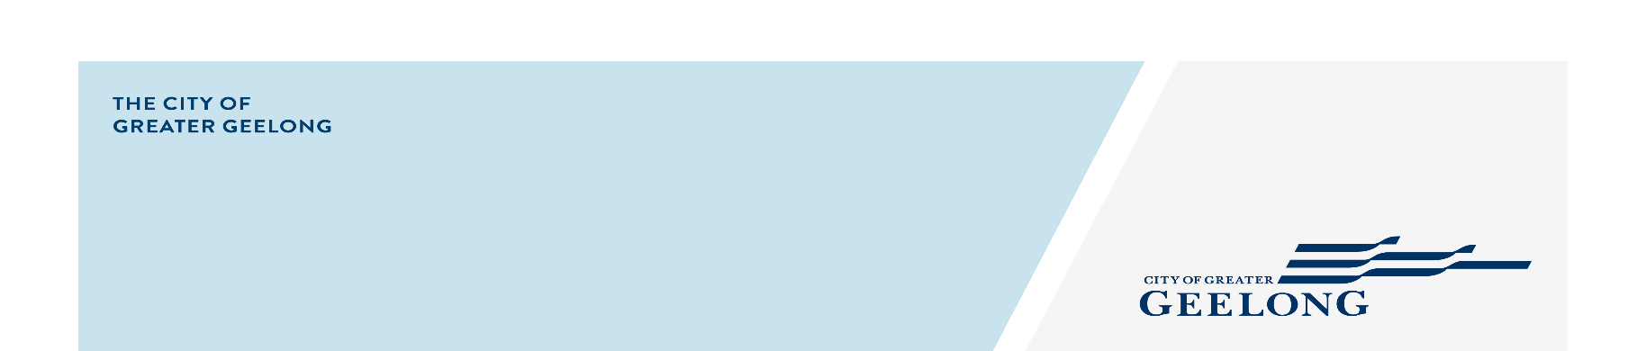
Expression of Interest
Biyala Public Art Creative Brief

We Acknowledge the Wadawurrung People as the Traditional Owners of the Land, Waterways and Skies. We pay our respects to their Elders, past and present. We Acknowledge all Aboriginal and Torres Strait Islander people who are part of our Greater Geelong community today.
Background
The City of Great Geelong is seeking an artist/team for the ‘Biyala’ Public Art Commission as part of and integrated into the School/Kinder and Community Hub precinct in Armstrong Creek.
Geelong is one of Australia’s fastest growing regional cities prized for its lifestyle, creative economy and rich heritage. As a UNESCO City of Design and Victoria’s second largest city, Geelong is shaped by deep First Nations cultural heritage, industrial legacy, distinctive coastal and river landscapes, and ongoing urban transformation.
Located 75 kilometres south-west of Melbourne, the municipality covers an area of 1,252 square kilometres. Our proximity and connection to metropolitan Melbourne, our unique CBD, townships, our natural assets and coastal areas make us a destination of choice attracting over 6 million visitors annually.
As the municipality evolves, public spaces play an increasingly important role in expressing local identity, strengthening community connection and supporting a more creative, inclusive and design-led city.
The site
In the Wadawurrung language, Biyala means "place of biyal (red gum)".
As Geelong’s population grows, places like Biyala, will become more important than ever to help us maintain the lifestyle and strong sense of community this region has always enjoyed. As a UNESCO City of Design, we have committed to building a more sustainable, resilient and inclusive community to improve the lives of our people.
This site presents the co-location and integration of a community hub hosting community recreational activities and classes, allied health services and early learning programs and a three-room kindergarten on Warralily Boulevard.
Complimenting this hub is Biyala Primary School Kindergarten on nearby Coastside Drive, built on adjacent land and connected by a pedestrian path. Together these facilities are strategically planned to meet the growing demand for early years services in Armstrong Creek, while providing families with integrated access to education, community spaces and allied health support.
Biyala Community Hub is an example of the City’s direction for social infrastructure. The development of any new infrastructure for children and family services will be focused on building integrated children’s centres. Co-location of schools, kinder, daycare, maternal and child health and allied health services build places where community can build and prosper.
Places like Biyala bring community together. Where friendships are made and where we can access important services. For many of us, they are our second home. The provision of social infrastructure, like Biyala in partnership with our community and key stakeholders, is essential for the health, wellbeing and economic prosperity of our community. Social infrastructure plays a key role in promoting social cohesion by providing focal points for community activity and providing places for people to meet and connect. It also provides opportunities for economic growth and serves as a key attractor for people to live, work, visit and play in our City.
Integrated community hubs are designed as intergenerational places that bring people of all ages together through the co-location of early years, health, community and learning services. By combining service delivery with flexible, bookable community spaces, hubs create opportunities for social connection, lifelong learning, community participation and shared experiences across generations. Community meeting rooms, multipurpose spaces and gathering areas are available for hire by local groups, organisations and residents, ensuring the facility functions not only as a service centre, but as a vibrant community destination that supports belonging, inclusion and community life.
This Public Art commission will contribute to co-location benefits by being a significant piece of art, but more than this a marker and place for people to meet. We welcome works that are interdisciplinary and draw connections between people, art, and the environment.
The artwork site:
The public artwork is proposed within a key gathering space that will function as a central meeting point for the Biyala precinct. Located between the Community Hub, kindergarten and Biyala Primary School, the space will be regularly used by families during kindergarten drop-off and pick-up times, as well as by primary school students and carers moving between the school and surrounding community facilities. At any one time, the precinct may accommodate up to 99 children attending the Community Hub kindergarten, 66 children attending the Biyala Primary School kindergarten and up to 650 primary students.
As part of an integrated community hub, this location will support daily interaction between children, parents, carers, older residents, community groups and visitors. The artwork will contribute to creating a welcoming and identifiable civic focal point within a broader intergenerational destination that combines early years services, education, health and flexible community spaces available.
The site sits between the Biyala Primary School, the kinder, daycare and other services.

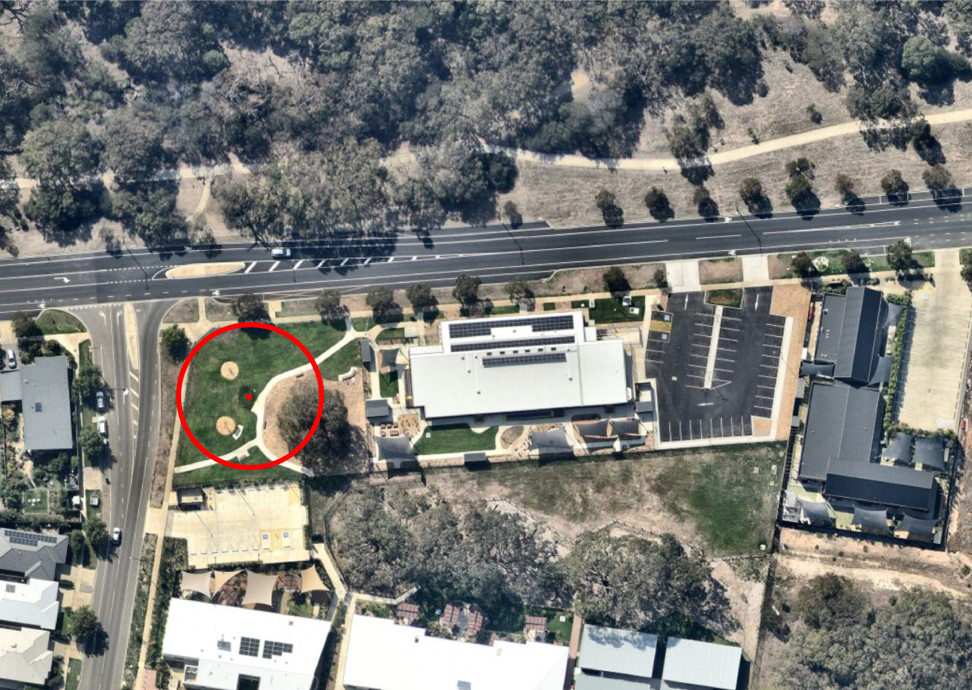
Figure 1 Site context with location of proposed artwork circled in red
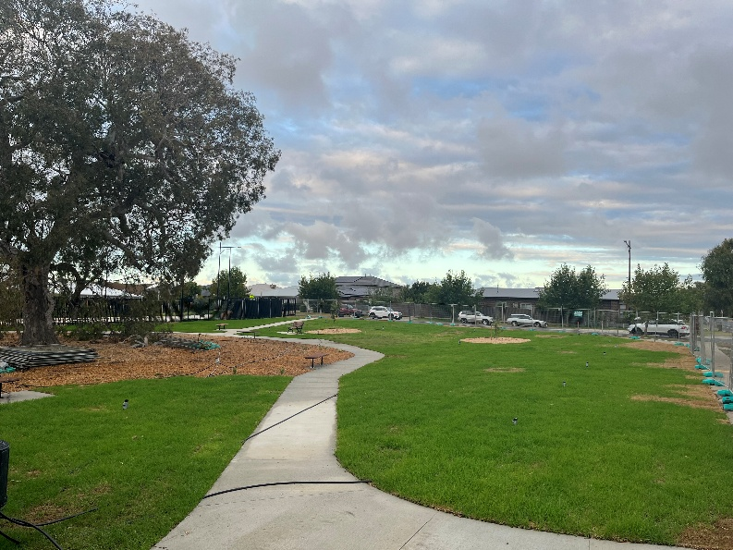
Figure 2 Site photo
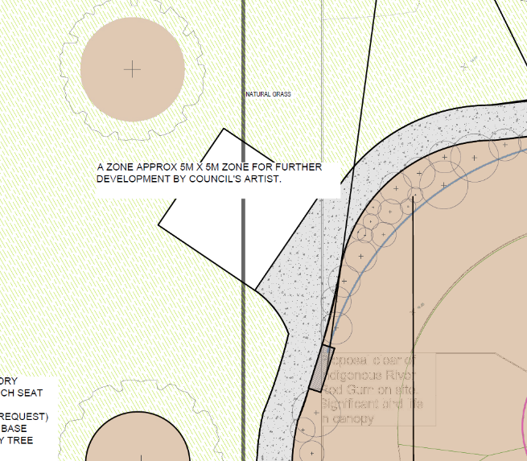
Figure 3 Site sketch
Our vision is to create a safe, fun, engaging space that children and families can gather and also is a meeting point. The artwork needs to serve as destination and marker, encouraging interaction and engagement from children and their carers. It should also be visible from adjacent footpaths and roads as a marker. Ideally the work will be a place that people be part of, but also a kind of beacon for the Biyala community that draws attention to itself.
Population growth is a primary driver of demand transforming Geelong. As such, it is essential that high-quality public spaces are delivered in the right locations to support new communities, maintain equitable access, and meet a diversity of user needs. In this context public art can help express this transformation signalling something new and exciting that becomes part of the fabric, connection and experience of community in the years to come.
There is an opportunity to incorporate the landscape as a structural component and feature of the art project. Manipulating the topography and using earthworks to both draw attention to the artwork and hold the space together as a place of safety, learning and care, but also as part of the broader environment. Similarly, we are keen to expand of the usage of local indigenous plant species. We are seeking a site driven work that can incorporate art, context and environment.
This artwork should draw connections between growth, place and the cosmos while being grounded in the environment and open space for curiosity, reflection and imagination. Like Blake’s idea about seeing the world in a grain of sand, the artwork will bring attention to connections and linkages between the intangible and unseen, the environment and community.
The artwork creates opportunities to-
- Make invisible processes like the ones inherent in education and learning tangible.
Learning is not merely the accumulation of information but the shifting of perception. It is the development of new ways of seeing, understanding, and engaging with the world.
Learning uncovers the hidden relationships between nature and human experience.
Accumulating information increases what you know. Learning, in a deeper philosophical sense, changes how you know. It reshapes the frameworks through which you interpret experience, make judgments, and act in the world. Rather than simply adding facts to the mind, genuine learning expands perception, refines understanding, and opens new possibilities for thought and action.
- Draw connections between learning and fun.
There is substantial literature on the connections between learning and fun. This artwork should spark curiosity and invite movement and play for young people as well as their carers.
- Acknowledge the evolving story of the Biyala community, both past and present while celebrating new directions and aspirations for the future.
Note: Power is available on site.
Commissioning Process
- Expression of Interest (EOI) process: as outlined below.
- Preliminary design stage: three short-listed artists will be paid to develop and present a design proposals that reflects the project’s aspirations, informed by this brief to the project team/public art panel.
- Final design: selected artist / team to refine the concept, incorporating feedback from the project team/public art panel.
- Project delivery: Develop a plan for project delivery in consultation with the Public Art Team. Design and delivery contracts and budgets will be separate and negotiated with the Public Art Team.
Budget:
The total budget for this commission is $200,000. This includes the artist/ design fee and all other costs.
Timeline:
2026
EOI opens: 29 July
EOI closes: 12 August
Shortlisted artists notified: 14 August
Information session for shortlisted artists: 17 August
Shortlisted concepts due: 28 August
Artist awarded: 4 September
Design Development/ Engineering: 4 September – 28 October
Engineering complete: 30 October
2027
Fabrication and site preparation: 30 October – 28 January 2027
Installation: 1 February-19 February
Commission complete: 22 February
Note: Dates may be subject to change
EOI Application Process:
If you are expressing interest in this commission, we require:
- Examples of your work that align with this brief.
- A current CV
- A short statement (max 500 words) responding to the key concepts in this brief.
Contact: Katharine Oliver
publicart@geelongcity.vic.gov.au

