PlanNING INFORMATION REQUEST

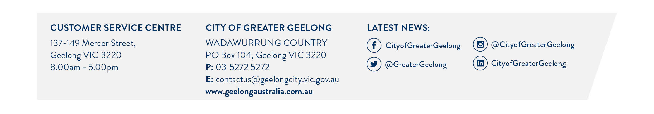

Planning and Environment Act 1987

PLANNING INFORMATION REQUESTS
A planning information request gives you planning information about a specific property.
We can provide:
- A list of what planning permits have been granted on a particular site
- A formal response to whether a planning permit would be required for a Use or Development
Please Note: This Form is not to be used for:
- Applications for Copies of Planning Permits, Endorsed Plans or any Documentation from a closed file.
If you wish to request a copy of any of the documents listed above, please follow this link to submit a Freedom of Information Request through our Governance Team

- Applications for Planning Certificates. Planning Certificates can be applied for through State Governments Website:
https://www.planning.vic.gov.au/guides-and-resources/guides/all-guides/planning-certificates

FEES
There are 3 variations of request that can be made which incur different fees:
- List of any Planning Permits previously issued for the site - $40.00
- Written Request for information – Residential - $220.00
- Written Request for Information – Commercial/Industrial/Other - $330.00
Fees can be submitted by using our credit card form found here; or by requesting an invoice when lodging the Request form.

Completing this form
If the space provided on the form is insufficient, please attach a separate sheet.
If you require assistance completing this form or any other enquiries, please contact Statutory Planning on 5272 4456.
Once the form is completed, please submit the form along with any other supporting documents (if required) to planninginfo@geelongcity.vic.gov.au
Did you know - You can lodge this application online. Click here to lodge via our Lodgement Portal on our council website.

aPPLICANT DETAILS
Contact Name:
(First and Last Name)
Organisation:
(if applicable)
Postal Address:
Email Address:
Telephone Number:  (Mobile): |  | Telephone Number:  (Home/Work):

PROPERTY INFORMATION
Address of the Land:
Lot(s) No: |  | Folio No:
LP/PS: |  | CA/CP:
Volume No: |  | Section:

REQUEST:
List of any Planning Permits previously issued for the site described above.  No copies of Planning Permits or Plans will be provided – If you wish to obtain copies of Plans or Permits, please apply through our Freedom of Information process: https://www.geelongaustralia.com.au/governance/article/item/8cdda1931b05dec.aspx | $40 ☐
Written request for information- Residential | $220 ☐
Written request for information- Commercial/Industrial/Other | $330 ☐
Please describe what information you require and attach any relevant supporting documents:

The personal information on this form is collected by The City of Greater Geelong for the purposes of the planning process, as set out in the Planning and Environment Act 1987.

