
Pre-gazettal REVIEW

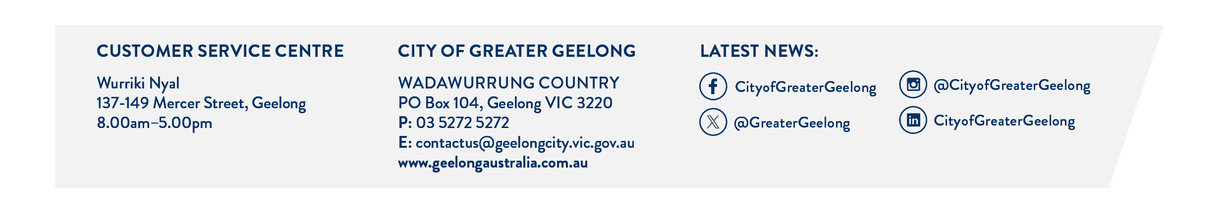
process
At the City of Greater Geelong, we offer a pre-gazettal process providing advice on your eligible subdivision proposals while awaiting approval of the relevant planning scheme amendment for a Precinct Structure Plan (PSP) or Development Plan Overlay (DPO) from the Minister for Planning.

The pre-gazettal process may only commence after Council has adopted the planning scheme amendment or it has been submitted for Ministerial approval. We anticipate that if followed in the spirit it’s intended, this process could save weeks/months in the assessment of your application once formally lodged.

The process may only be used for proposed subdivisions of 60+ lots within the proposed new PSP/DPO area. Any other developments/uses/subdivisions will need to wait for the planning scheme amendment to be approved by the Minister for Planning.

To see if you are eligible for the pre-gazettal process, please complete this enquiry form.

Once your proposal has been confirmed as being eligible for the pre-gazettal process, you will need to:

- complete the pre-gazettal submission form
- provide all the supporting documentation - this should include all the application requirements as listed in the adopted UGZ Schedule/zone and overlay controls (unless otherwise agreed). The submission must be generally in accordance with the Council adopted planning scheme amendment or as it has been submitted to the Minister for Planning, including any development staging plan; and
- pay the pre-gazettal submission fee.

Note: if you are submitting masterplans under a proposed DPO and plans for a proposed subdivision, this would be two separate submissions with two separate fees.

The pre-gazettal submission will be allocated to one of our growth team planners. They will be your contact person for this process.

The submission will be internally referred to relevant referral units for up to two rounds of referral comments only. A meeting will be organised with the internal referral teams and yourself to discuss the submission during the referral process. All comments and feedback provided on the submissions during this process is without prejudice to any future decision of the City. You will receive a summary of internal review comments along with pre-gazettal advice from Statutory Planning at the end of each round of referrals.

Please note: Draft conditions will not be provided during this process. Nor will detailed plans be accepted (eg FLP’s)

The City recognises some information may be emerging through the process. However, you are strongly encouraged to provide complete and consistent information packages. The City will not accept 'drip-fed' information as it can lead to unnecessary delays in reviewing the submission and comments being provided.

The pre-gazettal submission will not be externally referred during the process. We strongly encourage you to undertake separate discussions with any key external stakeholders.

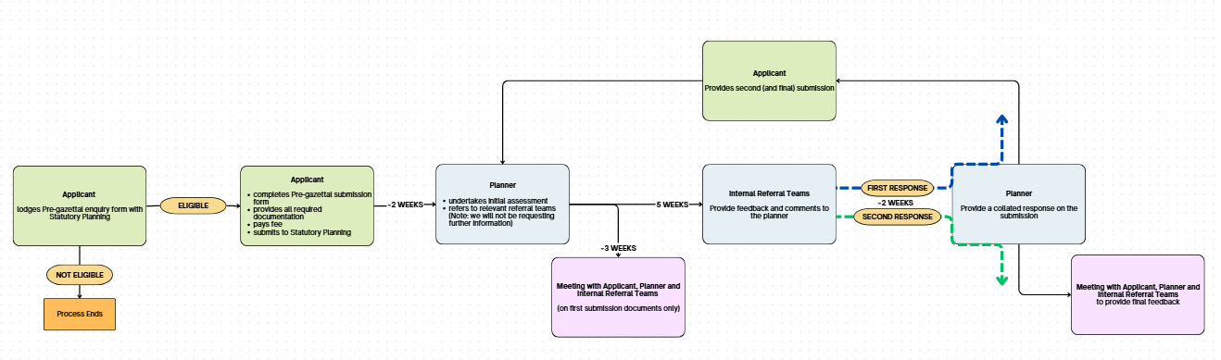

Last updated June 2026

