


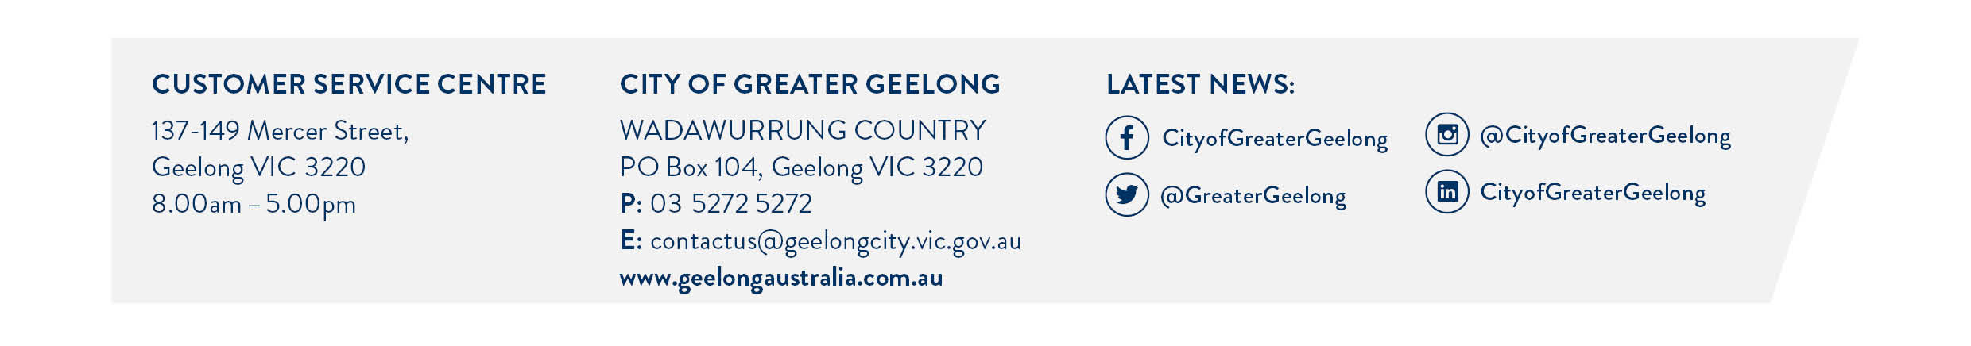
Please complete this form to request a pre-application meeting.
Complete the form
Make sure all sections have been completed
Provide supporting documents
This may include a description of the proposal, a site plan, concept drawings and photos of the site
Submit application
This form and supporting documents must be submitted via email to statplanning@geelongcity.vic.gov.au
For more information about the preapplication meeting process and how it works, please visit our website.
Application type & SUPPORTING INFORMATION REQUIRED |  | Fee
Other supporting documents also may include reports on traffic impact, sustainability, arborist, ecological assessment and waste management etc.
 | - Small residential (1-2 dwellings or subdivision) and/or works to a Dwelling within a Heritage Overlay  - Site plan  - Detailed sketches, that include dimensioned floor plans and elevations | $220.00
 | - Medium residential (3-9 dwellings or subdivision)  - Site plan  - Detailed sketches, that include dimensioned floor plans and elevations | $300.00
 | - Large residential (10+ dwellings or subdivision) or Small Commercial/Industrial or Aged Care/Child Care under $5million)  - Site plan  - Detailed sketches, that include dimensioned floor plans and elevations  - Details of the current use, as well as proposed future use, such as:  - the nature of the business, operating hours, number of employees, the type of vehicles that will come to the site and the expected number of vehicles per day/hour | $350.00
 | - Complex – Growth Area Subdivisions / Large Scale Development (30+ Lot Subdivision and/or development that cost $5million and over)  - Detailed sketches, site layout plans and floor plans  - Supporting documents of the proposal | $800.00

- aPPLICANT DETAILs
ORGANISATION: (if applicable)
fIRST AND lAST nAME:
RESIDENTIAL OR POSTAL ADDRESS:
pHONE NUMBER: |  | EMAIL:
Estimated Cost of Works: | $
aPPLICATION tYPE:
Type 1 – Small Residential: $220 ☐
Type 2 – Medium Residential: $300 ☐
Type 3 – Large Residential/Small ComMercial/SMALL Industrial (INcl Aged Care/Day Care under $5million): $350 ☐
Type 4 – Complex/Growth SUBDIVISION (30+ Lots) OR OVer $5million ESTIMATED Development cost: $800 ☐
2. tHE pROPOSAL
Property address:
DESCRIPTION OF PROPOSAL:
SPECIFIC planning TOPICS FOR DISCUSSION (or specific planning questions for written advice only):

3. MEETING DETAILS
PREFERRED ADVICE PLATFORM (please select one):
- Microsoft Teams
Please note: To use the Microsoft Teams platform, you must install the Teams Application prior to the meeting.
- In Person
Please note: Meetings will be held at Geelong City Council Offices. Wurriki Nyal, 137-149 Mercer Street, Geelong.
How many people will be attending? _____________

- Written advice only
Please note: You need to include your specific questions in the section above. We will not be undertaking a full assessment of your proposal – we will only be responding to the questions asked above.

4. Are you wanting ADVICE FROM AN ENGINEER?
No ☐
YES ☐ - Please circle what advice you are seeking – vehicle crossing, vehicle movements, other
If other, what advice are you seeking? _________________________________________________________________________

5. dECLARATION
- I am the current owner of the land (or the applicant / agent acting on their behalf)
- I am a potential purchaser of the land (or the applicant / agent acting on their behalf)

nAME:
sIGNATURE: |  | DATE:

6. OTHER
Planning investigations reference number (if applicable):

DISCLAIMER

All information and correspondence (including plans, drawings, photos, emails, etc.) that you submit to in relation to a preapplication proposal, as well as meeting notes and written feedback, will be held in the City of Greater Geelong’s Records Document Management System.

Any advice provided at the pre-application meeting is preliminary advice only. We will attempt to provide clear and concise advice based on the information tabled at the pre-application meeting and the relevant provisions within the Greater Geelong Planning Scheme. This advice may be impacted by consequential changes to the Greater Geelong Planning Scheme, the design, further information received, referral advice, site inspection, the public notice process, and any other change of circumstance.

The personal information requested on this form is being collected by City of Greater Geelong for requesting a pre-application meeting. Your personal information will not be disclosed, except as required to do so by law. Our privacy policy is available on our website. If you wish to alter any of the personal information you have supplied to City of Greater Geelong, please contact us by sending an email to privacy@geelongcity.vic.gov.au.

