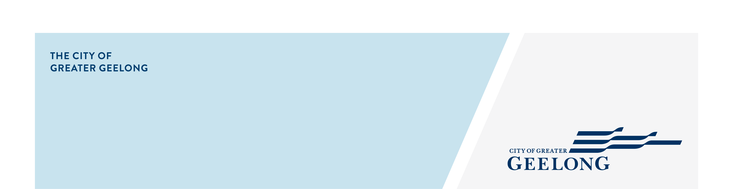
freedom of information

access request 2026-2027

DETAILS OF REQUEST
I request access to the following document(s):
___________________________________________________________________________________________________________
___________________________________________________________________________________________________________
___________________________________________________________________________________________________________
___________________________________________________________________________________________________________

FORM OF ACCESS REQUIRED
I want to inspect the document(s) I want a copy of the document(s)

YOUR DETAILS
Title: Mr / Mrs / Miss / Ms / Other: _____________________
Name: ______________________________________________________________________________________________
Organisation: ___________________________________________________________________________________________
Address: ___________________________________________________________________________ Postcode: _________
Telephone: _______________________________________________________________________________________________
Email: ___________________________________________________________________________________________________

Do you wish to be identified as the Applicant?
When processing your FOI application, we are required to seek the views of any individuals or businesses whose information is contained in the documents. During the consultation process, do you consent to the City of Greater Geelong identifying you as the FOI applicant?
Yes, I consent to being identified as the FOI applicant. No, I would prefer my identity remain anonymous.

Section 25 of the Act – Deletion of Exempt or Irrelevant Material
Where part of a document is exempt from release, or has irrelevant material to the request, I wish to receive access to the edited document(s) with deletions, in order to receive part of the document(s) that can be released.
Yes, I consent to the edited formatting. No, I do not consent.

Reason for your request: ______________________________________________________________________________________

___________________________________________________________________________________________________________

___________________________________________________________________________________________________________

___________________________________________________________________________________________________________

I understand that I have to pay a fee of $34.50 on lodgement of this request, that further charges may be levied in respect of this request and that I will be supplied with a statement of any additional charges that are to be levied.

SIGNATURE: ________________________________________________________ DATE: ________/________/__________

Please return this form to either:

foi@geelongcity.vic.gov.au OR

FOI Officer, City of Greater Geelong, PO Box 104, GEELONG VIC 3220

The personal information requested on this form is being collected by City of Greater Geelong for the purpose of processing your application or any other directly related purpose. Where required, your identity and a description of the documents which you seek access to will be provided to the City of Greater Geelong staff/contractors to enable them to search for the requested documents. We will not disclose your personal information without your consent, except where required to do so by law. Our privacy policy is available on our website. If you wish to alter any of the personal information, you have supplied to City of Greater Geelong, please contact us by sending an email to privacy@geelongcity.vic.gov.au

Office Use Only: Application fee received on …../…../…… Receipt Number ……………..

