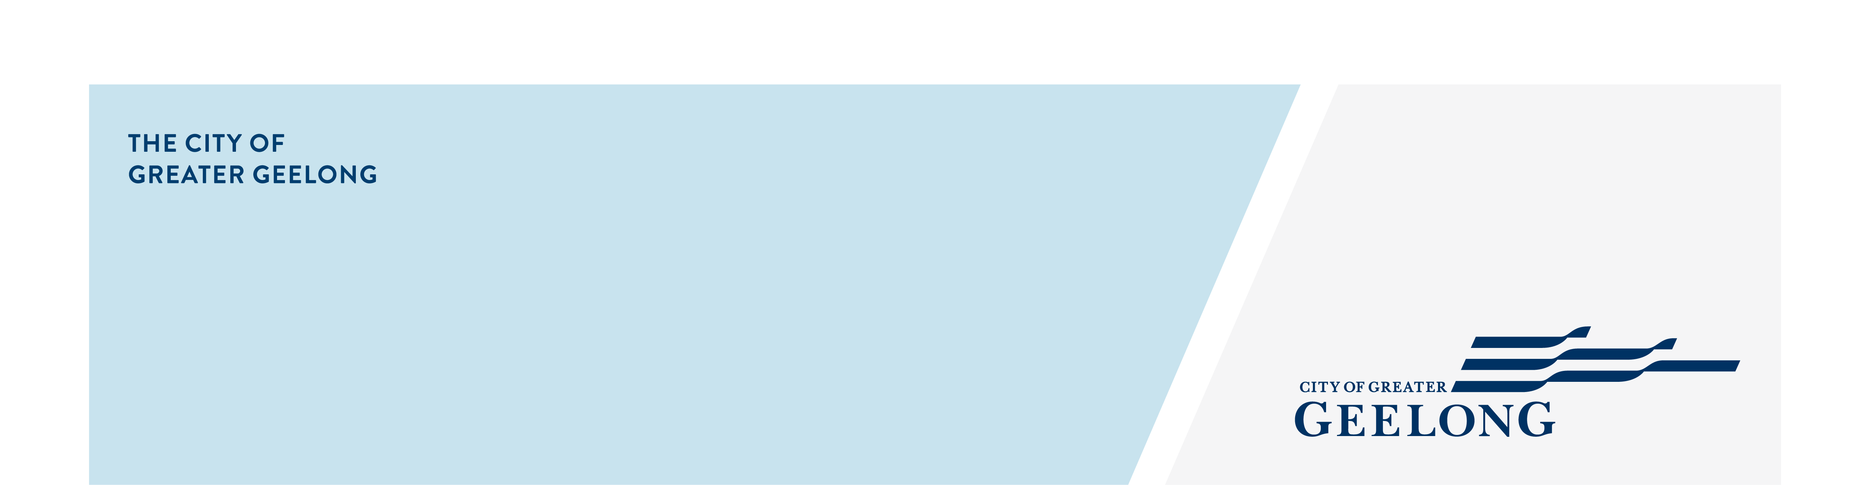
ONE DWELLING ON A LOT OR

A SMALL SECOND DWELLING

– CLAUSE 54
To assist us in assessing your application under clause 54 of the Greater Geelong Planning Scheme, the following information must be provided with your application for planning permit:

information requirements:
Fully dimensioned plans, at a preferred scale of 1:100 or 1:200 including:

- Existing and proposed buildings and works, including title boundaries, dimensions of the site, buildings, garden areas, driveways and parking areas;
- Floor plans
- Elevation plans, including heights above natural ground level;

Site description, as outlined in cl 54.01-1
Design response, as outlined in cl 54.01-2, including a landscape plan
Written statement outlining which standards are met and which are not met.

- Where a standard is met, you must explain/demonstrate how the standard is met (eg the height of the building is 5m (see Plan TP.03).
- Where the standard is not met, you must explain how the development meets the corresponding objective having regard to the decision guidelines.
See our Cl 54 template as a guide
Landscape plan that shows:

- Retention and planting of canopy trees;
- Planting of other vegetation, including location, species, number and size at maturity of vegetation;
- Where required, areas of deep soil and root barriers;
- Irrigation system to support existing and planted vegetation including details of any alternative water supply sources;
- Selection of canopy trees and vegetation, including species, that responds to the site’s environment, location and geographic factors;
- Location of site services, clothes drying and storage;
- How the minimum canopy cover required under cl 54.02-6 is met.

Shadow diagrams, as required by cl 54.04-3

Note: this includes a set of shadow diagrams showing overshadowing of the existing conditions.
Overlooking diagrams, where required, as outlined by cl 54.04-4

