CLAUSE 55 ASSESSMENT – TOWNHOUSE AND LOW-RISE CODE (UP TO 3 STOREYS)

Plans Assessed: INSERT
Permit Application Number: «Application_Number»

The following objectives and standards apply to an application to:

- Construct a dwelling if there is at least one dwelling existing on the lot.
- Construct two or more dwellings on a lot.
- Extend a dwelling if there are two or more dwellings on the lot.
- Construct or extend a dwelling on common property.
- Construct or extend a residential building.

in the Mixed Use Zone, Township Zone, Residential Growth Zone, General Residential Zone, Neighbourhood Residential Zone, or Housing Choice and Transport Zone.

APPLICATION REQUIREMENTS

An application to which this clause applies must be accompanied by:

- A site description – Clause 55.01-1.
- A design response – Clause 55.01-2 including a landscape plan.
- A written statement outlining which standards are met and which are not met. If a standard is not met, the written statement must include an explanation of how the development meets the corresponding objective having regard to the corresponding decision guidelines.

DEEMED TO COMPLY – CODIFIED

If a development meets the standard, it is deemed to meet the objective for that standard.
Where the standard is met, the decision guidelines for that standard do not apply to the application.

The below assessment confirms that all applicable standards are met and therefore codified. The applicable standards are:
- 55.02 – All Neighbourhood character standards (street setback, building height, side and rear setback, walls on boundaries, site coverage, access, tree canopy, front fence)
- 55.04-1 - Daylight to existing windows
- 55.04-2 - Existing north-facing windows
- 55.04-3 - Overshadowing secluded open space
- 55.04-4 – Overlooking
- 55.05-2 - Overshadowing domestic solar energy systems
Where the applicable standards are met, there are no third party review rights under section 82(1) of the Act.

When a standard is met, the council is not required to consider any other policy or decision guideline in the planning scheme and specified matters under section 60 of the P&E Act.

A planning permit can be issued.

Or

DEEMED TO NOT COMPLY – NOT CODIFIED

If a development does not the standard, it is deemed to meet the objective if an alternative design solution is considered appropriate.
Where the standard is not met, the decision guidelines for that standard apply to the alternative design solution.

Review rights under section 82(1) of the Act are applicable but only apply to the following standards:
- 55.02 – All Neighbourhood character standards (street setback, building height, side and rear setback, walls on boundaries, site coverage, access, tree canopy, front fence)
- 55.04-1 - Daylight to existing windows
- 55.04-2 - Existing north-facing windows
- 55.04-3 - Overshadowing secluded open space
- 55.04-4 – Overlooking
- 55.05-2 - Overshadowing domestic solar energy systems
The below assessment confirms that not all standards are met and therefore not all are codified.

The standards not met and therefore not codified are:

INSERT

A NOD can be issued if objections received, and based on the above review rights, the following standards can be reviewed at VCAT:

INSERT

Or

A permit can be issued as no objections received.

CLAUSE 55 ASSESSMENT

The following objectives and standards are current up to and including Amendment VC267 on 6/3/2025.

55.02 Neighbourhood character

55.02-1 Street setback objective  To ensure that the setbacks of buildings from a street respond to the existing or preferred neighbourhood character and make efficient use of the site. | Standard B2-1  Walls of new buildings are set back from streets:  - At least the distance specified in a schedule to the zone if the distance specified in the schedule is less than the distance specified in Table B2-1; or  - If no distance is specified in a schedule to the zone, the distance specified in Table B2-1.  Porches, pergolas and verandahs that are less than 3.6 metres high and eaves may encroach not more than 2.5 metres into the setbacks of this standard.  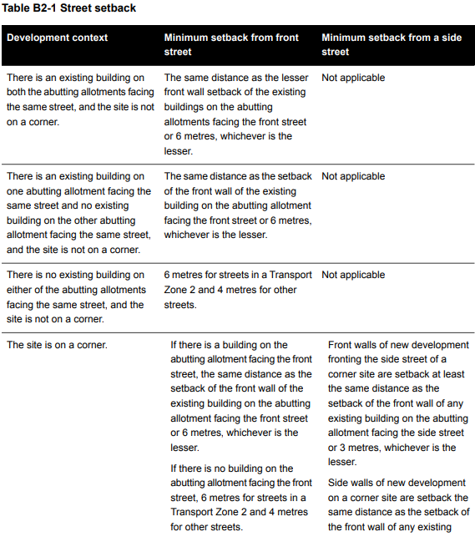  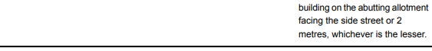 | Deemed to Comply  The lessor front wall setback of the existing buildings on the abutting allotments is INSERT metres, which results in a requirement for an INSERT metre street setback. This has been achieved as the building is setback INSERT metres from the street.  OR  The lessor setback of the adjoining building is INSERT metres which is greater than the lessor 6 metre setback therefore the setback must be 6m. This has been achieved as the building is setback INSERT metres from the street.  OR  One adjoining lot is vacant and the other lot has a building setback INSERT metres from the street. The proposed setback complies as it is the same setback of the adjoining dwelling at INSERT metres/is setback 6m which is the lessor setback.  OR  Both adjoining lots are vacant. The setback of INSERT metres meets the Transport Zone 2/other street setback.  OR  The site is located on a corner lot and the setback of INSERT metres meets the setback of the adjoining building/is the lessor setback. The side setback is INSERT metres which meets the setback of the adjoining building face the side street/is the lessor setback.  The front wall of the development fronting the side street is setback INSERT metres which meets the setback of the adjoining building facing the side street/is the lessor setback.  Not Applicable  The application proposes construction of new dwellings behind an existing dwelling such that the established front setback is to be retained.  Variation  INSERT  Before deciding on an application, the responsible authority must consider:  - Any relevant neighbourhood character objective, policy or statement set out in this scheme.  - The design response.  - Whether the siting of the building is constrained by the shape, dimensions, slope or other conditions of the site.  - Whether a different setback would be more appropriate taking into account the prevailing setbacks of existing buildings on nearby lots.  - The visual impact of the building when viewed from the street and from adjoining properties.  - Whether a different setback affects the ability to retain or plant canopy trees.  INSERT  Does not meet the objective  INSERT | Right of Appeal  No, standard met  Yes, standard varied
55.02-2 Building height objective  To ensure that the height of buildings responds the existing or preferred neighbourhood character. | Standard B2-2  The maximum building height of a new building does not exceed the maximum height specified in the zone, schedule to the zone or an overlay that applies to the land.  If no maximum height is specified in the zone, schedule to the zone or an overlay, the maximum building height of a new building does not exceed 9 metres, unless the slope of the natural ground level at any cross section wider than 8 metres of the site of the building is 2.5 degrees or more, in which case the maximum building height should not exceed 10 metres. | Deemed to Comply  The maximum building height applicable to the site is INSERT metres and INSERT storeys at any point (excluding a basement). The proposed maximum building height of INSERT metres meets the standard/mandatory building height requirement of the ZONE.  Variation  The maximum building height applicable to the site is INSERT metres which exceeds the Standard by INSERT metres  Before deciding on an application, the responsible authority must consider:  - Any relevant neighbourhood character objective, policy or statement set out in this scheme.  - Any maximum building height specified in the zone, a schedule to the zone or an overlay applying to the land.  - The design response.  - The effect of the slope of the site on the height of the building.  - The relationship between the proposed building height and the height of existing adjacent buildings.  - The visual impact of the building when viewed from the street and from adjoining properties.  INSERT  The dwellings are single storey in scale in line with surrounding development.  While the dwellings are double storey in scale, the design solution includes single storey elements in response to the scale of the surrounding area.  Does not meet the objective  INSERT | Right of Appeal  No, standard met  Yes, standard varied
55.02-3 Side and rear setbacks objective  To ensure that the height and setback of a building from a boundary responds to the existing or preferred neighbourhood character and limits the impact on the amenity of existing dwellings or small second dwellings. | Standard B2-3  A new building not on or within 200mm of a boundary is set back from side or rear boundaries in accordance with either B2-3.1 or B2-3.2.  Standard B2-3 is met if the building is set back in accordance with either B2-3.1 or B2-3.2, rather than needing to comply with both of these provisions:  - B2-3.1: The building is set back at least 1 metre, plus 0.3 metres for every metre of height over 3.6 metres up to 6.9 metres, plus 1 metre for every metre of height over 6.9 metres.  - B2-3.2: If the boundary is not to the south of the building, the building is set back at least 3 metres up to a height not exceeding 11 metres and at least 4.5 metres for a height over 11 metres. If the boundary is to the south of the building, the building is set back at least 6 metres up to a height not exceeding 11 metres and at least 9 metres for a height over 11 metres between south 30 degrees west to south 30 degrees east.  Sunblinds, verandahs, porches, eaves, facias, gutters, masonry chimneys, flues, pipes, domestic fuel or water tanks, and heating or cooling equipment or other services may encroach not more than 0.5 metres into the side and rear setbacks.  Landings that have an area of not more than 2 square metres and less than 1 metre high, stairways, ramps, pergolas, shade sails and carports may encroach into the side and rear setbacks.  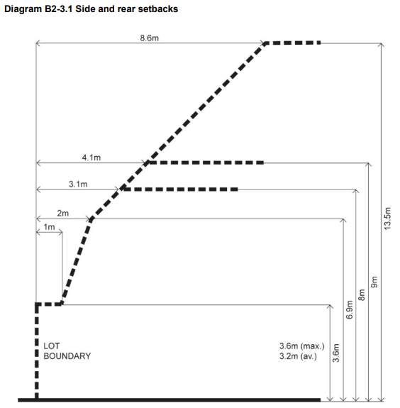  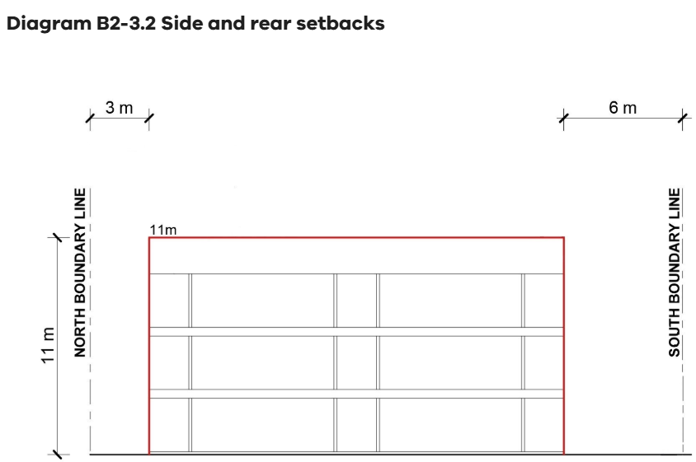 | Deemed to Comply  The required setbacks have been achieved for the development and all side and rear setbacks comply with the B2-3.1/B2-3.2 formula contained in the Standard.  Variation  INSERT  Before deciding on an application, the responsible authority must consider:  - Any relevant neighbourhood character objective, policy or statement set out in this scheme.  - The design response.  - The impact on the amenity of the habitable room windows and secluded private open space of existing dwellings or small second dwellings.  - Whether the wall is opposite an existing or simultaneously constructed wall built to the boundary.  - Whether the wall abuts a side or rear lane.  - Whether a different setback in a rear yard affects the ability to retain or plant canopy trees.  INSERT  Does not meet the objective  INSERT | Right of Appeal  No, standard met  Yes, standard varied
55.02-4 Walls on boundaries objective  To ensure that the location, length and height of a wall on a boundary responds to the existing or preferred neighbourhood character and limits the impact on the amenity of existing dwellings and small second dwellings. | Standard B2-4  A new wall constructed on or within 200mm of a side or rear boundary of a lot or a carport constructed on or within 1 metre of a side or rear boundary of lot does not abut the boundary for a length that exceeds the greater of the following distances:  - 10 metres plus 25 per cent of the remaining length of the boundary of an adjoining lot, or  - The length of existing or simultaneously constructed walls or carports abutting the boundary on an abutting lot.  A new wall or carport may fully abut a side or rear boundary where slope and retaining walls or fences would result in the effective height of the wall or carport being less than 2 metres on the abutting property boundary.  A building on a boundary includes a building set back up to 200mm from a boundary.  The height of a new wall constructed on or within 200mm of a side or rear boundary or a carport constructed on or within 1 metre of a side or rear boundary does not exceed an average of 3.2 metres with no part higher than 3.6 metres unless abutting a higher existing or simultaneously constructed wall. | Deemed to Comply  The proposed wall on the INSERT boundary extends for a length of INSERT metres, has an average height of INSERT metres, and a maximum height of INSERT metres.  There are no carports proposed to be on or within 1 metre of a side or rear boundary.  Not Applicable  No new walls on or within 200mm of a boundary, or carport within 1m of a boundary are proposed as part of this application.  Variation  The proposed wall on or within 200mm of the INSERT boundary extends for a length of INSERT metres, has an average height of INSERT metres, and a maximum height of INSERT metres. This wall exceeds the requirements of the Standard.  The proposed carport within 1 metre of the INSERT boundary extends for a length of INSERT metres, has an average height of INSERT metres, and a maximum height of INSERT metres. This carport exceeds the requirements of the Standard.  Before deciding on an application, the responsible authority must consider:  - Any relevant neighbourhood character objective, policy or statement set out in this scheme.  - The design response.  - The extent to which walls on boundaries are part of the neighbourhood character.  - The impact on the amenity of existing dwellings or small second dwellings.  - The opportunity to minimise the length of walls on boundaries by aligning a new wall on a boundary with an existing wall on a lot of an adjoining property.  - The orientation of the boundary that the wall is being built on.  - The width of the lot.  - The extent to which the slope and retaining walls or fences reduce the effective height of the wall.  - Whether the wall abuts a side or rear lane.  - The need to increase the wall height to screen a box gutter.  INSERT  Does not meet the objective  INSERT | Right of Appeal  No, standard met  Yes, standard varied
55.02-5 Site coverage objective  To ensure that the site coverage responds to the existing or preferred neighbourhood character and responds to the features of the site. | Standard B2-5  The site area covered by buildings does not exceed:  - The maximum site coverage specified in a schedule to a zone; or  - If no maximum site coverage specified in a schedule to a zone, the percentage specified in Table B2-5:  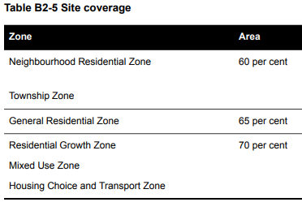 | Deemed to Comply  The maximum site coverage specified for this site is INSERT percent as per the schedule to the zone/Table B2-5.  The proposed site coverage of buildings is INSERT percent of the site, which meets the standard.  Variation  The maximum site coverage specified for this site is INSERT percent.  The proposed site coverage of buildings is INSERT percent of the site, which is greater than the maximum required by the standard.  Before deciding on an application, the responsible authority must consider:  - Any relevant neighbourhood character objective, policy or statement set out in this scheme.  - The design response.  - The existing site coverage and any constraints imposed by existing development or the features of the site.  - The site coverage of adjacent properties.  - The effect of the visual bulk of the building and whether this is acceptable in the neighbourhood.  - Whether a different area of site coverage affects the ability to retain or plant canopy trees.  INSERT  Does not meet the objective  INSERT | Right of Appeal  No, standard met  Yes, standard varied
55.02-6 Access objective  To ensure the number and design of vehicle crossovers responds to the neighbourhood character. | Standard B2-6  The width of new accessways or car spaces (other than to a rear lane) does not exceed:  - 33 per cent of the street frontage, or  - 40 per cent of the street frontage if the width of the street frontage is less than 20 metres.  The number of access points to a road in a Transport Zone 2 or a Transport Zone 3 is not increased.  The location of a new vehicle crossover or accessway does not encroach the tree protection zone of an existing tree, that is proposed to be retained in a road by more than 10 per cent. | Deemed to Comply  A total of INSERT% of the frontage is taken up with accessways or car spaces, which complies with the standard for this site with a street frontage of INSERT metres.  The number of access points to a road in a TRZ2 or TRZ3 has not increased.  The location of the vehicle crossover or accessway does not encroach more than 10% into the TPZ of the existing street tree.  Variation  INSERT  Before deciding on an application, the responsible authority must consider:  - Any relevant neighbourhood character objective, policy or statement set out in this scheme.  - The design response.  - The reduction of on-street car parking spaces.  - Whether a different accessway width, number of access points or encroachment of an existing tree affects the ability to retain or plant canopy trees on the site or footpath.  INSERT  Does not meet the objective  INSERT | Right of Appeal  No, standard met  Yes, standard varied
55.02-7 Tree canopy objective  To provide tree canopy that responds to the neighbourhood character of the area and reduces the visual impact of buildings on the streetscape.  To preserve existing canopy cover and support the provision of new canopy cover.  To ensure new canopy trees are climate responsive, support biodiversity, wellbeing and amenity, and help reduce urban heat | Standard B2-7  In this standard:  average canopy diameter means the average of the measurements of the distance between the  widest points of a tree’s drip line (the outer edge of foliage) in two perpendicular directions;  canopy cover means the area of a tree’s canopy;  existing canopy tree means a tree that has:  – a height of at least 5 metres above ground level; and  – an average canopy diameter of at least 4 metres; and  – a trunk that is located at least 4 metres from existing and proposed buildings.  new canopy tree means a tree proposed to be planted that is of a species and type that at maturity is expected to have:  – a height of at least 6 metres above ground level; and  – a canopy diameter of at least 4 metres.  The total canopy cover provided with the development is equivalent to at least the percentage of the site area specified in Column 2 to Table B2-7.1 corresponding to the applicable site area specified in Column 1.  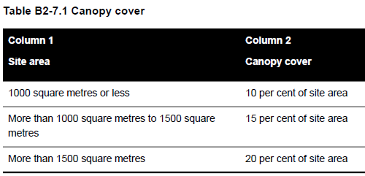  The canopy cover requirement can only be met by retaining an existing canopy tree, planting a new canopy tree or a combination of both, within the site.  The total canopy cover required by Table B2-7.1 includes:  - The total canopy cover of an existing canopy tree, whether or not the canopy cover is wholly contained within the boundaries of the site.  - The canopy cover within the boundaries of the site of a new canopy tree and any part of the canopy cover overhanging land in a public road or public open space.  - The canopy cover of an existing canopy tree and a new canopy tree that extends below, or overhangs, an existing or proposed building located on the site.  - Any overlapping canopy cover of an existing canopy tree or a new canopy tree provided that the overlapping canopy cover is only counted once.  At least one existing canopy tree or new canopy tree is to be located within the front setback. This does not apply if it is proposed to retain one existing canopy tree that meets the minimum total canopy cover requirement and that tree is not located in the front setback.  Each new canopy tree is planted in either deep soil or a planter that meets the following requirements:  - Deep soil must be at least the area and plan dimension specified in Columns 2 and 5, respectively, of Table B2-7.2 corresponding to the tree’s expected canopy diameter at maturity specified in Column 1.  - A planter must be at least the soil volume, soil depth, and plan dimension, specified in Columns 3, 4 and 5 of Table B2-7.2 corresponding to the tree’s expected canopy diameter at maturity specified in Column 1.  - If two or more new canopy trees are to be planted in the same area of deep soil, the required area of deep soil can be reduced by the percentage specified in Column 2 of Table B2-7.3 corresponding to the number of trees specified in Column 1.  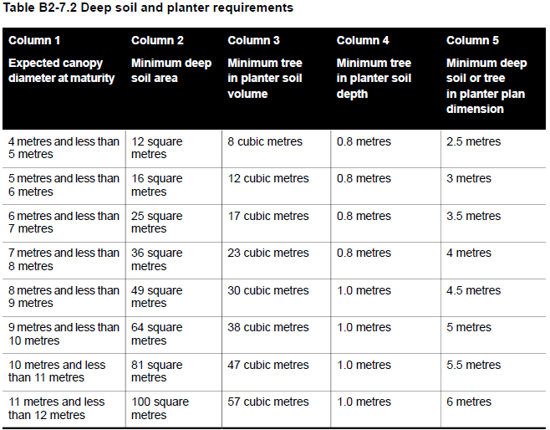  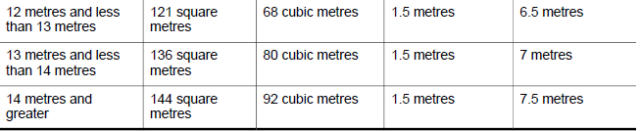  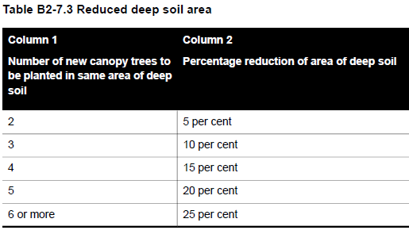  The following can encroach into the total area of deep soil:  - Impervious surfaces by no more than 10 per cent.  - Unroofed decking by no more than 50 per cent, provided the gap between the decking boards is at least:  – 4 millimetres for decking boards not more than 90 millimetres wide.  – 5 millimetres for decking boards more than 90 millimetres wide.  – 8 millimetres if the deck is less than 400 millimetres above ground level.  - An eave not exceeding a width of 600 millimetres. | Deemed to Comply  There are adequate areas available on site to allow for tree retention/planting which will complement the landscape character of the area.  The site is INSERT sqm in area and a total of INSERT% of the site or INSERT sqm has been set aside for canopy cover using the retention of trees on site/planting of new canopy trees to meet the canopy coverage required.  Deep soil areas/planter requirements have been provided in accordance with Table B2-7.2.  Reduced deep soil areas have been provided in accordance with Table B2-7.3.  An appropriate landscaping plan has been submitted for assessment.  Variation  INSERT  Before deciding on an application, the responsible authority must consider:  - Any relevant neighbourhood character objective, policy or statement set out in this scheme.  - The site context and design response.  - The extent to which the existing and proposed canopy trees contribute to a greener environment and reduce urban heat.  - Whether the growth characteristics of existing trees and proposed canopy trees will provide the required canopy cover.  - The suitability of the planting location, deep soil areas and planter soil volume for proposed canopy trees.  - Whether the species of canopy tree is suited to the soil conditions of the site.  - The suitability of providing deep soil area within an easement on the subject land.  INSERT  Does not meet the objective  INSERT | Right of Appeal  No, standard met  Yes, standard varied
55.02-8 Front Fences  To encourage front fence design that responds the existing or preferred neighbourhood character.  . | Standard B2-8  Either the development:  - does not include a new, or an extension to an existing, front fence within three metres of a street; or  - includes a new, or extension to an existing, front fence within 3 metres of a street if the height of the fence does not exceed:  - The maximum height specified in a schedule to the zone, or  - If no maximum height is specified in a schedule to the zone, the maximum height specified in Table B2-8.  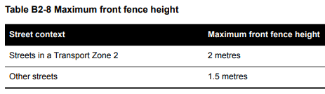 | Deemed to Comply  The new front fence/extension to the existing front fence is 1.5m (other Street)/2m (Streets in a Transport Zone 2) in height.  Not Applicable  No new front fence/extension to the existing fence is proposed as part of this permit application.  Variation  INSERT  Before deciding on an application, the responsible authority must consider:  - Any relevant neighbourhood character objective, policy or statement set out in this scheme.  - The design response.  - The setback, height and appearance of front fences on adjacent properties.  - The extent to which slope and retaining walls reduce the effective height of the front fence.  - Whether the fence is needed to minimise noise intrusion.  INSERT  Does not meet the objective  INSERT | Right of Appeal  No, standard met  Yes, standard varied

55.03 Liveability

55.03-1 Dwelling diversity objective  To encourage a range of dwelling sizes and types in developments of ten or more dwellings. | Standard B3-1  Developments include at least:  - One dwelling that contains a kitchen, bath or shower, bedroom and a toilet and wash basin at ground floor level for every 10 dwellings.  - One dwelling that includes no more and no less than 2 bedrooms for every 10 dwellings.  - One dwelling that includes no more and no less than 3 bedrooms for every 10 dwellings | Deemed to Comply  The development proposes INSERT number of dwellings which requires at least INSERT dwelling/s at ground floor, INSERT 2 bedroom dwelling/s and INSERT 3 bedroom dwelling/s.  This has been provided in the form of INSERT dwelling/s at ground floor, INSERT two bedroom dwelling/s, INSERT three bedroom dwelling/s.  Not Applicable  Fewer than ten dwellings are proposed.  Variation  INSERT  Does not meet the objective  INSERT | Right of Appeal  No
55.03-2 Parking location objective  To minimise the impact of vehicle noise within developments on residents | Standard B3-2  Habitable room windows with sill heights of less than 3 metres above ground level are setback from accessways and car parks by at least:  - 1.5 metres; or  - If there is a solid fence with a height of at least 1.5 metres between the accessway or car park and the window, 1 metre; or  - 1 metre where window sills are at least 1.5 metres above ground level.  This standard is met if an accessway or relevant car parking space is used exclusively by the resident of the building with the habitable room. | Deemed to Comply  Accessways and car parks are located at least 1.5 metres from the windows of habitable rooms.  Accessways and car parks are located at least 1 metre from the windows of habitable rooms where there is a solid fence with a height of at least 1.5m.  Accessways and car parks are located at least 1 metre from the windows of habitable rooms where the window sill is at least 1.5m above ground level.  While the setback has not been achieved, the accessway or relevant car parking space is used exclusively by the resident of the building with the habitable room.  Variation  INSERT  Before deciding on an application, the responsible authority must consider the design response.  INSERT  Does not meet the objective  INSERT | Right of Appeal  No
55.03-3 Street integration objective  To integrate the layout of development with the street to support the safety and amenity of residents | Standard B3-3  Where a development fronts a street, a vehicle accessway or abuts public open space:  - Passive surveillance is provided by a direct view from a balcony or a habitable room window to each street, vehicle accessway and public open space.  - The total cumulative width of all site services to be located within 3 metres of a street, do not take up more than 20 per cent of the width of the frontage and are screened from view from the street or located behind a fence. Screens or fences are to provide no more than 25 per cent transparency.  Lighting is provided to all external accessways and paths.  Mailboxes are provided for each dwelling and can be communally located. | Deemed to Comply  The development is designed to provide passive surveillance of INSERT Street/a vehicle accessway/public open space through a direct view from a balcony or habitable room window from dwellings INSERT.  The total cumulative width of site services within 3m of a street is INSERT metres which is no more than 20% of the width of the frontage and are screened from view or located behind a fence which is no more than 25% transparent.  Lighting is provided to all external accessways and paths.  Mailboxes are provided for each dwelling and are communally located where applicable.  Variation  INSERT  Before deciding on an application, the responsible authority must consider:  - Any relevant neighbourhood character objective, policy or statement set out in this scheme.  - The design response.  INSERT  Does not meet the objective  INSERT | Right of Appeal  No
55.03-4 Entry objective  To provide each dwelling, apartment development or residential building with its own sense of identity.  To provide entries with weather protection, safe design, natural light and ventilation. | Standard B3-4  Dwellings (other than a dwelling in or forming part of an apartment development) and residential buildings  Each dwelling and each residential building has a ground level entry door that:  - Has a direct line of sight from a street, accessway or shared walkway.  - Is not accessed through a garage.  - Has an external covered area of at least 1.44 square metres with a minimum dimension of least 1.2 metres over the entry door.  Apartment development and residential building with a shared entry  An apartment development and each residential building has:  - A ground level entry door, gate or walkway with a direct line of sight from a street, accessway or shared walkway.  - An external covered area of at least 1.44 square metres with a minimum dimension of least 1.2 metres over the entry door to the building.  - Shared corridors and common areas have at least one source of natural light and natural ventilation. | Deemed to Comply  Each dwelling/residential building has a direct line of sight from the street/accessway/shared walkway, is not accessed through a garage and has an external covered area of 1.44sqm with a minimum dimension of 1.2m over the door entry.  Or  The apartment development/residential building has a ground level entry door/gate/walkway with a direct line of sight from the street, accessway or shared walkway, has an external covered area of 1.44sqm with a minimum dimension of 1.2m over the entry door to the building and has shared corridors and common areas with at least one source of natural light and ventilation in the form of INSERT.  Variation  INSERT  Before deciding on an application, the responsible authority must consider:  - Whether the entry is visible and easily identifiable from the streets and other public areas.  - Whether the entry provides shelter, a sense of address and a transitional space around the entry.  INSERT  Does not meet the objective  INSERT | Right of Appeal  No
55.03-5 Private open space objective  To provide adequate private open space for the reasonable recreation and service needs of residents. | Standard B3-5  A dwelling or residential building has private open space of an area and dimensions specified in the schedule to the zone.  If no area or dimensions are specified in the schedule to the zone, a dwelling or residential building has private open space with direct access from a living room, dining area or kitchen consisting of:  - An area of 25 square metres of secluded private open space with a minimum dimension of 3 metres width; or  - A balcony with at least the area and dimensions specified in Table B3-5; or  - An area on a podium or similar of at least 15 square metres with a minimum dimension of 3m width; or  - An area on a roof of at least 10 square metres with a minimum width of 2 metres.  If the area and dimensions of the private open space or secluded private open space is specified in a schedule to the zone:  - The area and dimensions specified in the schedule must be 25 square metres or less; and  - The area and dimensions specified for a podium, balcony or an area on a roof must be less than the area and dimensions specified in this standard.  If a cooling or heating unit is located in the secluded private open space or private open space the required area is increased by 1.5 square metres.  Where ground level private open space is provided, an area for clothes drying is provided.  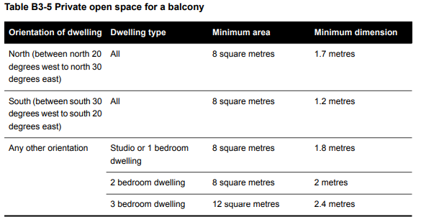 | Deemed to Comply  Schedule INSERT to the ZONE requires INSERT sqm/There is no area specified in a schedule to the zone.  An area of 25 square metres of secluded private open space with a minimum dimension of 3 metres with direct access from a living room/dining area/kitchen has been provided for dwellings/apartments INSERT.  A balcony area of at least INSERT square metres with a minimum dimension of INSERT metres with direct access from a living room/dining area/kitchen has been provided for dwellings/apartments INSERT in accordance with Table B3-5.  An area on a podium level or similar of at least 15 square metres with a minimum width of 3 metres with direct access from a living room/dining area/kitchen has been provided for dwellings/apartments INSERT.  A roof area of at least 10 square metres and a minimum width of 3 metres with direct access from a living room/dining area/kitchen has been provided for dwellings/apartments INSERT.  An additional 1.5 square metres has been provided as a cooling/heating unit is located in the secluded private open space or private open space areas of dwellings/apartments INSERT.  Clothes drying has been provided in the ground level private open space of dwellings/apartments INSERT.  Variation  INSERT  Before deciding on an application, the responsible authority must consider:  - The design response.  - The useability of the private open space, including its size and accessibility.  - The availability of and access to public or communal open space.  - The orientation of the lot to the street and the sun.  INSERT  Does not meet the objective  INSERT | Right of Appeal  No
55.03-6 Solar access to open space objective  To allow solar access into the secluded private open space of new dwellings and residential buildings. | Standard B3-6  The southern boundary of secluded private open space is set back from any wall on the north of the space at least (2+0.9h) metres, where ‘h’ is the height of the wall.  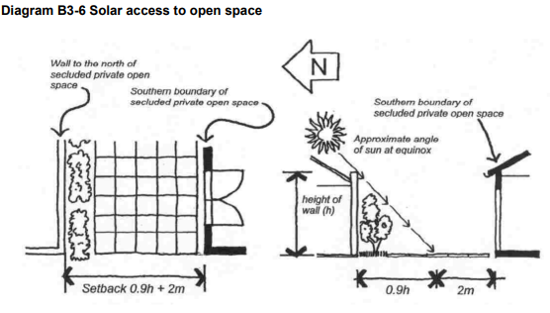 | Deemed to Comply  All proposed secluded private open space receives adequate solar access.  The wall located on the northern side of the proposed secluded private open space is INSERT metres high, requiring the southern boundary of the proposed secluded private open space to be set back INSERT metres from the wall. The southern boundary is set back INSERT metres from the north wall in accordance with the standard.  Variation  INSERT  Before deciding on an application, the responsible authority must consider:  - The design response.  - The useability and amenity of the secluded private open space based on the sunlight it will receive.  INSERT  Does not meet the objective  INSERT | Right of Appeal  No
55.03-7 Functional layout objective  To ensure dwellings provide functional areas that meet the needs of residents. | Standard B3-7  Bedrooms:  - Meet the minimum internal room dimensions specified in Table B3-7.1.  - Provide an additional area of at least 0.8 square metres to accommodate a wardrobe.  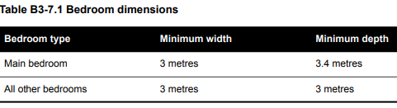  Living areas (excluding dining and kitchen areas) meet the minimum internal room dimensions specified in Table B3-7.2.  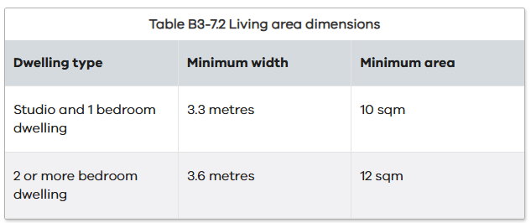 | Deemed to Comply  All dwellings/apartments are provided with a main bedroom with a width and depth of not less than 3.0m x 3.4m, and other bedrooms of not less than 3.0m x 3.0m and all excluding areas provided for a wardrobe.  An additional area of 0.8 square metres has been provided to accommodate a wardrobe.  All studio and 1 bedroom dwellings/apartments are provided with a living area (excluding dining and kitchen areas) with an internal room width of not less than 3.3m and area of not less than 10 square metres.  All 2 or more bedroom dwellings/apartments are provided with a living area (excluding dining and kitchen areas) with an internal room width of not less than 3.6m and area of not less than 12 square metres.  Variation  INSERT  Before deciding on an application, the responsible authority must consider:  - The design response.  - The useability and amenity of habitable rooms.  INSERT  Does not meet the objective  INSERT | Right of Appeal  No
55.03-8 Room depth objective  To allow adequate daylight into single aspect habitable rooms. | Standard B3-8  The depth of a single aspect habitable room does not exceed 2.5 times the ceiling height measured from the external surface of the habitable room window to the rear wall of the room.  The depth of a single aspect, open plan, habitable room may be increased to 9 metres if all the following requirements are met:  - The room combines the living area, dining area and kitchen; and  - The kitchen is located furthest from the window; and  - The ceiling height is at least 2.7 metres measured from finished floor level to finished ceiling level, this excludes where services are provided above the kitchen; and  - An overhang extends no more than 2m beyond the window of the single aspect habitable room.  In Clause 55.03-8, a single aspect habitable room is a habitable room with windows on only one wall | Deemed to Comply  The minimum proposed single aspect habitable room ceiling height is INSERT metres requiring a maximum room depth of not more than INSERT metres. The maximum room depth is INSERT metres.  All single aspect habitable rooms with a ceiling height of at least 2.7 metres have a maximum room depth of not more than 9 metres, are a combined living area, dining area and kitchen with the kitchen furthest from the window and an overhang does not extend more than 2m beyond the window of the single aspect habitable room.  Variation  INSERT  Before deciding on an application, the responsible authority must consider:  - The design response.  - The extent to which the habitable room is provided with reasonable daylight access through the number, size, location and orientation of windows.  - The useability, functionality and amenity of the dwelling based on layout, siting, size and orientation of habitable rooms.  - Any overhang above habitable room windows that limits daylight access.  INSERT  Does not meet the objective  INSERT | Right of Appeal  No
55.03-9 Daylight to new windows objective  To allow adequate daylight into new habitable room windows. | Standard B3-9  Dwelling (other than a dwelling in or forming part of an apartment development)  A window in an external wall of the building is provided to all habitable rooms.  Habitable rooms in a dwelling have a window that faces:  - An outdoor space clear to the sky or a light court with a minimum area of 3 square metres and minimum dimension of 1 metre clear to the sky, not including land on an abutting lot; or  - A verandah provided it is open for at least one third of its perimeter; or  - A carport provided it has two or more open sides and is open for at least one third of its perimeter.  Dwelling in or forming part of an apartment development  A window in an external wall of the building is provided to all habitable rooms.  Where daylight to a bedroom is provided from a smaller secondary area within the bedroom, the secondary area is to have:  - A minimum width of 1.2 metres.  - A maximum depth of 1.5 times the width, measured from the external surface of the window.  - A window clear to the sky | Deemed to Comply  All habitable room windows are located on an external wall.  All habitable room windows face:  - An outdoor space clear to the sky or a light court with a minimum area of 3 square metres and minimum dimension of 1 metre clear to the sky, not including land on an abutting lot; or  - A verandah provided it is open for at least one third of its perimeter; or  - A carport provided it has two or more open sides and is open for at least one third of its perimeter.  Dwelling in an apartment development  Where daylight to a bedroom is provided from a smaller secondary area within the bedroom, the secondary area has:  - A minimum width of 1.2 metres.  - A maximum depth of 1.5 times when measured from the external surface of the window.  - A window clear to the sky  Variation  INSERT  Before deciding on an application, the responsible authority must consider:  - The design response.  - The extent to which habitable rooms are provided with reasonable daylight access through the number, size, location and orientation of windows.  - The useability and amenity of the dwelling based on the layout, siting, size and orientation of habitable rooms.  - Whether there are other windows in the habitable room which have access to daylight.  INSERT  Does not meet the objective  INSERT
55.03-10 Natural ventilation objective  To encourage natural ventilation of dwellings.  To allow occupants to effectively manage natural ventilation of dwellings. | Standard B3-10  Dwelling (other than a dwelling in or forming part of an apartment development)  Dwellings have openable windows, doors or other ventilation devices in external walls of the building that provide:  - A maximum breeze path through the dwelling of 18 metres.  - A minimum breeze path through the dwelling of 5 metres.  - Ventilation openings with approximately the same size.  The breeze path is measured between the ventilation openings on different orientations of the dwelling.  Dwelling in or forming part of an apartment development  At least 40 per cent of dwellings have openable windows, doors or other ventilation devices in external walls of the building that provide:  - A maximum breeze path through the dwelling of 18 metres.  - A minimum breeze path through the dwelling of 5 metres.  - Ventilation openings with approximately the same size.  The breeze path is measured between the ventilation openings on different orientations of the dwelling. | Deemed to Comply  Each dwelling has openable windows, doors or other ventilation devices in external walls of the building that provides for:  - A maximum breeze path through the dwelling of 18 metres.  - A minimum breeze path through the dwelling of 5 metres.  - Ventilation openings with approximately the same size.  Dwellings in apartment developments  At least 40 per cent of the dwellings in the apartment development have openable windows, doors or other ventilation devices in external walls of the building that provides for:  - A maximum breeze path through the dwelling of 18 metres.  - A minimum breeze path through the dwelling of 5 metres.  - Ventilation openings with approximately the same size.  Variation  INSERT  Before deciding on an application, the responsible authority must consider:  - The design response.  - The size, orientation, slope and wind exposure of the site.  - The extent to which the orientation of the building and the layout of dwellings maximises opportunities for cross ventilation.  - Whether an alternative design meets the relevant objectives having regard to the amenity of the dwelling and the site context.  INSERT  Does not meet the objective  INSERT | Right of Appeal  No
55.03-11 Storage objective  To provide adequate storage facilities for each dwelling. | Standard B3-11  Dwelling (other than a dwelling in or forming part of an apartment development)  Each dwelling has exclusive access to at least 6 cubic metres of externally accessible, secure storage space.  Dwelling in or forming part of an apartment development  Each dwelling has exclusive access to storage at least the total minimum storage volume that is specified in Table B3-11.  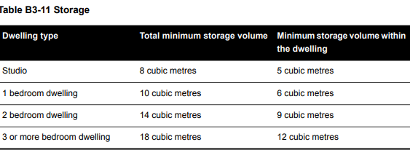 | Deemed to Comply  Each dwelling has been provided with exclusive access to 6 cubic metres of externally accessible, secure storage shown to be located in the INSERT of each dwelling.  Dwellings in an apartment development  Each studio has been provided with exclusive access to a minimum total of 8 cubic metres with a minimum 5 cubic metres in the dwelling  Each 1 bedroom dwelling has been provided with exclusive access to a minimum total of 10 cubic metres with a minimum 6 cubic metres in the dwelling  Each 2 bedroom dwelling has been provided with exclusive access to a minimum total of 14 cubic metres with a minimum 9 cubic metres in the dwelling  Each 3 or more bedroom dwelling has been provided with exclusive access to a minimum total of 18 cubic metres with a minimum 12 cubic metres in the dwelling  Variation  INSERT  Before deciding on an application, the responsible authority must consider:  - The design response.  - The useability, functionality and location of storage facilities provided for the dwelling  INSERT  Does not meet the objective  INSERT | Right of Appeal  No
55.03-12 Accessibility for apartment developments objective  To ensure the design of dwellings meets the needs of people with limited mobility | Standard B3-12  At least 50 per cent of dwellings in or forming part of an apartment development have:  - A clear opening width of at least 850mm at the entrance to the dwelling and main bedroom.  - A clear path with a minimum width of 1.2 metres that connects the dwelling entrance to the main bedroom, an adaptable bathroom and the living area.  - A main bedroom with access to an adaptable bathroom.  - At least one adaptable bathroom that meets all of the requirements of either Design A or Design B specified in Table B3-12.  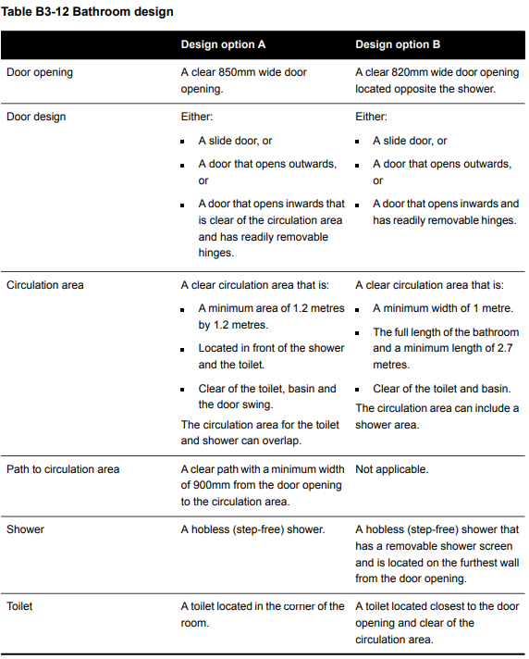 | N/A  No apartments are proposed.  Deemed to Comply  Apartments INSERT all provide accessible entries with clear paths to accessible bathrooms in accordance with the Standard.  Variation to Standard  INSERT  There are no relevant decision guidelines for this objective.  INSERT  Does not meet the objective  INSERT | Right of Appeal  No

55.04 External Amenity

55.04-1 Daylight to existing windows objective  To allow adequate daylight into existing habitable room windows. | Standard B4-1  New buildings opposite an existing habitable room window provide for a light court to the existing window that has a minimum area of 3 square metres and minimum dimension of 1 metre clear to the sky. The calculation of the area may include land on the abutting lot.  New walls or carports more than 3 metres in height opposite an existing habitable room window are set back from the window at least 50 per cent of the height of the new wall if the wall is within a 55 degree arc from the centre of the existing window. The arc may be swung to within 35 degrees of the plane of the wall containing the existing window.  Where the existing window is above ground floor level, the wall height is measured from the floor level of the room containing the window.  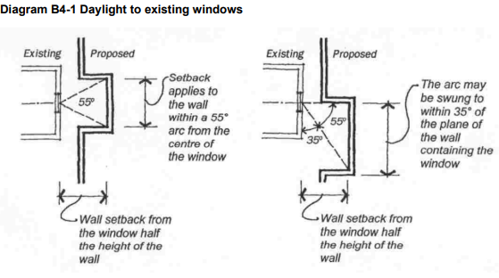 | Deemed to Comply  The required light court of 3 square metres with a minimum dimension of 1 metre clear to the sky has been achieved and all windows have access to the required level of daylight.  The proposed wall/carport is more than 3m in height at INSERT metres. The wall/carport has been setback INSERT metres which is 50% of the proposed wall height.  Not Applicable  There are no existing habitable room windows opposite the proposed buildings that require consideration.  Variation  Before deciding on an application, the responsible authority must consider:  - The design response.  - The extent to which the existing dwelling or small second dwelling has provided for reasonable daylight access to its habitable rooms through the siting and orientation of its habitable room windows.  - The impact on the amenity of existing dwellings.  INSERT  Does not meet the objective  INSERT | Right of Appeal  No, standard met  Yes, standard varied
55.04-2 Existing north facing windows objective  To allow adequate solar access to existing north-facing habitable room windows. | Standard B4-2  Where a north-facing habitable room window of a neighbouring dwelling or small second dwelling is within 3 metres of a boundary on an abutting lot:  - A new building is to be set back from the boundary 1 metre, plus 0.6 metres for every metre of height over 3.6 metres up to 6.9 metres, plus 1 metre for every metre of height over 6.9 metres. This setback is to be provided for a distance of at least 3 metres from the edge of each side of the window.  - For new buildings that meet the Standard B2-3.2 setback, the building is set back from the boundary by at least 6 metres up to a height not exceeding 11 metres and at least 9 metres for a height over 11 metres between south 30 degrees west to south 30 degrees east. This setback is to be provided for a distance of at least 3 metres from the edge of each side of the window.  For this standard, a north-facing window is a window with an axis perpendicular to its surface oriented north 20 degrees west to north 30 degrees east.  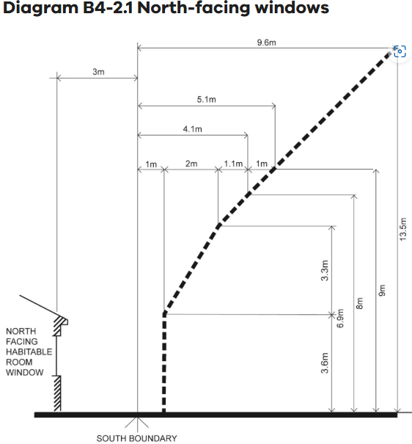  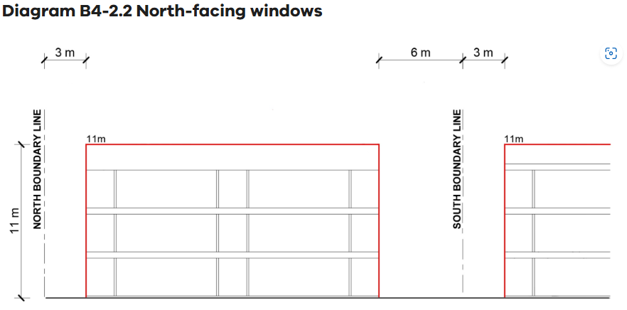 | Not Applicable  There are no north facing habitable room windows on abutting lots that require consideration.  Deemed to Comply  There is a north facing window on the neighbouring dwelling to the INSERT. The proposed building has been setback INSERT meeting the standard.  Variation  INSERT  Before deciding on an application, the responsible authority must consider:  - The design response.  - Existing sunlight to the north-facing habitable room window of the existing dwelling or small second dwelling.  - The impact on the amenity of existing dwellings or small second dwellings.  INSERT  Does not meet the objective  INSERT | Right of Appeal  No, standard met  Yes, standard varied
55.04-3 Overshadowing secluded open space objective  To ensure buildings do not significantly overshadow existing secluded private open space. | Standard B4-3  The area of secluded private open space that is not overshadowed by the new development is greater than 50 per cent, or 25 square metres with a minimum dimension of 3 metres, whichever is the lesser area, for a minimum of five hours between 9 am and 3 pm on 22 September.  If existing sunlight to the secluded private open space of an existing dwelling or small second dwelling is less than the requirements of this standard, the amount of sunlight will not be further reduced | Deemed to Comply  The extent of overshadowing associated with the proposed development is within the requirements of the standard as:  More than 50% of the SPOS or 25sqm with a minimum dimension of 3m is not overshadowed for a minimum of 5 hours between 9am and 3pm on 22 September  Not Applicable  There is no secluded private open space on adjoining land that requires consideration.  Variation  INSERT  Before deciding on an application, the responsible authority must consider:  - The design response.  - The impact on the amenity of existing dwellings or small second dwelling.  - Existing sunlight penetration to the secluded private open space of the existing dwelling or small second dwelling.  - The time of day that sunlight will be available to the secluded private open space of the existing dwelling or small second dwelling.  - The effect of a reduction in sunlight on the existing use of the existing secluded private open space.  INSERT  Does not meet the objective  INSERT | Right of Appeal  No, standard met  Yes, standard varied
55.04-4 Overlooking objective  To limit views into existing secluded private open space and habitable room windows. | Standard B4-4  In Clause 55.04-4 a habitable room does not include a bedroom.  A habitable room window, balcony, podium, terrace, deck or patio is located and designed to avoid direct views into the secluded private open space of an existing dwelling or small second dwelling within a horizontal distance of 9 metres (measured at ground level) of the window, balcony, terrace, deck or patio. Views are measured within a 45 degree angle from the plane of the window or perimeter of the balcony, terrace, deck or patio, and from a height of 1.7 metres above floor level.  A habitable room window, balcony, terrace, deck or patio that is located with a direct view into a habitable room window of existing dwelling or small second dwelling within a horizontal distance of 9 metres (measured at ground level) of the window, balcony, terrace, deck or patio:  - Is offset a minimum of 1.5 metres from the edge of one window to the edge of the other; or  - Has sill heights of at least 1.7 metres above floor level; or  - Has fixed, obscure glazing in any part of the window below 1.7 metre above floor level; or  - Has permanently fixed external screens to at least 1.7 metres above floor level and be no more than 25 per cent transparent; or  - Has fixed elements that prevent direct views, such as horizontal ledges or vertical fins.  Obscure glazing in any part of the window below 1.7 metres above floor level may be openable provided that there are no direct views as specified in this standard.  Screens used to obscure a view should be:  - Perforated panels or trellis with a maximum of 25 per cent openings or solid translucent panels.  - Permanent, fixed and durable.  - Designed and coloured to blend in with the development.  This standard does not apply to a new habitable room window, balcony, terrace, deck or patio which faces a property boundary where there is a visual barrier at least 1.8 metres high and the floor level of the habitable room, balcony, terrace, deck or patio is less than 0.8 metres above ground level at the boundary.  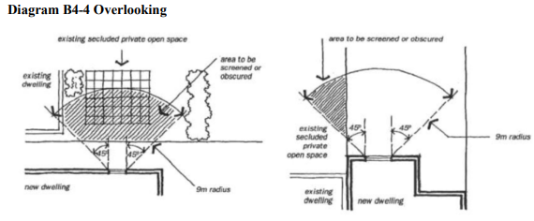 | Deemed to Comply  The development is designed to meet the requirements of the standard with overlooking into existing secluded private open space areas and habitable room windows limited in accordance with the Standard in the form of:  INSERT  Not Applicable  There are no habitable room windows or secluded private open space on adjoining land that require consideration.  Variation  INSERT  Before deciding on an application, the responsible authority must consider:  - The design response.  - The impact on the amenity of the secluded private open space or habitable room window.  - The existing extent of overlooking into the secluded private open space and habitable room windows of existing dwellings.  - The internal daylight to and amenity of the proposed dwelling or residential building.  INSERT  Does not meet the objective  INSERT | Right of Appeal  No, standard met  Yes, standard varied
55.04-5 Internal views objective  To limit views into the secluded private open space and habitable room windows of dwellings and residential buildings within a development. | Standard B4-5  In Clause 55.04-5 a habitable room does not include a bedroom.  Within the development, a habitable room window, balcony, terrace, deck or patio that is located with a direct view into the secluded private open space of another dwelling:  - Is offset a minimum of 1.5 metres from the edge of the secluded private open space; or  - Has a sill height of at least 1.7 metres above floor level; or  - Has a fixed, visually obscure balustrade to at least 1.7 metre above floor level; or  - Has permanently fixed external screens to at least 1.7 metres above floor level; or  - Has fixed elements that prevent the direct view, such as horizontal ledges or vertical fins.  Direct views are measured at a height of 1.7 metres above floor level and within:  - A 45 degree horizontal angle from the edge of the new window or balcony.  - A 45 degree angle in the downward direction.  Screens provided for overlooking are no more than 25 per cent transparent. Screens may be openable provided that this does not allow direct views as specified in this standard | Deemed to Comply  The development is designed to meet the requirements of the standard with overlooking into proposed secluded private open space areas and habitable room windows limited in accordance with the Standard in the form of:  INSERT  Not Applicable  There is no proposed internal overlooking that require consideration.  Variation  INSERT  Before deciding on an application, the responsible authority must consider the design response.  INSERT  Does not meet the objective  INSERT | Right of Appeal  No
55.05 Sustainability

55.05-1 Permeability and stormwater management objectives  To reduce the impact of increased stormwater run-off on the drainage system.  To facilitate on-site stormwater infiltration.  To encourage stormwater management that maximises the retention and reuse of stormwater.  To contribute to urban cooling | Standard B5-1  The site area covered by the pervious surfaces is at least 20 percent of the site.  The development includes a stormwater management system designed to:  - Meet the best practice quantitative performance objectives for stormwater quality specified in the Urban stormwater management guidance (EPA Publication 1739.1, 2021) of:  – Suspended solids 80% reduction in mean annual load.  – Total phosphorus and Total Nitrogen 45% reduction in mean annual load.  – Litter 70% reduction of mean annual load.  Note: A certificate generated from a stormwater assessment tool demonstrating a minimum 100 per cent Blue Factor tool score, or documentation from Model for Urban Stormwater Improvement Conceptualisation  (MUSIC) or an equivalent product accepted by the responsible authority showing the performance objectives for stormwater quality are met.  - Direct flows of stormwater into treatment areas, garden areas, tree pits and permeable surfaces, with drainage of residual flows to the legal point of discharge. | Deemed to Comply  The site retains INSERT per cent permeability, assisting in on site stormwater filtration.  A STORM/Blue Factor/MUSIC report has been provided which corresponds with the assessment plans which show suitably sized rainwater tanks and/or raingardens to meet best practice to meet EPA Publication 1739.1, 2021 with stormwater directed to flow into treatment areas, garden areas, tree pits and permeable surfaces, with drainage of residual flows to the legal point of discharge  Variation  INSERT  Before deciding on an application, the responsible authority must consider:  - The design response.  - The capacity of the site to incorporate stormwater retention and reuse.  - The existing site coverage and any constraints imposed by existing development.  - The capacity of the drainage network to accommodate additional stormwater.  - Whether the owner has entered into an agreement to contribute to off-site stormwater management in lieu of providing an on-site stormwater management system.  INSERT  Does not meet the objective  INSERT | Right of Appeal  No
55.05-2 Overshadowing domestic solar energy systems  To ensure that the height and setback of a building from a boundary allows reasonable solar access to existing domestic solar energy systems on the roofs of buildings | Standard B5-2  Any part of a new building that will reduce the sunlight at any time between 9am and 4 pm on 22 September to an existing domestic solar energy system on the roof of a building on an adjoining lot be set back from the boundary to that lot by at least 1 metre at 3.6 metres above ground level, plus 0.3 metres for every metre of building height over 3.6 metres up to 6.9 metres, plus 1 metre for every metre of height over 6.9 metres.  This standard applies to an existing building in a Township Zone, General Residential Zone or Neighbourhood Residential Zone.  In Clause 55.05-2, domestic solar energy system means a domestic solar energy system that existed at the date the application was lodged. | N/A  There are no existing domestic solar energy systems on adjoining buildings that require consideration.  or  The site is located in the Residential/Mixed Use Zone/Housing Choice and Transport Zone.  Deemed to Comply  There is an existing domestic solar system on the adjoining building to the INSERT.  Overshadowing diagrams demonstrate that the domestic solar system will not be overshadowed at anytime between 9am and 4pm on 22 September.  or  Overshadowing diagrams demonstrate that the domestic solar system will be overshadowed between 9am and 4pm on 22 September. The building has been setback INSERT metres in accordance with the Standard.  Variation  INSERT  Decision guidelines  Before deciding on an application, the responsible authority must consider whether the domestic solar energy system has been sited to optimise efficiency and protection from overshadowing.  INSERT  Does not meet the objective  INSERT | Right of Appeal  No, standard met  Yes, standard varied
55.05-3 Rooftop solar energy generation area objective  To support the future installation of appropriately sited rooftop solar energy systems for a dwelling. | Standard B5-3  In Clause 55.05-3, rooftop solar energy area means an area provided on the roof of a dwelling to enable the future installation of a solar energy system.  An area on the roof is capable of siting a rooftop solar energy area for each dwelling which:  - Has a minimum dimension of 1.7 metres.  - Has a minimum area in accordance with Table B5-3.  - Is oriented to the north, west or east.  - Is positioned on the top two thirds of a pitched roof.  - Can be a contiguous area or multiple smaller areas.  - Is free of obstructions on the roof of the dwelling within twice the height of each obstruction (H), measured horizontally (D) from the centre point of the base of the obstruction to the nearest point of the rooftop solar energy area.  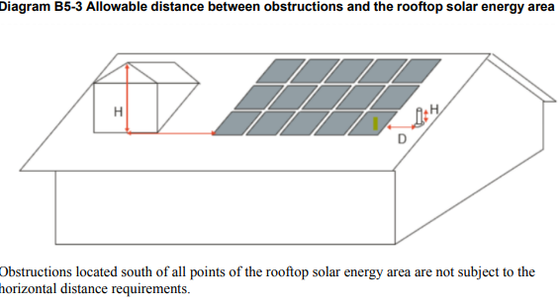  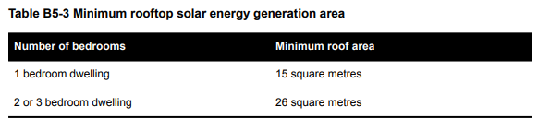  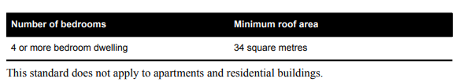 | Deemed to Comply  The submitted plans demonstrate that each dwelling is capable of a future solar energy installation as it:  - Has a minimum dimension of 1.7 metres.  - Has a minimum area of INSERT sqm in accordance with Table B5-3.  - Is oriented to the north, west or east.  - Is positioned on the top two thirds of a pitched roof.  - Is an contiguous area or multiple smaller areas.  - Is free of obstructions on the roof of the dwelling within twice the height of each obstruction (H), measured horizontally (D) from the centre point of the base of the obstruction to the nearest point of the rooftop solar energy area.  Variation  INSERT  Decision guidelines  Before deciding on an application, the responsible authority must consider:  - The design response.  - The size and orientation of the building.  - The availability of solar access to the rooftop.  - The extent to which the rooftop solar energy generation area is overshadowed by existing buildings, other permanent structures or equipment on the rooftop.  INSERT  Does not meet the objective  INSERT | Right of Appeal  No
55.05-4 Solar protection to new north facing windows objective  To encourage external shading of north facing windows to minimise summer heat gain | Standard B5-4  North facing windows are shaded by eaves, fixed horizontal shading devices or fixed awnings with a minimum horizontal depth of 0.25 times the window height. | Deemed to Comply  North facing windows are shaded by eaves, fixed horizontal shading devices or fixed awnings with a minimum horizontal depth of INSERT metres being 0.25 x the window height of INSERT metres.  Variation  INSERT  Before deciding on an application, the responsible authority must consider:  - The design response.  - The size and orientation of the lot.  - The type and useability of external solar shading devices, including alternative design responses.  INSERT  Does not meet the objective  INSERT | Right of Appeal  No
55.05-5 Waste and recycling objective  To ensure dwellings are designed to facilitate waste recycling.  To ensure that waste and recycling facilities are accessible and are of sufficient size to manage organic and general waste, and mixed and glass recycling.  To ensure that waste and recycling facilities are designed and managed to minimise impacts on residential amenity. | Standard B5-5  Dwelling (other than a dwelling in or forming part of an apartment development)  The development includes an individual bin storage area for each dwelling, or a shared bin storage area for use by each dwelling, of at least the applicable area, depth and height specified in Table B5-5.1.  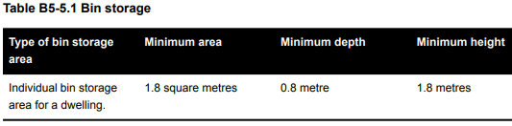  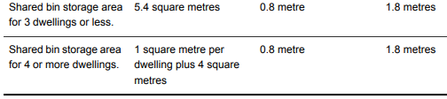  If the development includes a shared bin storage area:  - The shared bin storage area:  – Is located within 40 metres of a kerbside collection point.  – Includes a tap for bin washing.  - There is a continuous path of travel free of steps and obstructions from dwellings to the bin storage area.  Where access is provided for private bin collection on the land the design of access ways must allow the vehicle to enter and exit in a forward direction.  Each dwelling includes an internal waste and recycling storage space of at least 0.07 cubic metres with a minimum depth of 250 millimetres.  Dwelling in or forming part of an apartment development  The development includes a shared bin storage area for use by each dwelling of at least the applicable area, depth and height specified in Table B5-5.2.  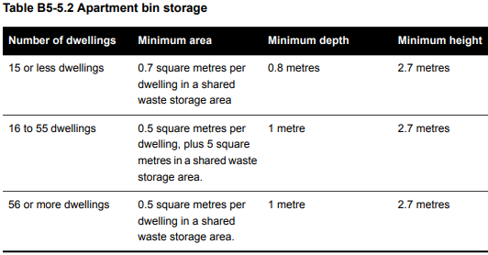  Enclosed bin storage areas are ventilated by:  - Natural ventilation openings to the external air with an area of at least 5 per cent of the area for bin storage area; or  - A mechanical exhaust ventilation system.  A tap and drain is provided to wash bins.  A continuous path of travel is provided from each dwelling to bin storage areas.  Each dwelling includes an internal waste and recycling storage space of at least 0.07 cubic metres with a minimum depth of 250 millimetres. | Deemed to Comply  Each dwelling has been provided with individual bin storage of a minimum area of 1.8sqm, with a minimum depth of 0.8m and a minimum height of 1.8m.  Each dwelling includes an internal waste and recycling storage space of at least 0.07 cubic metres with a minimum depth of 250 millimetres.  or  A shared bin area has been provided with a minimum area of 5.4sqm, with a minimum depth of 0.8m and a minimum height of 1.8m. The shared bin area is within 40m of the kerbside collection point and includes a tap for bin washing. There is a continuous path of travel free of steps and obstructions from dwellings to the bin storage area.  Where access has been provided for private bin collection, the accessway has been designed that a private bin collection vehicle can enter and exist in a forward direction.  Each dwelling includes an internal waste and recycling storage space of at least 0.07 cubic metres with a minimum depth of 250 millimetres.  or  A shared bin area has been provided with a minimum area of 1sqm per dwelling plus 4sqm, with a minimum depth of 0.8m and a minimum height of 1.8m. The shared bin area is within 40m of the kerbside collection point and includes a tap for bin washing. There is a continuous path of travel free of steps and obstructions from dwellings to the bin storage area.  Where access has been provided for private bin collection, the accessway has been designed that a private bin collection vehicle can enter and exist in a forward direction.  Each dwelling includes an internal waste and recycling storage space of at least 0.07 cubic metres with a minimum depth of 250 millimetres.  Dwelling in or forming part of an apartment development  A shared bin storage area of INSERT sqm (0.7sqm x INSERT of dwellings) with a minimum depth of 0.8m and a minimum height of 2.7m has been provided.  or  A shared bin storage area of INSERT sqm (0.5sqm x INSERT of dwellings plus 5sqm) with a minimum depth of 1m and a minimum height of 2.7m has been provided.  or  A shared bin storage area of INSERT sqm (0.5sqm x INSERT of dwellings) with a minimum depth of 1m and a minimum height of 2.7m has been provided.  The enclosed bin storage areas are ventilated by natural ventilation openings to the external air with an area of at least 5 per cent of the area for bin storage area or a mechanical exhaust ventilation system. A tap and drain are provided and there is a continuous path of travel from each dwelling to the bin storage area.  In addition, each dwelling has an internal waste and recycling space of at least 0.07 cubic metres with a minimum depth of 250mm.  Variation  INSERT  Before deciding on an application, the responsible authority must consider:  - The design response, including a Waste Management Plan.  - Any relevant waste and recycling objective, policy or statement set out in this planning scheme.  - The functionality and accessibility of waste and recycling facilities, including for people with limited mobility.  - Whether facilities are provided for on-site reuse or management of food and garden organics through composting or other waste recovery.  - Whether waste and recycling facilities are designed to meet the better practice design options specified in Waste management and recycling in multi-unit developments (Sustainability Victoria, 2019).  INSERT  Does not meet the objective  INSERT | Right of Appeal  No
55.05-6 Noise impacts objective  To minimise the impact of mechanical plant noise located in the development | Standard B5-6  Mechanical plant, including mechanical car storage and lift facilities are not located immediately adjacent to bedrooms of new or existing dwellings or small second dwellings, unless a solid barrier is in place to provide a line of sight barrier to transmission of noise and the location of all relevant bedrooms. | Not Applicable  There are no external noise sources that require consideration as part of this application.  Deemed to Comply  Mechanical plant, including mechanical car storage and lift facilities are not located immediately adjacent to bedrooms of new or existing dwellings or small second dwellings  Or  Mechanical plant, including mechanical car storage and lift facilities are located immediately adjacent to bedrooms of new or existing dwellings or small second dwellings however a solid barrier is in place to provide a line of sight barrier to transmission of noise and the location of all relevant bedrooms.  Variation  INSERT  Before deciding on an application, the responsible authority must consider:  - The design response.  - Whether the impact of potential noise sources within a development have been mitigated through design, location and siting.  - Whether an alternative design meets the relevant objectives having regard to the amenity of the dwelling or small second dwelling and the site context.  INSERT  Does not meet the objective  INSERT | Right of Appeal  No
55.05-7 Energy efficiency for apartment dwellings  To achieve energy efficient dwellings and buildings.  To ensure dwellings achieve adequate thermal efficiency. | Standard B5-7  Dwellings in or forming part of an apartment development located in a climate zone identified in Table B5-7 do not exceed the maximum NatHERS annual cooling load.  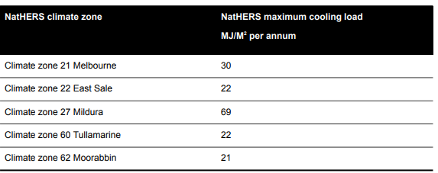  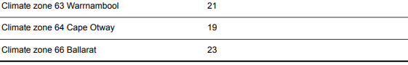  Note: Refer to NatHERS zone map, Nationwide House Energy Rating Scheme (Commonwealth Department of Environment and Energy). | N/A  This is not an apartment development.  Deemed to Comply  Climate Zone 60 Tullamarine  Each dwelling has been provided with a maximum cooling load of 22 MJ/M2 per annum.  or  Climate Zone 64 Cape Otway  Each dwelling has been provided with a maximum cooling load of 19 MJ/M2 per annum.  Variation  INSERT  Before deciding on an application, the responsible authority must consider:  - The design response.  - The size, orientation and layout of the site.  - The availability of solar access to north-facing windows on the site.  - The annual cooling load for each dwelling.  INSERT  Does not meet the objective  INSERT | Right of Appeal  No

…………………………
INSERT – Planning Officer

………………………….
Team Leader

