CLAUSE 57 ASSESSMENT – MID-RISE CODE (4-6 STOREYS)

Plans Assessed: INSERT
Permit Application Number: «Application_Number»

The following objectives and standards apply to an application to:

- Construct a dwelling if there is at least one dwelling existing on the lot.
- Construct two or more dwellings on a lot.
- Extend a dwelling if there are two or more dwellings on the lot.
- Construct or extend a dwelling on common property.
- Construct or extend a residential building.

in the Mixed Use Zone, Township Zone (on land within the urban growth boundary in metropolitan Melbourne), Residential Growth Zone or Housing Choice and Transport Zone.

APPLICATION REQUIREMENTS

An application to which this clause applies must be accompanied by:

- A site description – Clause 57.01-1.
- A design response – Clause 57.01-2 including a landscape plan.
- A written statement outlining which standards are met and which are not met. If a standard is not met, the written statement must include an explanation of how the development meets the corresponding objective having regard to the corresponding decision guidelines.

DEEMED TO COMPLY – CODIFIED

If a development meets the standard, it is deemed to meet the objective for that standard.
Where the standard is met, the decision guidelines for that standard do not apply to the application.

The below assessment confirms that all applicable standards are met and therefore codified. The applicable standards are:
- 57.02 – All Urban context standards (street setback, side and rear setback, walls on boundaries, site coverage, access, tree canopy & front fence)
- 57.04 – All External amenity standards (Overshadowing secluded open space & Overlooking)
Where the applicable standards are met, there are no third party review rights under section 82(1) of the Act.

When a standard is met, the council is not required to consider any other policy or decision guideline in the planning scheme and specified matters under section 60 of the P&E Act.

A planning permit can be issued.

Or

DEEMED TO NOT COMPLY – NOT CODIFIED

If a development does not the standard, it is deemed to meet the objective if an alternative design solution is considered appropriate.
Where the standard is not met, the decision guidelines for that standard apply to the alternative design solution.

Review rights under section 82(1) of the Act are applicable but only apply to the following standards:
- 57.02 – All Urban context standards (street setback, side and rear setback, walls on boundaries, site coverage, access, tree canopy & front fence)
- 57.04 – All External amenity standards (Overshadowing secluded open space & Overlooking)
The below assessment confirms that not all standards are met and therefore not all are codified.

The standards not met and therefore not codified are:

INSERT

A NOD can be issued if objections received, and based on the above review rights, the following standards can be reviewed at VCAT:

INSERT

Or

A permit can be issued as no objections received.

CLAUSE 57 ASSESSMENT

The following objectives and standards are current up to and including Amendment VC300 on 2/3/2026.

57.02 Urban context

57.02-1 Street setback objective  - To ensure that the setbacks of buildings from a street provide space for canopy trees and make efficient use of the site.  - To ensure that the setbacks of buildings from the street respond to the future urban development of the area. | Standard E2-1  Walls of new buildings are set back from streets:  - At least the distance specified in a schedule to the zone or;  - If no distance is specified in a schedule to the zone, the distance specified in Table E2-1.  Entry canopies, pergolas and awnings for windows or doors may encroach up to 1.5 metres into the setbacks of this standard.  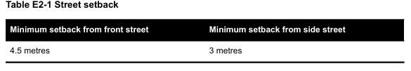 | Deemed to Comply  The front wall is setback INSERT metres from the front street.  The minimum setback from the side street is INSERT metres.  Variation  INSERT  Before deciding on an application, the responsible authority must consider:  - Any relevant urban design objective, policy or statement set out in this scheme.  - The design response.  - Whether the siting of the building is constrained by the shape, dimensions, slope or other conditions of the site.  - Whether a different setback would be more appropriate taking into account the prevailing setbacks of existing buildings on nearby lots.  - Whether a different setback affects the ability to retain or plant canopy trees.  INSERT  Does not meet the objective  INSERT | Right of Appeal  No, standard met  Yes, standard varied
57.02-2 Side and rear setbacks objective  - To ensure the setback of a building from a boundary provides sufficient space for canopy trees and landscaping.  - To ensure the setback of a building from a boundary responds to the future urban development of the area and limits the impact on the amenity of existing dwellings and small second dwellings. | Standard E2-2  A new building not on or within 200mm of a boundary is set back from side or rear boundaries at least 4.5 metres.  If the boundary is to the south of the building, the building is set back at least 6 metres up to a height not exceeding 13.5 metres and at least 12 metres for a height over 13.5 metres between south 30 degrees west to south 30 degrees east.  Sunblinds, awnings, privacy screens, eaves, facias, gutters, rainwater goods, flues, pipes, domestic water tanks, heating or cooling equipment or other services may encroach not more than 0.5 metres into the side and rear setbacks.  Stairways and ramps (including landings) that are less than 1 metre above the ground level may encroach into the side and rear setbacks.  Pergolas and shade sails may encroach into the side and rear setbacks.  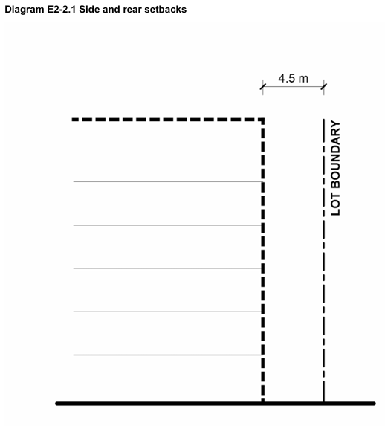  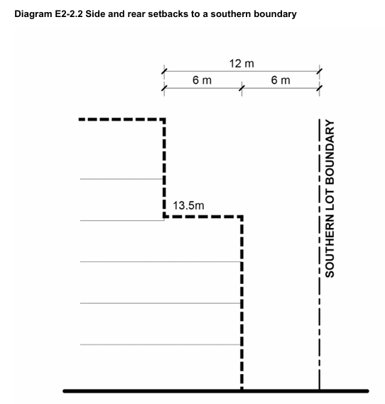 | Deemed to Comply  The required setbacks have been achieved for the development, and all side and rear setbacks comply with the Standard.  Variation  INSERT  Before deciding on an application, the responsible authority must consider:  - Any relevant urban design objective, policy or statement set out in this scheme.  - The design response.  - Whether the boundary abuts public open space and how the interface responds to the public open space  - The impact on the amenity of the habitable room windows and private open space of existing dwellings or small second dwellings.  - The relationship between the setbacks and those of existing adjacent buildings, including the interface with laneways.  - Whether a different setback would be more appropriate, considering the slope of the land and the effective height of the building in relation to adjoining properties.  - Whether a different setback in a rear yard affects the ability to provide landscaping or retain or plant canopy trees.  INSERT  Does not meet the objective  INSERT | Right of Appeal  No, standard met  Yes, standard varied
57.02-3 Walls on boundaries objective  To ensure that the location, length and height of a wall on a boundary responds to the future urban development of the area and limits the impact on the amenity of existing dwellings and small second dwellings. | Standard E2-3  A new wall constructed on or within 200mm of a side or rear boundary of a lot or a carport constructed on or within 1 metre of a side or rear boundary of lot does not abut the boundary for a length that exceeds the greater of the following distances:  - 10 metres plus 25 per cent of the remaining length of the boundary of an adjoining lot, or  - The length of existing or simultaneously constructed walls or carports abutting the boundary on an abutting lot.  A new wall or carport may fully abut a side or rear boundary where slope and retaining walls or fences would result in the effective height of the wall or carport being less than 2 metres on the abutting property boundary.  A building on a boundary includes a building set back up to 200mm from a boundary.  The height of a new wall constructed on or within 200mm of a side or rear boundary or a carport constructed on or within 1 metre of a side or rear boundary does not exceed 3.6 metres unless abutting a higher existing or simultaneously constructed wall. | Deemed to Comply  The proposed wall on the INSERT boundary extends for a length of INSERT metres and a maximum height of INSERT metres.  There are no carports proposed to be on or within 1 metre of a side or rear boundary.  Not Applicable  No new walls on or within 200mm of a boundary, or carport within 1m of a boundary are proposed as part of this application.  Variation  The proposed wall on or within 200mm of the INSERT boundary extends for a length of INSERT metres and a maximum height of INSERT metres. This wall exceeds the requirements of the Standard.  The proposed carport within 1 metre of the INSERT boundary extends for a length of INSERT metres, and a maximum height of INSERT metres. This carport exceeds the requirements of the Standard.  Before deciding on an application, the responsible authority must consider:  - Any relevant urban design objective, policy or statement set out in this scheme.  - The design response.  - The extent to which walls on boundaries are part of the site context or contribute to the future urban development of the area.  - The orientation of the boundary.  - The impact on the amenity of existing dwellings or small second dwellings.  - The extent to which the slope and retaining walls of fences reduce the effective height of the wall.  - Whether the wall abuts a side or rear lane.  - The location of existing light courts and habitable room windows.  INSERT  Does not meet the objective  INSERT | Right of Appeal  No, standard met  Yes, standard varied
57.02-4 Site coverage objective  To ensure that the site coverage responds to future urban development of the area and to the features of the site. | Standard E2-4  The site area covered by buildings does not exceed:  - The maximum site coverage specified in a schedule to a zone; or  - If no maximum site coverage specified in a schedule to a zone, 70 per cent. | Deemed to Comply  The maximum site coverage specified for this site is INSERT percent as per the schedule to the zone.  The proposed site coverage of buildings is INSERT percent of the site, which meets the standard.  Variation  The maximum site coverage specified for this site is INSERT percent as per the schedule to the zone.  The proposed site coverage of buildings is INSERT percent of the site, which is greater than the maximum required by the standard.  Before deciding on an application, the responsible authority must consider:  - Any relevant urban design objective, policy or statement set out in this scheme.  - The design response.  - Any constraints imposed by existing development or features of the site.  - Whether a different area of site coverage affects the ability to retain or plant canopy trees.  - Whether the arrangement of buildings on site is efficient and allows for separation between buildings.  INSERT  Does not meet the objective  INSERT | Right of Appeal  No, standard met  Yes, standard varied
57.02-5 Access objective  - To ensure the number and design of vehicle crossovers responds to the future urban development of the area.  - To ensure that vehicle crossovers are designed and located to provide safe access for pedestrians, cyclists and other vehicles. | Standard E2-5  The width of new accessways or car spaces (other than to a rear lane) does not exceed:  - 33 per cent of the street frontage, or  - 40 per cent of the street frontage if the width of the street frontage is less than 20 metres.  The number of access points to a road in a Transport Zone 2 or a Transport Zone 3 is not increased.  The location of a new vehicle crossover or accessway does not encroach the tree protection zone of an existing tree, that is proposed to be retained in a road by more than 10 per cent. | Deemed to Comply  A total of INSERT% of the frontage is taken up with accessway or car spaces, which complies with the standard for this site with a street frontage of INSERT metres.  The number of access points to a road in a TRZ2 or TRZ3 has not increased.  The location of the vehicle crossover or accessway does not encroach more than 10% into the TPZ of the existing street tree.  Variation  INSERT  Before deciding on an application, the responsible authority must consider:  - Any relevant urban design objective, policy or statement set out in this scheme.  - The design response.  - The impact on the street.  - The impact of the safety of pedestrians and cyclists.  - The reduction of on-street car parking spaces.  - Whether a different accessway width, number of access points or encroachment of an existing tree affects the ability to retain or plant canopy trees on the site or footpath.  INSERT  Does not meet the objective  INSERT | Right of Appeal  No, standard met  Yes, standard varied
57.02-6 Tree canopy objective  - To provide tree canopy that responds to the future urban development of the area.  - To preserve existing canopy cover and support the provision of new canopy cover.  - To ensure new canopy trees are climate responsive, support biodiversity, wellbeing and amenity, and help reduce urban heat.  - To ensure that basements allow for space for deep soil planting at the front of the site. | Standard E2-6  In this standard:  average canopy diameter means the average of the measurements of the distance between the  widest points of a tree’s drip line (the outer edge of foliage) in two perpendicular directions;  canopy cover means the area of a tree’s canopy;  existing canopy tree means a tree that has:  – a height of at least 5 metres above ground level; and  – an average canopy diameter of at least 4 metres; and  – a trunk that is located at least 4 metres from existing and proposed buildings.  new canopy tree means a tree proposed to be planted that is of a species and type that at maturity is expected to have:  – a height of at least 6 metres above ground level; and  – a canopy diameter of at least 4 metres.  Basements of a building are setback at least 3 metres from the frontage and at least one other boundary.  The total canopy cover provided with the development is equivalent to at least the percentage of the site area specified in Column 2 to Table E2-6.1 corresponding to the applicable site area specified in Column 1.  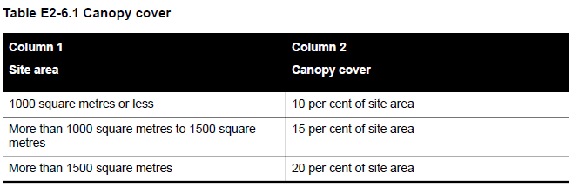  The canopy cover requirement can only be met by retaining an existing canopy tree, planting a new canopy tree or a combination of both, within the site.  The total canopy cover required by Table E2-6.1 includes:  - The total canopy cover of an existing canopy tree, whether or not the canopy cover is wholly contained within the boundaries of the site.  - The canopy cover within the boundaries of the site of a new canopy tree and any part of the canopy cover overhanging land in a public road or public open space.  - The canopy cover of an existing canopy tree and a new canopy tree that extends below, or overhangs, an existing or proposed building located on the site.  - Any overlapping canopy cover of an existing canopy tree or a new canopy tree provided that the overlapping canopy cover is only counted once.  At least one existing canopy tree or new canopy tree is to be located within the front setback. This does not apply if it is proposed to retain one existing canopy tree that meets the minimum total canopy cover requirement and that tree is not located in the front setback.  Each new canopy tree is planted in either deep soil or a planter that meets the following requirements:  - Deep soil must be at least the area and plan dimension specified in Columns 2 and 5, respectively, of Table E2-6.2 corresponding to the tree’s expected canopy diameter at maturity specified in Column 1.  - A planter must be at least the soil volume, soil depth, and plan dimension, specified in Columns 3, 4 and 5 of Table E2-6.2 corresponding to the tree’s expected canopy diameter at maturity specified in Column 1.  If two or more new canopy trees are to be planted in the same area of deep soil, the required area of deep soil can be reduced by the percentage specified in Column 2 of Table E2-6.3 corresponding to the number of trees specified in Column 1.  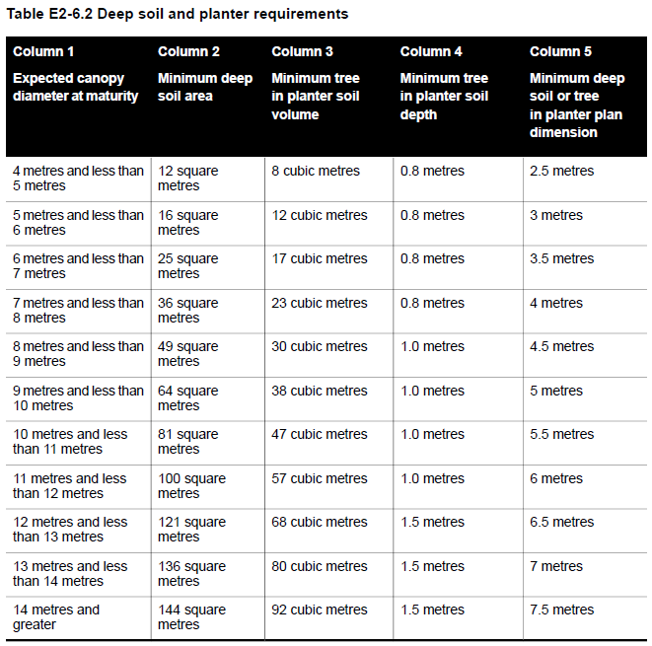  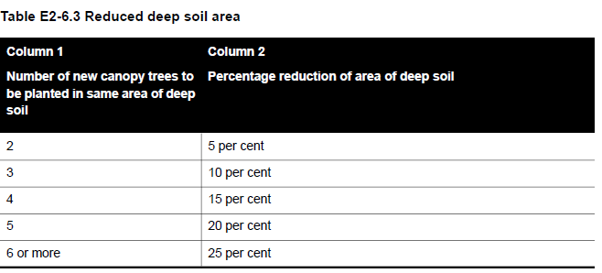  The following can encroach into the total area of deep soil:  - Impervious surfaces by no more than 10 per cent.  - Unroofed decking by no more than 50 per cent, provided the gap between the decking boards is at least:  – 4 millimetres for decking boards not more than 90 millimetres wide.  – 5 millimetres for decking boards more than 90 millimetres wide.  – 8 millimetres if the deck is less than 400 millimetres above ground level.  An eave not exceeding a width of 600 millimetres. | Deemed to Comply  There are adequate areas available on site to allow for tree retention/planting which will complement the landscape character of the area.  The site is INSERT sqm in area and a total of INSERT% of the site or INSERT sqm has been set aside for canopy cover using the retention of trees on site/planting of new canopy trees to meet the canopy coverage required.  Deep soil areas/planter requirements have been provided in accordance with Table E2-6.2.  Reduced deep soil areas have been provided in accordance with Table E2-6.3.  An appropriate landscaping plan has been submitted for assessment.  Variation  INSERT  Before deciding on an application, the responsible authority must consider:  - Any relevant urban design objective, policy or statement set out in this scheme.  - The site context and design response.  - The extent to which the existing and proposed canopy trees contribute to a greener environment and reduce urban heat.  - Whether the growth characteristics of existing trees and proposed canopy trees will provide the required canopy cover.  - The suitability of the proposed location and deep soil areas for proposed canopy trees.  - Whether the species of canopy tree is suited to the soil conditions of the site.  - The suitability of the proposed landscaping in communal outdoor open space.  INSERT  Does not meet the objective  INSERT | Right of Appeal  No, standard met  Yes, standard varied
57.02-7 Front Fences  To encourage front fence design that responds to the future urban development of the area.  . | Standard E2-7  Either the development:  - does not include a new, or an extension to an existing, front fence within three metres of a street; or  - includes a new, or extension to an existing, front fence within 3 metres of a street if the height of the fence does not exceed:  - The maximum height specified in a schedule to the zone, or  - If no maximum height is specified in a schedule to the zone, the maximum height specified in Table E2-7.  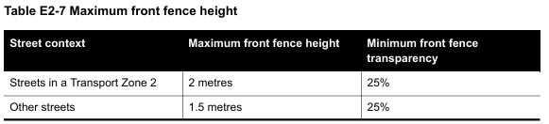 | Deemed to Comply  The new front fence/extension to the existing front fence is 1.5m (other Street)/2m (Streets in a Transport Zone 2) in height.  Not Applicable  No new front fence/extension to the existing fence is proposed as part of this permit application.  Variation  INSERT  Before deciding on an application, the responsible authority must consider:  - Any relevant urban design objective, policy or statement set out in this scheme.  - The design response.  - The setback, height and appearance of front fences on adjacent properties.  - The extent to which slope and retaining walls reduce the effective height of the front fence.  - Whether the fence is needed to minimise noise intrusion.  INSERT  Does not meet the objective  INSERT | Right of Appeal  No, standard met  Yes, standard varied

57.03 Liveability

57.03-1 Parking location objective  To minimise the impact of vehicle noise within developments on residents | Standard E3-1  Habitable room windows with sill heights of less than 3 metres above ground level are setback from accessways and car parks by at least:  - 1.5 metres; or  - If there is a solid fence with a height of at least 1.5 metres between the accessway or car park and the window, 1 metre; or  - 1 metre where window sills are at least 1.5 metres above ground level. | Deemed to Comply  Accessways and car parks are located at least 1.5 metres from the windows of habitable rooms.  Accessways and car parks are located at least 1 metre from the windows of habitable rooms where there is a solid fence with a height of at least 1.5m.  Accessways and car parks are located at least 1 metre from the windows of habitable rooms where the window sill is at least 1.5m above ground level.  While the setback has not been achieved, the accessway or relevant car parking space is used exclusively by the resident of the building with the habitable room.  Variation  INSERT  Before deciding on an application, the responsible authority must consider:  - The design response.  - The need for landscaping adjacent to the accessway and car park  INSERT  Does not meet the objective  INSERT | Right of Appeal  No
57.03-2 Street integration objectives  - To integrate the layout of development with the street and open spaces to support the safety and amenity of residents  - To support development that activates and provides passive surveillance to streets and public open spaces. | Standard E3-2  Development is oriented to front a street  Where a development fronts a street or abuts public open space:  - Passive surveillance is provided by a direct view from at least one balcony or habitable room window to each storey of the building to each street and public open space.  - The total cumulative width of all site services to be located within 3 metres of a street, do not take up more than 20 per cent of the width of the frontage.  Pedestrian entries are located on street frontages.  Car parking and internal waste collection areas are visually concealed from the street.  Lighting is provided to all external accessways and paths.  One mailbox is provided for each dwelling, and at least one parcel locker provided for every five dwellings. Mailboxes and parcel lockers can be communally located. | Deemed to Comply  The development is oriented to a street and designed to provide passive surveillance of INSERT Street/ public open space through a direct view from a balcony or habitable room window from a dwelling on each storey of the building.  The total cumulative width of site services within 3m of a street is INSERT metres which is no more than 20% of the width of the frontage.  Pedestrian entries are located on a street frontage.  Car parking and internal waste areas are concealed from the street.  Lighting is provided to all external accessways and paths.  Mailboxes are provided for each dwelling, one parcel locker has been provided for each 5 dwellings and are communally located where applicable.  Variation  INSERT  Before deciding on an application, the responsible authority must consider:  - Any relevant urban design objective, policy or statement set out in this scheme.  - The design response.  - The design of screening for services.  - Whether the pedestrian entry is to an active frontage.  INSERT  Does not meet the objective  INSERT | Right of Appeal  No
57.03-3 Building entry and circulation objectives  - To provide safe, weather protected building entries with a sense of address.  - To ensure the internal layout of buildings provide for the safe, functional and efficient movement of residents.  - To ensure internal common circulation areas provide adequate access to daylight and natural ventilation. | Standard E3-3  An apartment development or residential building has:  - A ground level entry door, gate or walkway with a direct line of sight from a street.  - An external covered area of at least 1.44 square metres with a minimum dimension of least 1.2 metres over the entry door to the building.  Pedestrian building entries are separated from vehicle entry points.  Shared corridors and common areas:  - Have at least one source of natural light and natural ventilation.  - Are unobstructed by building services; and  - Have a clear sightline from the building entry to the lift lobby at ground level. | Deemed to Comply  The apartment development/residential building has a ground level entry door/gate/walkway with a direct line of sight from the street and has an external covered area of at least 1.44sqm with a minimum dimension of 1.2m over the entry door to the building  The pedestrian entrance to the building is separated from vehicle entry points.  The shared corridors and common areas have at least one source of natural light and ventilation in the form of INSERT, are unobstructed from building services and has a clear sightline from the building entry to the lift lobby at ground level.  Variation  INSERT  Before deciding on an application, the responsible authority must consider:  - Whether the building entry is visible and easily identifiable from the streets and other public areas.  - Whether the entry provides shelter, a sense of address and a transitional space around the entry.  - The useability and amenity of internal common areas and circulation spaces based on daylight access and the natural ventilation they will receive.  - The level of passive surveillance to the street, public open space and communal space.  - The length of corridors and any concealed areas.  INSERT  Does not meet the objective  INSERT | Right of Appeal  No
57.03-4 Private open space objective  To provide adequate private open space for the reasonable recreation and service needs of residents. | Standard E3-4  A dwelling or residential building has private open space with direct access from a living room, dining area or kitchen consisting of:  - An area of 15 square metres of private open space at ground level or on a podium, with a minimum dimension of 2.4 metres width; or  - A balcony with at least the area and dimensions specified in Table E3-4; or  - An area on a roof of at least 10 square metres with a minimum width of 2 metres.  If a cooling or heating unit is located in the secluded private open space or private open space the required area is increased by 1.5 square metres.  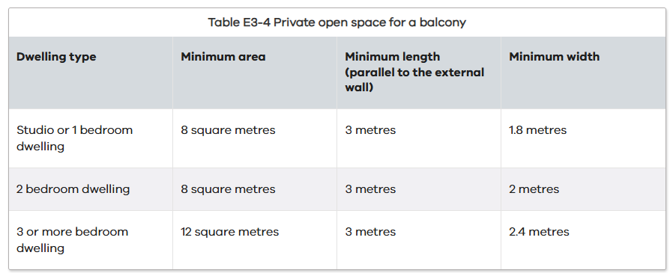 | Deemed to Comply  An area of 15 square metres of private open space with a minimum dimension of 2.4 metres with direct access from a living room/dining area/kitchen has been provided for dwellings INSERT.  A balcony area of at least INSERT square metres with a minimum width of INSERT metres with direct access from a living room/dining area/kitchen has been provided for dwellings/apartments INSERT in accordance with Table E3-4.  A roof area of at least 10 square metres and a minimum width of 2 metres with direct access from a living room/dining area/kitchen has been provided for dwellings/apartments INSERT.  An additional 1.5 square metres has been provided as a cooling/heating unit is located in the private open space of dwellings/apartments INSERT.  Variation  INSERT  Before deciding on an application, the responsible authority must consider:  - The design response.  - The useability of the private open space, including its size and accessibility.  - The availability of and access to public or communal open space.  - The orientation of the lot to the street and the sun.  INSERT  Does not meet the objective  INSERT | Right of Appeal  No
57.03-5 Communal space objectives  - To provide communal space that meets the recreation and amenity needs of residents.  - To ensure that communal space is accessible, practical, attractive and easily maintained.  - To ensure that communal space is integrated with the layout of the development and enhances resident amenity. | Standard E3-5  A development of 10 or more dwellings includes communal space accessible to all residents of at least:  - 2.5 square metres per dwelling; or  - 25 per cent of the site area, whichever is the lesser.  This may consist of multiple separate areas of communal space.  This may include indoor communal space or outdoor communal space.  If outdoor communal space is provided, 50 per cent of the area or 25 square metres whichever is the greater, is not overshadowed for a minimum of two hours between 9 am and 3 pm on 22 September. | Deemed to Comply  As the development includes more than 10 dwellings, a total area of INSERT sqm (2.5sqm x INSERT number of dwellings/ INSERT % of the site (INSERT site area sqm) has been provided.  This has been provided as one communal area/broken up into multiple communal areas and consists of internal and external areas.  As part of the communal area is outdoors, 50% of the area or 25sqm of the area, is not overshadowed for a minimum of two hours between 9am and 3pm on 22 September.  N/A  The development does not include more than 10 dwellings.  Variation  INSERT  Before deciding on an application, the responsible authority must consider:  - Any relevant urban design objective, policy or statement set out in this scheme.  - The design response.  - The availability of and access to public open space.  - The useability of communal space, including its size and accessibility.  INSERT  Does not meet the objective  INSERT | Right of Appeal  No
57.03-6 Functional layout objective  To ensure dwellings provide functional areas that meet the needs of residents. | Standard E3-6  Bedrooms:  - Meet the minimum internal room dimensions specified in Table E3-6.1; and  - Provide an additional area of at least 0.8 square metres to accommodate a wardrobe.  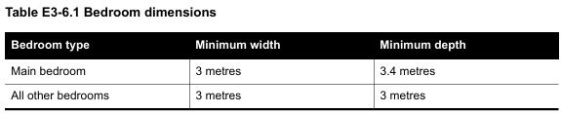  Living areas (excluding dining and kitchen areas) meet the minimum internal room dimensions specified in Table E3-6.2.  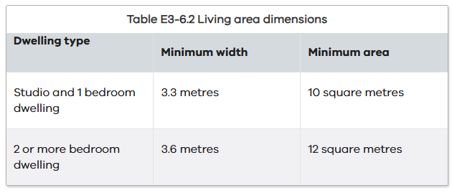 | Deemed to Comply  The main bedroom has a width and depth of not less than 3.0m x 3.4m, and all other bedrooms of not less than 3.0m x 3.0m with an additional area of at least 0.8 square metres provided to accommodate a wardrobe.  All studio and 1 bedroom dwellings are provided with a living area (excluding dining and kitchen areas) with an internal room width of not less than 3.3m and area of not less than 10 square metres.  All 2 or more bedroom dwellings are provided with a living area (excluding dining and kitchen areas) with an internal room width of not less than 3.6m and area of not less than 12 square metres.  Variation  INSERT  Before deciding on an application, the responsible authority must consider:  - The design response.  - The useability and amenity of habitable rooms.  INSERT  Does not meet the objective  INSERT | Right of Appeal  No
57.03-7 Room depth objective  To allow adequate daylight into single aspect habitable rooms. | Standard E3-7  The depth of a single aspect habitable room does not exceed 2.5 times the ceiling height measured from the external surface of the habitable room window to the rear wall of the room.  The depth of a single aspect, open plan, habitable room may be increased to 9 metres if all the following requirements are met:  - The room combines the living area, dining area and kitchen; and  - The kitchen is located furthest from the window; and  - The ceiling height is at least 2.7 metres measured from finished floor level to finished ceiling level, this excludes where services are provided above the kitchen.  The room depth is measured from the external surface of the habitable room window to the rear wall of the room.  For the purposes of Clause 57.03-7, a single aspect habitable room is a habitable room with windows on only one wall. | Deemed to Comply  The minimum proposed single aspect habitable room ceiling height is INSERT metres requiring a maximum room depth of not more than INSERT metres. The maximum room depth is INSERT metres.  All single aspect habitable rooms with a ceiling height of at least 2.7 metres have a maximum room depth of not more than 9 metres, are a combined living area, dining area and kitchen with the kitchen furthest from the window.  Variation  INSERT  Before deciding on an application, the responsible authority must consider:  - The design response.  - The extent to which the habitable room is provided with reasonable daylight access through the number, size, location and orientation of windows.  - The useability, functionality and amenity of the dwelling based on layout, siting, size and orientation of habitable rooms.  - Any overhang above habitable room windows that limits daylight access.  INSERT  Does not meet the objective  INSERT | Right of Appeal  No
57.03-8 Daylight to new windows objective  To allow adequate daylight into new habitable room windows. | Standard E3-8  Habitable rooms are to have a window in an external wall of the building.  A habitable window is not located in a basement.  Where daylight to a bedroom is provided from a smaller secondary area within the bedroom, the secondary area is to have:  - A minimum width of 1.2 metres.  - A maximum depth of 1.5 times the width, measured from the external surface of the window.  - A window clear to the sky | Deemed to Comply  All habitable room windows are located on an external wall and are not located in a basement.  Where daylight to a bedroom is provided from a smaller secondary area within the bedroom, the secondary area has:  - A minimum width of 1.2 metres.  - A maximum depth of 1.5 times when measured from the external surface of the window.  - A window clear to the sky.  Variation  INSERT  Before deciding on an application, the responsible authority must consider:  - The design response.  - The extent to which habitable rooms are provided with reasonable daylight access through the number, size, location and orientation of windows.  - The useability and amenity of the dwelling based on the layout, siting, size and orientation of habitable rooms.  - Whether there are other windows in the habitable room which have access to daylight.  INSERT  Does not meet the objective  INSERT
57.03-9 Natural ventilation objective  - To encourage natural ventilation of dwellings.  - To allow occupants to effectively manage natural ventilation of dwellings. | Standard E3-9  At least 40 per cent of dwellings have openable windows, doors or other ventilation devices in external walls of the building that provide:  - A maximum breeze path through the dwelling of 18 metres.  - A minimum breeze path through the dwelling of 5 metres.  - Ventilation openings with approximately the same size.  The breeze path is measured between the ventilation openings on different orientations of the dwelling. | Deemed to Comply  At least 40 per cent of the dwellings have openable windows, doors or other ventilation devices in external walls of the building that provides for:  - A maximum breeze path through the dwelling of 18 metres.  - A minimum breeze path through the dwelling of 5 metres.  - Ventilation openings with approximately the same size.  Variation  INSERT  Before deciding on an application, the responsible authority must consider:  - The design response.  - The size, orientation, slope and wind exposure of the site.  - The extent to which the orientation of the building and the layout of dwellings maximises opportunities for cross ventilation.  - Whether an alternative design meets the relevant objectives having regard to the amenity of the dwelling and the site context.  INSERT  Does not meet the objective  INSERT | Right of Appeal  No
57.03-10 Storage objective  To provide adequate storage facilities for each dwelling. | Standard E3-10  Each dwelling has exclusive access to storage at least the total minimum storage volume that is specified in Table E3-10.  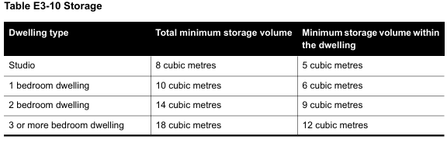 | Deemed to Comply  Each studio has been provided with exclusive access to a minimum total of 8 cubic metres with a minimum 5 cubic metres in the dwelling  Each 1 bedroom dwelling has been provided with exclusive access to a minimum total of 10 cubic metres with a minimum 6 cubic metres in the dwelling  Each 2 bedroom dwelling has been provided with exclusive access to a minimum total of 14 cubic metres with a minimum 9 cubic metres in the dwelling  Each 3 or more bedroom dwelling has been provided with exclusive access to a minimum total of 18 cubic metres with a minimum 12 cubic metres in the dwelling  Variation  INSERT  Before deciding on an application, the responsible authority must consider:  - The design response.  - The useability, functionality and location of storage facilities provided for the dwelling  INSERT  Does not meet the objective  INSERT | Right of Appeal  No
57.03-11 Accessibility objective  To ensure the design of dwellings meets the needs of people with limited mobility | Standard E3-11  At least 50 per cent of dwellings have:  - A clear opening width of at least 850mm at the entrance to the dwelling and main bedroom.  - A clear path with a minimum width of 1.2 metres that connects the dwelling entrance to the main bedroom, an adaptable bathroom and the living area.  - A main bedroom with access to an adaptable bathroom.  - At least one adaptable bathroom that meets all of the requirements of either Design A or Design B specified in Table E3-11.  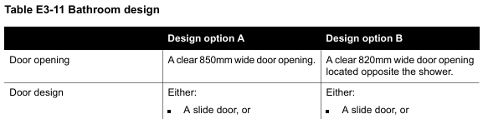  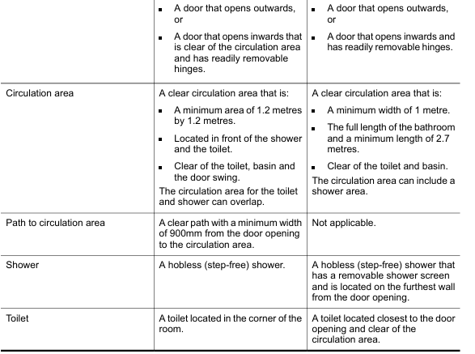 | Deemed to Comply  At least 50% of dwellings provide a clear opening of at least 850mm at the entrance of the dwelling and the main bedroom. A clear path with a minimum width of 1.2m connects the dwelling entrance to the main bedroom, an adaptable bathroom and living area. A main bedroom has access to an adaptable bathroom and at least one adaptable bathroom has been provided in accordance with Design A/B specified in Tabel E3-11.  Variation to Standard  INSERT  There are no relevant decision guidelines for this objective.  INSERT  Does not meet the objective  INSERT | Right of Appeal  No
57.03-12 Building separation within a site objective  To ensure that the separation between buildings (other than a light court) within a site provides a reasonable outlook and adequate daylight to new dwellings, and sufficient space for canopy trees and landscaping. | Standard E3-12  Walls of buildings that contain a habitable room window or balcony are set back from other walls of buildings on a site by at least 9 metres. This does not apply to a wall that forms part of a light court.  Sunblinds, awnings, privacy screens, eaves, facias, gutters, rainwater goods, flues, pipes, domestic water tanks, heating or cooling equipment or other services may encroach up to 0.5 metres into the building separation setback.  Stairways and ramps (including landings) that are less than 1 metre above the ground level may encroach into the building separation setback.  Pergolas and shade sails may encroach into the building separation setback.  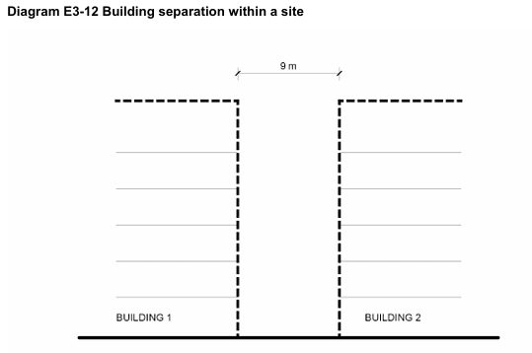 | Deemed to Comply  The required setbacks have been achieved for the development and complies with the Standard.  Variation  INSERT  Before deciding on an application, the responsible authority must consider:  - The design response.  - The design, function and layout of the building separation setback.  - Whether the building separation setback provides reasonable outlook and adequate daylight to new dwellings.  - Views between private open space and habitable room windows.  - Whether a different building separation setback affects the ability to retain or plant canopy trees.  INSERT  Does not meet the objective  INSERT | Right of Appeal  No
57.03-13 Light court objective  To ensure that a light court provides adequate daylight into a new bedroom or non-habitable room window. | Standard E3-13  A light court:  - Has a minimum dimension of at least 4.5 metres and an area of at least 20.25 square metres.  - Has a maximum dimension of 6 metres and a maximum area of 36 square metres.  - Is enclosed by the wall of a building for at least 75 per cent of its perimeter.  - Is clear to the sky.  - Is not the primary source of daylight to a living room or private open space. | Deemed to Comply  The light court has been designed to comply with the Standard.  Variation  INSERT  Before deciding on an application, the responsible authority must consider:  - The design response.  - Whether the light court provides adequate daylight to a new bedroom or not habitable room window.  - The arrangement of windows facing the light court.  INSERT  Does not meet the objective  INSERT | Right of Appeal  No

57.04 External Amenity

57.04-1 Overshadowing secluded open space objective  To ensure that any part of a building that does not meet standards E2-2 and E2-3 does not significantly overshadow existing secluded private open space. | Standard E4-1  The area of secluded private open space that is not overshadowed by the new development is greater than 50 per cent, or 25 square metres with a minimum dimension of 3 metres, whichever is the lesser area, for a minimum of five hours between 9 am and 3 pm on 22 September.  If existing sunlight to the secluded private open space of an existing dwelling or small second dwelling is less than the requirements of this standard, the amount of sunlight will not be further reduced.  This standard does not apply to any part of a new building that meets standards E2-2 and E2-3. | Deemed to Comply  The extent of overshadowing associated with the proposed development is within the requirements of the standard as:  More than 50% of the SPOS or 25sqm with a minimum dimension of 3m is not overshadowed for a minimum of 5 hours between 9am and 3pm on 22 September.  The existing sunlight to the secluded private open space of an existing dwelling or small second dwelling is less than the requirements of this standard, and the proposed development does not further reduce the sunlight to this area.  Not Applicable  The proposed building meets Standards E2-2 and E2-3.  Variation  INSERT  Before deciding on an application, the responsible authority must consider:  - The design response.  - The impact on the amenity of existing dwellings or small second dwelling.  - Existing sunlight penetration to the secluded private open space of the existing dwelling or small second dwelling.  - The time of day that sunlight will be available to the secluded private open space of the existing dwelling or small second dwelling.  - The effect of a reduction in sunlight on the existing use of the existing secluded private open space.  INSERT  Does not meet the objective  INSERT | Right of Appeal  No, standard met  Yes, standard varied
57.04-2 Overlooking objective  To limit views from any part of a building that does not meet standard E2-2 into existing secluded private open space and habitable room windows. | Standard B4-4  A habitable room window, balcony, podium, terrace, deck or patio is located and designed to avoid direct views into the secluded private open space of an existing dwelling or small second dwelling within a horizontal distance of 6 metres (measured at ground level) of the window, balcony, terrace, deck or patio. Views are measured within a 45 degree angle from the plane of the window or perimeter of the balcony, terrace, deck or patio, and from a height of 1.5 metres above floor level.  A habitable room window, balcony, terrace, deck or patio that is located with a direct view into a habitable room window of existing dwelling or small second dwelling within a horizontal distance of 6 metres (measured at ground level) of the window, balcony, terrace, deck or patio:  - Is offset a minimum of 1.5 metres from the edge of one window to the edge of the other; or  - Has sill heights of at least 1.5 metres above floor level; or  - Has fixed, obscure glazing in any part of the window below 1.5 metre above floor level; or  - Has permanently fixed external screens to at least 1.5 metres above floor level and be no more than 25 per cent transparent; or  - Has fixed elements that prevent direct views, such as horizontal ledges or vertical fins.  Obscure glazing in any part of the window below 1.5 metres above floor level may be openable provided that there are no direct views as specified in this standard.  Screens used to obscure a view should be:  - Perforated panels or trellis with a maximum of 25 per cent openings or solid translucent panels.  - Permanent, fixed and durable.  - Designed and coloured to blend in with the development.  This standard does not apply to a new habitable room window, balcony, terrace, deck or patio which faces a property boundary where there is a visual barrier at least 1.5 metres high and the floor level of the habitable room, balcony, terrace, deck or patio is less than 0.8 metres above ground level at the boundary.  This standard does not apply to a new habitable room window, balcony, terrace, deck or patio that is located in any part of a building that meets standard E2-2.  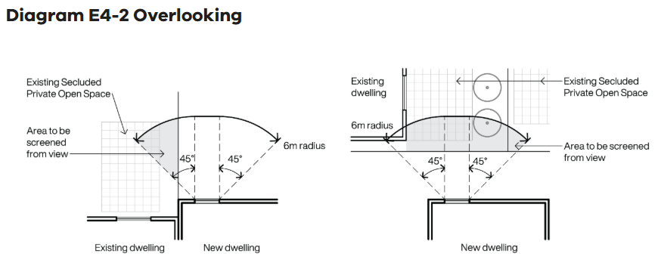 | Deemed to Comply  The development is designed to meet the requirements of the standard with overlooking into existing secluded private open space areas and habitable room windows limited in accordance with the Standard in the form of:  INSERT  Not Applicable  The proposed building meets Standards E2-2.  There are no habitable room windows or secluded private open space on adjoining land that require consideration.  Variation  INSERT  Before deciding on an application, the responsible authority must consider:  - The design response.  - The impact on the amenity of the secluded private open space or habitable room window.  - The existing extent of overlooking into the secluded private open space and habitable room windows of existing dwellings or small second dwellings.  - The internal daylight to and amenity of the proposed dwelling or residential building.  - The orientation and location of windows to limit views.  INSERT  Does not meet the objective  INSERT | Right of Appeal  No, standard met  Yes, standard varied
57.05 Sustainability

57.05-1 Permeability and stormwater management objectives  - To reduce the impact of increased stormwater run-off on the drainage system.  - To facilitate on-site stormwater infiltration.  - To encourage stormwater management that maximises the retention and reuse of stormwater.  - To contribute to urban cooling | Standard E5-1  The site area covered by the pervious surfaces is at least 20 percent of the site.  Buildings are connected to a non-potable dual pipe reticulate water supply, where available from the water authority.  The development includes a stormwater management system designed to:  - Meet the best practice quantitative performance objectives for stormwater quality specified in the Urban stormwater management guidance (EPA Publication 1739.1, 2021) of:  – Suspended solids 80% reduction in mean annual load.  – Total phosphorus and Total Nitrogen 45% reduction in mean annual load.  – Litter 70% reduction of mean annual load.  Note: A certificate generated from a stormwater assessment tool demonstrating a minimum 100 per cent Blue Factor tool score, or documentation from Model for Urban Stormwater Improvement Conceptualisation (MUSIC) or an equivalent product accepted by the responsible authority showing the performance objectives for stormwater quality are met.  - Direct flows of stormwater into treatment areas, garden areas, tree pits and permeable surfaces, with drainage of residual flows to the legal point of discharge. | Deemed to Comply  The site retains INSERT per cent permeability, assisting in on site stormwater filtration.  A Blue Factor/MUSIC report has been provided which corresponds with the assessment plans which show suitably sized rainwater tanks and/or raingardens to meet best practice to meet EPA Publication 1739.1, 2021 with stormwater directed to flow into treatment areas, garden areas, tree pits and permeable surfaces, with drainage of residual flows to the legal point of discharge  Variation  INSERT  Before deciding on an application, the responsible authority must consider:  - The design response.  - The capacity of the site to incorporate stormwater retention and reuse.  - The existing site coverage and any constraints imposed by existing development.  - The capacity of the drainage network to accommodate additional stormwater.  - Whether the stormwater treatment areas can be effectively maintained.  - Whether the owner has entered into an agreement to contribute to off-site stormwater management in lieu of providing on-site stormwater management system.  - Whether the owner has entered into an agreement to contribute to off-site stormwater management in lieu of providing an on-site stormwater management system.  INSERT  Does not meet the objective  INSERT | Right of Appeal  No
57.05-2 Waste and recycling objectives  - To ensure dwellings are designed to facilitate waste recycling.  - To ensure that waste and recycling facilities are accessible and are of sufficient size to manage organic and general waste, and mixed and glass recycling.  - To ensure that waste and recycling facilities are designed and managed to minimise impacts on residential amenity. | Standard E5-2  The development includes a shared bin storage area for use by each dwelling of at least the applicable area, depth and height specified in Table E5-2.  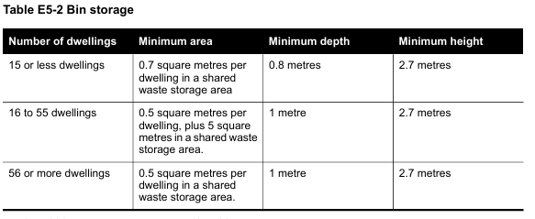  Enclosed bin storage areas are ventilated by:  - Natural ventilation openings to the external air with an area of at least 5 per cent of the area for bin storage area; or  - A mechanical exhaust ventilation system.  A tap and drain are provided to wash bins.  A continuous path of travel is provided from each dwelling to bin storage areas.  Each dwelling includes an internal waste and recycling storage space of at least 0.07 cubic metres with a minimum depth of 250 millimetres. | Deemed to Comply  A shared bin storage area of INSERT sqm (0.7sqm x INSERT of dwellings) with a minimum depth of 0.8m and a minimum height of 2.7m has been provided.  or  A shared bin storage area of INSERT sqm (0.5sqm x INSERT of dwellings plus 5sqm) with a minimum depth of 1m and a minimum height of 2.7m has been provided.  or  A shared bin storage area of INSERT sqm (0.5sqm x INSERT of dwellings) with a minimum depth of 1m and a minimum height of 2.7m has been provided.  The enclosed bin storage areas are ventilated by natural ventilation openings to the external air with an area of at least 5 per cent of the area for bin storage area/a mechanical exhaust ventilation system.  A tap and drain are provided and there is a continuous path of travel from each dwelling to the bin storage area.  In addition, each dwelling has an internal waste and recycling space of at least 0.07 cubic metres with a minimum depth of 250mm.  Variation  INSERT  Before deciding on an application, the responsible authority must consider:  - The design response, including a Waste Management Plan.  - Any relevant waste and recycling objective, policy or statement set out in this planning scheme.  - The functionality and accessibility of waste and recycling facilities, including for people with limited mobility.  - Whether facilities are provided for on-site reuse or management of food and garden organics through composting or other waste recovery.  - Whether waste and recycling facilities are designed to meet the better practice design options specified in Waste management and recycling in multi-unit developments (Sustainability Victoria, 2019).  INSERT  Does not meet the objective  INSERT | Right of Appeal  No
57.05-3 Noise impacts objective  - To minimise the impact of mechanical plant noise located in the development.  - To contain noise sources in developments that may affect existing dwellings.  - To protect residents from external and internal noise sources. | Standard E5-3  Mechanical plant, including mechanical car storage, lift facilities, building services, non-residential uses, car parking, communal areas are not located immediately adjacent to bedrooms of new or existing dwellings or small second dwellings, unless a solid barrier is in place to provide a line of sight barrier to transmission of noise and the location of all relevant bedrooms.  Buildings within a noise influence area specified in Table E5-3 are designed and constructed to achieve the following noise levels:  - Not greater than 35dB(A) for bedrooms, assessed as an LAeq,8h from 10pm to 6am.  - Not greater than 40dB(A) for living areas, assessed LAeq,16h from 6am to 10pm.  Buildings, or part of a building screened from a noise source by an existing solid structure, or the natural topography of the land, do not need to meet the specified noise level requirements.  Noise levels are assessed in unfurnished rooms with a finished floor and the windows closed.  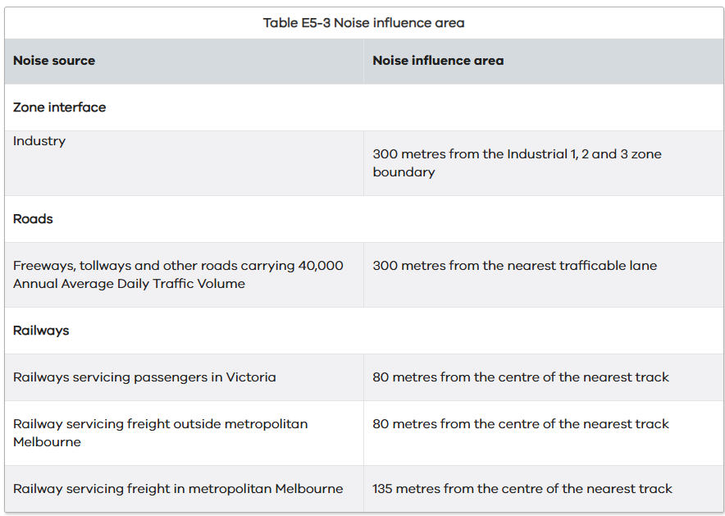 | Not Applicable  There are no external noise sources that require consideration as part of this application.  Deemed to Comply  Mechanical plant, including mechanical car storage and lift facilities are not located immediately adjacent to bedrooms of new or existing dwellings or small second dwellings  Or  Mechanical plant, including mechanical car storage and lift facilities are located immediately adjacent to bedrooms of new or existing dwellings or small second dwellings however a solid barrier is in place to provide a line of sight barrier to transmission of noise and the location of all relevant bedrooms.  The noise levels for bedrooms and living areas required by the Standard are achieved as per the noise source Table E3-5.  Variation  INSERT  Before deciding on an application, the responsible authority must consider:  - The design response.  - Whether the impact of potential noise sources within a development have been mitigated through design, location and siting.  - Whether the layout of rooms within a dwelling mitigates noise transfer within and between dwellings.  - Whether it can be demonstrated that the design treatment incorporated into the development meets the specified noise levels or an acoustic report by a suitably qualified consultant submitted with the application.  INSERT  Does not meet the objective  INSERT | Right of Appeal  No
57.05-4 Energy efficiency objectives  - To achieve energy efficient dwellings and buildings.  - To ensure dwellings achieve adequate thermal efficiency. | Standard E5-4  Dwellings located in a climate zone identified in Table E5-4 do not exceed the maximum NatHERS annual cooling load.  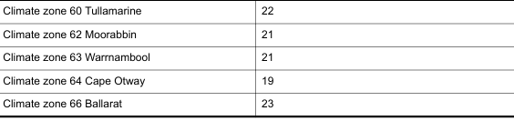  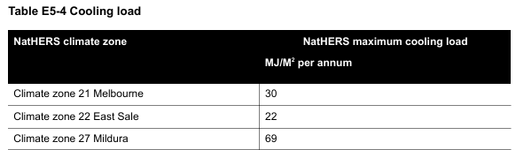  Note: Refer to NatHERS zone map, Nationwide House Energy Rating Scheme (Commonwealth Department of Environment and Energy). | Deemed to Comply  Climate Zone 60 Tullamarine  Each dwelling has been provided with a maximum cooling load of 22 MJ/M2 per annum.  or  Climate Zone 64 Cape Otway  Each dwelling has been provided with a maximum cooling load of 19 MJ/M2 per annum.  Variation  INSERT  Before deciding on an application, the responsible authority must consider:  - The design response.  - The size, orientation and layout of the site.  - The availability of solar access to north-facing windows on the site.  - The annual cooling load for each dwelling.  INSERT  Does not meet the objective  INSERT | Right of Appeal  No

…………………………
INSERT – Planning Officer

………………………….
Team Leader

