INTRODUCTION
This report provides a bi-annual update on Council’s progress against the major initiatives and adopted indicators as part of our Council Plan 2025–29.
The Council Plan 2025-2029 sets our strategic direction for the next four years and outlines how we will deliver meaningful outcomes for the City of Greater Geelong.
The plan is guided by the community’s 30-year vision, Greater Geelong: A Clever and Creative Future, and reflects Council’s commitment to inclusive, sustainable and innovative local governance. It provides a clear framework to guide decision-making, prioritise resources and maximise the impact of Council’s services, infrastructure and advocacy.

The six guiding strategic objectives are:
1 | CORE AND CRITICAL INFRASTRUCTURE - Plan, deliver, manage and optimise infrastructure across the region
2 | HEALTHY AND CARING COMMUNITY - Identify, promote, advocate for, and deliver equitable health and wellbeing outcomes for our diverse communities
3 | ECONOMIC DEVELOPMENT - Lead efforts to strengthen the economy and workforce to enhance prosperity across the community
4 | HERITAGE AND CULTURE - Champion Greater Geelong’s unique heritage and cultural identity
5 | ENVIRONMENT AND CIRCULAR ECONOMY - Protect and enhance the natural environment and surrounds
6 | GOVERNANCE AND INTEGRITY - Commit to the highest levels of leadership, integrity, financial stewardship and meaningful community engagement

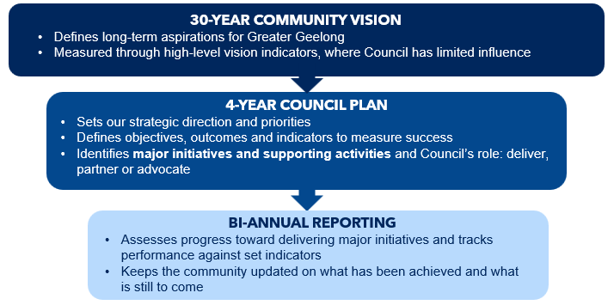
The document fits into a broader cascading framework that includes:
EXECUTIVE SUMMARY & OVERVIEW

Reporting Process
Progress against The City’s 31 Council Plan Major Initiatives have been assessed and categorised into five stages:

COMPLETED – Fully Delivered
ON TRACK – Progressing as planned and expected to meet delivery target
DELAYED – Behind schedule; still expected to be delivered within Council Plan
AT RISK – Behind schedule; unlikely to be delivered within Council Plan term
WITHDRAWN – No longer progressing

These major initiatives are aligned with the six strategic objectives outlined in the Council Plan and represent the key actions Council is undertaking to achieve these objectives. Progress against the major initiatives is reviewed on a bi-annual basis to support transparent and accountable reporting on Council Plan delivery.
The adopted indicators, which define how we measure success, have also been reviewed. However, many indicators are reported on an annual basis and therefore do not have data available for this bi-annual reporting period.

Results
Based on results from the first half of the 2025–2026 financial year (H1), the City is tracking well against the major initiatives and supporting actions committed to in the Council Plan. Overall, 97% of initiatives (30 initiatives) are on track, with 3% (1 initiative) identified as at risk of delay.

Results for each Strategic Objective are summarised below:
CORE AND CRITICAL INFRASTRUCTURE | HEALTHY AND CARING COMMUNITY | ECONOMIC DEVELOPMENT
HERITAGE AND CULTURE | ENVIRONMENT AND CIRCULAR ECONOMY | GOVERNANCE AND INTEGRITY

STRATEGIC OBJECTIVE 1
Core and Critical Infrastructure: Plan, deliver, manage and optimise core and critical infrastructure across the region

Outcomes
- Responsible and sustainable growth and development.
- Community facilities and public spaces are accessible and fit for purpose.
- Multi-modal transport networks are well-connected and accessible.

Major Initiatives
No. |  | Major Initiative | Progress comment | Status
1.1 | Accelerate planning for housing, employment land and major infrastructure development in response to the Plan for Victoria |  | Progress continues across key precincts including Elcho Road West and Heales Road West, with consultancy support in place and planning activities advancing. Some dependencies remain around Department of Transport and Planning input and third-party funding agreements, however overall timelines are tracking with staged agency engagement and exhibition milestones underway. | On Track
1.2 | Develop and implement the Public Realm Strategy to guide the landscape character, transport and economic outcomes of key streets |  | The Public Realm Strategy draft is nearing completion and is scheduled for Council consideration to commence community engagement. Work on public realm standards and implementation planning is expected to commence following endorsement. | On Track
1.3 | Develop and commence implementation of a new Integrated Transport Strategy. |  | Development of the Integrated Transport Strategy is progressing, with internal workshops completed and a working draft circulated for review. External dependencies remain with the Department of Transport and Planning Bus Network Review and State-led initiatives, with the strategy expected to progress toward public consultation following internal governance processes. | On Track
1.4 | Upgrade and develop community, sports, and active recreation infrastructure to enhance access and participation in local sports and activities |  | Delivery is progressing well across major projects including North Bellarine Aquatic Centre Stage 2. Construction has commenced, with operational planning, budget development and workforce planning underway ahead of future activation milestones. | On Track
1.5 | Improve and expand regional sporting facilities as part of the Regional Sports Infrastructure Program |  | Major projects under the Regional Sports Infrastructure Program are progressing as planned, with construction underway and operational planning advancing for multiple facilities. Remaining milestones relate to data finalisation, workforce structures and preparation for facility activation. | On Track
1.6 | Invest in flood management and mitigation initiatives across Greater Geelong |  | Flood mitigation projects are progressing through modelling, procurement and early delivery stages, including work supported by Cumulus and Water Technology. Community engagement and construction activities are scheduled, with on-ground works expected to commence in early 2026. | On Track

Indicators
Indicator | Calculation | Target | Baseline | Actual | Status
Increase the kilometres of transport infrastructure. | The length of pedestrian footpaths and bicycle paths per head of population. | Increase | New indicator – no baseline | N/A | Indicator Reported Annually
Asset renewal and upgrade expense compared to depreciation above 85%. | Asset renewal and upgrade expense compared to deprecation assesses whether council spending on assets is focused on purchasing new assets or renewing and upgrading existing ones. | >85% | 58.47% (FY2024-25) | N/A | Indicator Reported Annually
Increase the provision of open space. | Hectares of open public space (civic, community parks, sports reserves and heritage open space). | Increase | 1,048.8 hectares – 503 sites (June 2025) | N/A | Indicator Reported Annually
Increase the proportion of housing construction within existing urban areas | Percentage of housing construction within existing urban areas. | Increase | 15% (2025) | N/A | Indicator Reported Annually

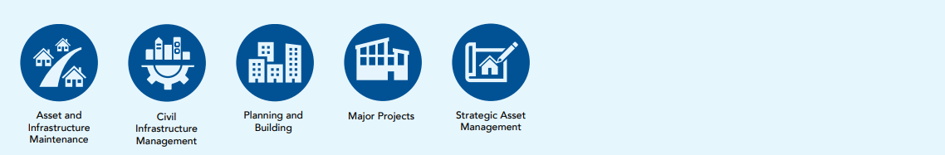

Supporting Services
Land Use Planning and Building
Strategic Planning and Design
Strategic Asset Management
Capital Delivery
Civil Infrastructure Management
Asset and Infrastructure Maintenance

Links to Community’s Aspirations
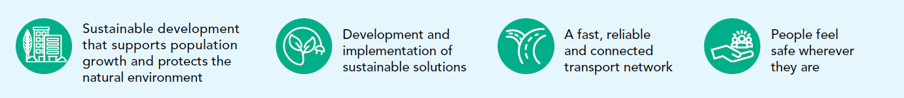

STRATEGIC OBJECTIVE 2
Healthy and Caring Community: Identify, promote, advocate for, and deliver equitable health and wellbeing outcomes for our diverse communities

Outcomes
- A community that is fair, compassionate and inclusive.
- Services and facilities that enhance health and wellbeing are accessible to all.
- A community with the resources and capacity to control their health and wellbeing.

Major Initiatives
No. |  | Major Initiative | Progress comment | Status
2.1 | Transition the delivery of Aged Care services to a Support at Home model in response to the Commonwealth's Aged Care reforms. |  | Transition to the Support at Home model is ongoing, with care plan reviews and service agreements progressing. Some delays remain outside Council’s control due to Services Australia documentation and client contribution processes. | On Track
2.2 | Develop and implement the Domestic Animal Management Plan 2026-29. |  | The Domestic Animal Management Plan was endorsed by Council in November 2025 and implementation activities are underway and planned to progress over the duration of the plan. | On Track
2.3 | Implement the Community Health and Wellbeing Strategy 2025-29. |  | Implementation of the Municipal Public Health and Wellbeing Plan 2025–29 is progressing through annual action planning, partnerships and grant activity. Delivery of initiatives including the 16 Days of Activism campaign and establishment of a regional food systems partnership are key highlights from this quarter. | On Track
2.4 | Ensure equitable access to open space, community sport and recreation facilities and assets across Greater Geelong. |  | Strategic planning is progressing through the Open Space Strategy and supporting policy work, with Council endorsement achieved for key components and community engagement underway. Funding advocacy initiatives such as Pick My Park, alongside asset renewal planning, continue in parallel. | On Track
2.5 | Support participation of women, girls and diverse groups in community sport and recreation. |  | Gender+ Impact Assessments (GIA+) have been completed to understand how policy, programs or services might impact different people in different ways, supporting improved participation outcomes across community sport and recreation settings. | On Track

Indicators
Indicator | Calculation | Target | Baseline | Actual | Status
Maintain participation rates in City-operated community services. | Participation in MCH services  Participation in youth development activities | Maintain | New indicator – no baseline | MCH services – Annual  Youth participation  - Youth Hubs: 1,754  - School Holiday Programs: 415  - Youth Events: 1,098  - L2P Program: 37  - School & Community Programs: 420 | Baseline Data Only
Increase utilisation of the City’s swim, sport and leisure facilities. | The number of visits to aquatic facilities per head of municipal population. | Increase | 7.72 (FY2024-25)  3.95 (H1 2024-25) | 3.92 | Positive Trend Against Target
Increase the number of Gender+ Impact Assessments completed. | Number of projects with Gender+ Impact Assessments completed. | Increase | For 2024/25: 10  (24 GIAs that have commenced for FY2025-26) | 17 GIAs completed for H1 | Positive Trend Against Target

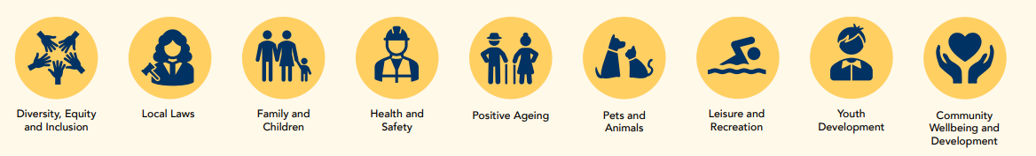
Supporting Services

Links to Community’s Aspirations


STRATEGIC OBJECTIVE 3
Economic Development: Lead efforts to strengthen our diverse economy and workforce to enhance prosperity across our community

Outcomes
- New businesses, events and investment are attracted to the region.
- Local businesses and industries are supported to thrive.
- Greater Geelong attracts, retains and develops workforce capacity and capability.
- Sufficient land supply to enable sustainable growth, business expansion and attraction.

Major Initiatives
No. | Major Initiative | Progress comment | Status
3.1 | Activate Central Geelong | Progress continues across key components of the Central Geelong Action Plan, including stakeholder collaboration, place activation initiatives and strategic planning. Work is advancing on place activation projects such as Labuan Square place planning and the broader Place Strategy, with delivery of actions ongoing. | On Track
3.2 | Champion First Nations products and services | The City’s Social Procurement Policy has been drafted, with internal stakeholder workshops scheduled to refine the framework. Plans for endorsement will be communicated as part of the annual update. Further to this, the City is supporting the growth of First Nations artists and businesses by embedding creative and commercial opportunities across its cultural venues. Recent progress includes the delivery of First Nations-led exhibitions and professional masterclasses, the growth of permanent collections through new commissions, and the sustained presence of First Nations representation within retail environments. | On Track
3.3 | Increase visitation to Greater Geelong and The Bellarine | Visitation initiatives are tracking to plan, supported by delivery of the Business Events website, preparation for Australian Tourism Exchange, and industry training with Visit Victoria. A new multi-year destination marketing campaign remains on track to launch in early 2026. | On Track
3.4 | Attract, support and deliver major events across the region | Advocacy and delivery efforts continue across major events including the PayPal Melbourne Fashion Festival and Mapei Cadel Evans Great Ocean Road Race. Work is underway with partners on future opportunities, including a proposed Geelong Gallery major exhibition in 2026, pending funding certainty. | On Track
3.5 | Support the growth of Greater Geelong businesses | The Geelong Small Business Festival has been successfully delivered, with evaluation and reporting completed. Work continues to align future initiatives with the overarching goal of supporting Greater Geelong businesses. | On Track
3.6 | Grow Geelong’s cruise tourism sector | Engagement with major industry partners continues, with new regional berthing opportunities identified as highly viable options starting from the 2027–28 season. Advocacy efforts remain focused on rebuilding sector confidence following cancellations in the 2025–26 cruise season. | On Track
3.7 | Increase capacity and capability of Greater Geelong's workforce | Workforce planning and service delivery activities are progressing, including educator recruitment and allocation planning to support early years and education services. | On Track
3.8 | Ensure appropriate supply of industrial land across Greater Geelong | The initiative is scheduled to progress through Council decision-making processes in the next reporting period. | On Track

Indicators
Indicator | Calculation | Target | Baseline | Actual | Status
Increase the economic benefit of major events funded by the City | Estimated return on investment (ROI) for major events funded by the City. | Increase  Anchor events 40:1  Priority events 30:1  Developing events 20:1 | 56:1 ROI (FY2024-25) | 1 x developing event delivered with ROI 30:1 | Positive Trend Against Target
Maintain the supply of employment land. | Estimated years of zoned industrial land available | Maintain | 13 years (June 2024) *based on zoned supply only and not future identified precincts as part of the South West Geelong Employment Land Review in 2022. | N/A | Indicator Reported Annually
Increase the number of businesses supported through the City’s Business Concierge service. | Number of businesses supported through the City’s Business Concierge service. | Increase | 461 (FY2024-25) | N/A | Indicator Reported Annually


Supporting Services

Links to Community’s Aspirations

STRATEGIC OBJECTIVE 4
Heritage and Culture: Champion our unique heritage and culture

Outcomes
- Increased engagement in arts, culture and heritage experiences across Greater Geelong. We are acknowledged and recognised as a leading council and organisation
- Increased investment in our creative, cultural and sporting activity hubs.
- Greater Geelong’s diverse culture is shared and celebrated.

Major Initiatives
No. |  | Major Initiative | Progress comment | Status
4.1 | Strengthen Geelong's artists, arts and cultural organisations and creative enterprises |  | Progress continues on the Design and Creative Hub, with Council endorsement of a new City Hall location and construction works underway following approval of a State Government grant variation. | On Track
4.2 | Celebrate Geelong's unique culture of art and design |  | The successful delivery of ROAM Geelong demonstrated strong cultural and economic outcomes for the region. Development of the Arts and Culture Strategy has experienced some delays due to capacity constraints, with Council consideration now anticipated later in 2026. | On Track
4.3 | Protect the cultural heritage of Greater Geelong through review of the Geelong Heritage Strategy |  | Planning scheme and implementation work is progressing, with consultation extended to support property owner engagement. | On Track

Indicators
Indicator | Calculation | Target | Baseline | Actual | Status
Increase visitation to our arts and culture facilities/venues in person and online. | Number of visitors to the following:  - National Wool Museum onsite visitation  - Potato Shed  - The Carousel  - National Wool Museum Digital and online programs and activities | Increase | FY2024-25: 1,718,670  - National Wool Museum: (onsite) 113,844  - Potato Shed: 78,000  - The Carousel: 162,629  - Combined NWM Digital online programs and activities: 1,364,197 | N/A | Indicator Reported Annually
Maintain the number of artists, groups and organisations supported by the City (Community Grants Program). | Number of grants provided via the following grants streams:  - Artists and Creatives Professional Development  - Arts Projects  - Clever and Creative Seed  - Creative Commissions Program  - Geelong Heritage | Maintain | FY2024-25: 38  - Artists and Creatives Professional Development (10 projects funded)  - Arts Projects (13 projects funded)  - Clever and Creative Seed (9 projects funded)  - Creative Commissions Program (4 projects funded)  - Geelong Heritage (4) | N/A | Indicator Reported Annually
Increase Aboriginal and Torres Strait Islander cultural projects and participation. | TBC | Increase | New indicator - no baseline | TBC | Indicator Reported Annually


Supporting Services

Links to Community’s Aspirations


STRATEGIC OBJECTIVE 5
Environment and Circular Economy: Protect and enhance our unique natural environment and surrounds

Outcomes
- Natural habitat and areas of important biodiversity are identified, protected, connected and restored.
- Significant reductions in emissions and increased community resilience to climate change impacts.
- Minimise waste and manage effective recovery of resources.

Major Initiatives

No. |  | Major Initiative | Progress comment | Status
5.1 | Develop and implement the Geelong Growth Areas Strategic Assessment |  | Exhibition and submission processes have been completed, with assessment and next steps now underway. | On Track
5.2 | Implementation of the Environment Strategy Action Plan 2024-26 |  | Delivery of priority actions is tracking well, including successful planting programs, grant outcomes and preparation of key strategy documents for Council consideration. | On Track
5.3 | Upgrade existing resource recovery facilities to prepare for new Food Organics and Green Organics (FOGO) and glass kerbside collection services |  | Detailed design for the FOGO facility upgrade is progressing. The construction tender is scheduled for release in the fourth quarter of the 2026 financial year, with construction of the upgraded facility expected to commence in late 2026 or early 2027.  In December 2025, Council resolved to oppose the rollout of a separate kerbside glass bin service. The City continues to advocate to the State Government for the consideration of more cost effective and sustainable glass recycling alternatives. | Delayed
5.4 | Design, deliver, and renew resource recovery  and waste recycling infrastructure for the region |  | Consultants have been engaged and design work is underway, progressing the next phase of infrastructure planning. | On Track

Indicators
Indicator | Calculation | Target | Baseline | Actual | Status
Decrease the volume of greenhouse gas emissions from City-managed operations. | Tonnes CO2-emissions from City-managed operations | Decrease | 24,301 tonnes (2023−24) | N/A | Indicator Reported Annually
Increase the amount of hectares of natural habitat on City-managed land. | Hectares of protected natural habitat on City-managed land | Increase | 1,493.02 ha (June 2025) | N/A | Indicator Reported Annually
Decrease the amount of (kerbside) waste produced each year per household. | Tonnage of waste divided by the number of residential households | Decrease | 58,652/129,914 = 0.45 tonnes/household  =451.47kg/household (FY2024-25) | N/A | Indicator Reported Annually

Supporting Services
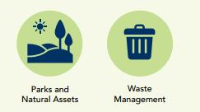

Links to Community’s Aspirations

STRATEGIC OBJECTIVE 6
Governance and Integrity: Commit to the highest levels of leadership, integrity, financial stewardship, and meaningful community engagement

Outcomes
- Public funds and assets are used equitably and efficiently.
- Decision making is evidence-based, transparent and strategically aligned.
- Community engagement, strong partnerships and effective advocacy delivers value and impact

Major Initiatives
No. |  | Major Initiative | Progress comment | Status
6.1 | Enhance customer service experience |  | The Customer Relationship and Experience System (CRES) program has been realigned, with the Project Control Group reformed and an updated delivery schedule endorsed. Procurement for probity and assurance partners and preparation of the Asset and Field Workforce stream tender are progressing, alongside targeted recruitment to support delivery. | On Track
6.2 | Strengthen the Council's long term financial sustainability |  | Work continues on the Long Term Financial Plan refresh and FY27 Budget development, supported by Council workshops and actions to reduce debt through approved surplus property sales. | On Track
6.3 | Deliver the Service Review Program |  | 70% of service plans are now complete or in progress. These plans ensure ongoing operational alignment with our new Council Plan and Long-Term Financial Plan. Concurrently, the broader service review program is being delivered in accordance with the prioritised roadmap, incorporating quality assurance improvements to ensure service consistency and community value. | On Track
6.4 | Drive good governance and a strong safety culture |  | Progress on governance improvements remains on track following a formal update to the Minister in late 2025. The City remains positioned to adopt the new Model Governance Rules once finalised and released by Local Government Victoria. Simultaneously, the Health, Safety, and Wellbeing Strategy is achieving key outcomes through a new Psychological Health and Safety Framework and targeted initiatives to address Occupational Violence and Aggression (OVA). | On Track
6.5 | Increase opportunities for community engagement and contribution in Council decision-making |  | Community Engagement Policy development and engagement activities are progressing, with community and staff feedback currently underway following Council endorsement. | On Track

Indicators
Indicator | Calculation | Target | Baseline | Actual | Status
Delivery of capital project program. | % allocated budget delivered | Deliver | FY2024-25: 67%  Budgeted - $207.7 million  Actual - $139.3 million | N/A | Indicator Reported Annually
Increase the number of grants secured that support strategic initiatives. | Value of incoming grants awarded that support strategic initiatives (aligned to strategic directions) | Increase | FY2024-25  52 awarded $27,936,255.48 (co-contribution $10,182.932.49) | - 12 grants awarded for total of $3,372,652.00 (co-contribution 2,314,455.68)  - 27 Grant applications submitted with an ask of $47,631,461.58 (Co-contribution $2,563,747.00 | Positive Trend Against Target
Increase community engagement and participation opportunities. | Number of projects available for community feedback on Have Your Say platform | Increase | 58 projects (FY2024-25) | N/A | Indicator Reported Annually

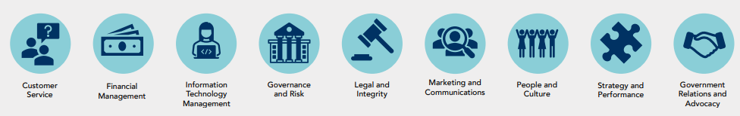
Supporting Services

Links to Community’s Aspirations
