INTRODUCTION
This report provides a bi-annual update on Council’s progress against the major initiatives and adopted indicators as part of our Council Plan 2025–29.
The Council Plan 2025-2029 sets our strategic direction for the next four years and outlines how we will deliver meaningful outcomes for the City of Greater Geelong.
The plan is guided by the community’s 30-year vision, Greater Geelong: A Clever and Creative Future, and reflects Council’s commitment to inclusive, sustainable and innovative local governance. It provides a clear framework to guide decision-making, prioritise resources and maximise the impact of Council’s services, infrastructure and advocacy.

The six guiding strategic objectives are:
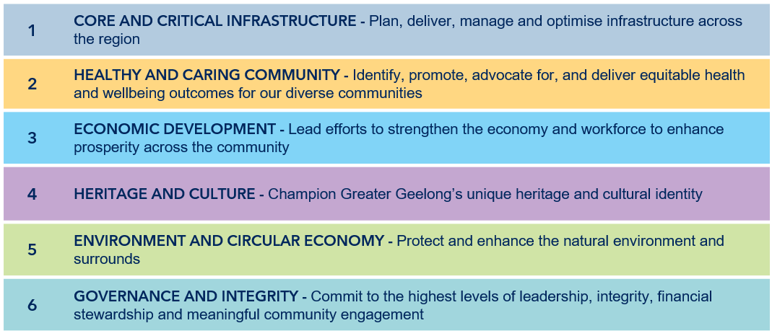

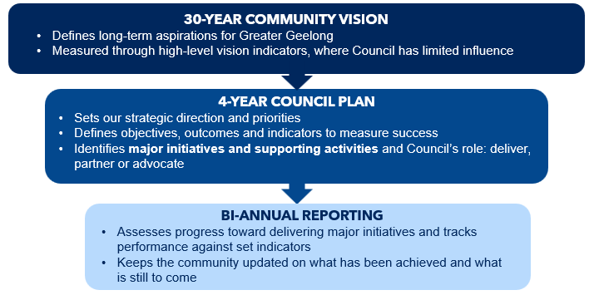
The document fits into a broader cascading framework that includes:

EXECUTIVE SUMMARY & OVERVIEW

Reporting Process
Progress against The City’s 31 Council Plan Major Initiatives have been assessed and categorised into five stages:

COMPLETED – Fully Delivered
ON TRACK – Progressing as planned and expected to meet delivery target
DELAYED – Behind schedule; still expected to be delivered within Council Plan
AT RISK – Behind schedule; unlikely to be delivered within Council Plan term
WITHDRAWN – No longer progressing

These major initiatives are aligned with the six strategic objectives outlined in the Council Plan and represent the key actions Council is undertaking to achieve these objectives. Progress against each initiative is reviewed bi-annually to support transparent and accountable reporting on the delivery of the Council Plan.
The adopted indicators, which measure progress and success, have also been reviewed. Annual results for FY2025-26 have been recorded, together with an assessment of performance against each target, indicating whether results show a positive trend, negative trend, or no significant change.

Results
Based on the yearly results for the 2025–2026 financial year, the City is tracking well against the major initiatives and supporting actions committed to in the Council Plan. Overall, 100% of initiatives (31 initiatives) are on track, with none identified as at risk or delayed.

Results for each Strategic Objective are summarised below:
ECONOMIC DEVELOPMENT

HEALTHY AND CARING COMMUNITY
CORE AND CRITICAL INFRASTRUCTURE
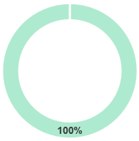
HERITAGE AND CULTURE | GOVERNANCE AND INTEGRITY  ENVIRONMENT AND CIRCULAR ECONOMY

STRATEGIC OBJECTIVE 1
Core and Critical Infrastructure: Plan, deliver, manage and optimise core and critical infrastructure across the region

Outcomes
- Responsible and sustainable growth and development.
- Community facilities and public spaces are accessible and fit for purpose.
- Multi-modal transport networks are well-connected and accessible.

Major Initiatives
No. |  | Major Initiative | Progress comment | Status
1.1 | Accelerate planning for housing, employment land and major infrastructure development in response to the Plan for Victoria. |  | Planning for the Northern and Western Geelong Growth Areas progressed throughout the year, with key milestones achieved across several Precinct Structure Plans. Elcho Road West, Elcho Road East and Creamery Road advanced through important planning, engagement and approval phases, while work continued on the West Fyans/Fyans Street Precinct Structure Plan. The State Government also confirmed it will lead progression of the four remaining precincts in the Northern and Western Growth areas. Together, these initiatives will position several growth areas for their next stages of planning and implementation. | On Track
1.2 | Develop and implement the Public Realm Strategy to guide the landscape character, transport and economic outcomes of key streets. |  | The City has continued work on the Public Realm Strategy, which will guide the future planning, design and management of key streets and public spaces across Greater Geelong. The strategy is scheduled for executive consideration early in the next financial year. | On Track
1.3 | Develop and commence implementation of a new Integrated Transport Strategy. |  | The City has progressed the draft Integrated Transport Strategy in response to community engagement. A draft strategy is now ready and will soon go to Council, with community consultation on the draft to follow. | On Track
1.4 | Upgrade and develop community, sports, and active recreation infrastructure to enhance access and participation in local sports and activities. |  | Significant progress was made on the delivery of community sport and recreation infrastructure across Greater Geelong. The Rippleside Park all-abilities playground was completed and opened to the community, while construction progressed on both the Ocean Grove District Ride Centre and North Bellarine Aquatic Centre Stage 2. Operational planning also advanced to support future activation and community use of these facilities. | On Track
1.5 | Improve and expand regional sporting facilities as part of the Regional Sports Infrastructure Program. |  | Major sporting infrastructure projects continued to progress through the Regional Sports Infrastructure Program. Commonwealth Games legacy projects moved through key stages of delivery, and planning continued to get facilities ready for future use. All projects within the Regional Sports Infrastructure Program will be delivered for the community by March 2027. | On Track
1.6 | Invest in flood management and mitigation initiatives across Greater Geelong. |  | The City continued flood management and mitigation work across Greater Geelong. Stormwater studies for Central Geelong and South Geelong are now (substantially) complete, while studies for Highton and Waurn Ponds are progressing towards completion and community engagement. A contractor has been appointed to undertake works for the High Street Drysdale culvert upgrades with the project manager working through some logistical site matters before works can progress. | On Track

Indicators
Indicator | Calculation | Target | Baseline | Actual | Status
Increase the kilometres of transport infrastructure. | The length of pedestrian footpaths and bicycle paths per head of population. | Increase | New indicator – no baseline | - 32.8km new footpaths and shared paths (a 1.33% overall increase)  - 11.2km new roads (0.36% increase) | No Baseline Data
Asset renewal and upgrade expense compared to depreciation above 85%. | Asset renewal and upgrade expense compared to deprecation assesses whether council spending on assets is focused on purchasing new assets or renewing and upgrading existing ones. | >85% | - 58.47% (FY2024-25) | 84.51%  *Note: LGRPF Indicator. Interim result pending VAGO / ARC review. | Negative Trend Against Target
Increase the provision of open space. | Hectares of open public space (civic, community parks, sports reserves and heritage open space). | Increase | - 1,048.8 hectares  - 503 sites (June 2025) | - 1,058.7 hectares  - 509 Sites (June 2026) | Positive Trend Against Target
Increase the proportion of housing construction within existing urban areas. | Percentage of housing construction within existing urban areas. | Increase | - 15% (FY2024-25) | - 32% (FY25-26) | Positive Trend Against Target

Supporting Services


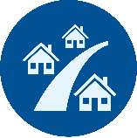
Land Use Planning and Building
Strategic Planning and Design
Strategic Asset Management
Capital Delivery
Civil Infrastructure Management
Asset and Infrastructure Maintenance

Links to Community’s Aspirations
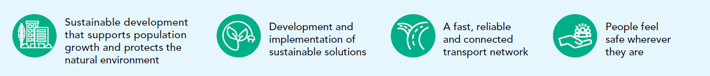

STRATEGIC OBJECTIVE 2
Healthy and Caring Community: Identify, promote, advocate for, and deliver equitable health and wellbeing outcomes for our diverse communities

Outcomes
- A community that is fair, compassionate and inclusive.
- Services and facilities that enhance health and wellbeing are accessible to all.
- A community with the resources and capacity to control their health and wellbeing.

Major Initiatives
No. |  | Major Initiative | Progress comment | Status
2.1 | Transition the delivery of Aged Care services to a Support at Home model in response to the Commonwealth's Aged Care reforms. |  | The transition to the Support at Home model has now been completed. The program is being delivered as business as usual, with an ongoing focus on quality, continuous improvement and compliance with Commonwealth Aged Care requirements. | On Track
2.2 | Develop and implement the Domestic Animal Management Plan 2026-29. |  | The Domestic Animal Management Plan 2026–29 was developed and adopted during the year. The plan establishes the strategic framework that will guide domestic animal management priorities and service delivery over the coming four years. | On Track
2.3 | Implement the Community Health and Wellbeing Strategy 2025-29. |  | The City continued to deliver actions under the Municipal Public Health & Wellbeing Plan 2025-29, including preparing quarterly and annual reporting. The City also supported several community initiatives promoting respect and preventing violence, including webinars, the Sexual Assault and Family Violence Centre's 'Collective Conversations', and Zonta Club of Geelong's '16 Days of Activism' launch, through planning support and by promoting these events across its communication channels and social media. | On Track
2.4 | Ensure equitable access to open space, community sport and recreation facilities and assets across Greater Geelong. |  | Several key initiatives were progressed to support equitable access to open space, sport and recreation opportunities across Greater Geelong. The Fair Play Strategy was adopted, while the Open Space Strategy completed Stage 2 public engagement, which will be used to guide open space planning and investment decisions. | On Track
2.5 | Support participation of women, girls and diverse groups in community sport and recreation. |  | The City continued to implement Fair Access actions to support participation and inclusion in community sport and recreation. Adoption of the Fair Play Strategy further strengthened the City's commitment to improving equitable access for women, girls and diverse communities. | On Track

Indicators
Indicator | Calculation | Target | Baseline | Actual | Status
Maintain participation rates in City-operated community services. | Participation in MCH services.  Participation in youth development activities. | Maintain | New indicator – no baseline | - Participation in MCH services: 71.61%. *Note: LGRPF Indicator. Interim result pending VAGO / ARC review)  - Youth Hubs: 3,364  - School Holiday Programs: 773  - Youth Events: 1,320  - L2P Program: 62 (number of young people who successfully attained their Probationary License)  - School and Community Programs: 745 | No Baseline Data
Increase utilisation of the City’s swim, sport and leisure facilities. | The number of visits to aquatic facilities per head of municipal population. | Increase | - 7.72 (FY2024-25)  - 3.95 (H1 2024-25) | - 8.14 (FY2025-26)  - 3.92 (H1 2025-26)  *Note: LGRPF Indicator. Interim result pending VAGO / ARC review. | Positive Trend Against Target
Increase the number of Gender+ Impact Assessments completed. | Number of projects with Gender+ Impact Assessments completed. | Increase | - 10 GIAs (for FY 2024-25) with 24 commenced for FY2025-26 | - 20 GIAs completed with another  10 commenced | Positive Trend Against Target

Supporting Services










Youth Development
Leisure and Recreation
Family and Children
Diversity, Equity and Inclusion
Community Wellbeing and Development
Local Laws
Health and Safety
Pets and Animals
Positive Ageing

Links to Community’s Aspirations


STRATEGIC OBJECTIVE 3
Economic Development: Lead efforts to strengthen our diverse economy and workforce to enhance prosperity across our community

Outcomes
- New businesses, events and investment are attracted to the region.
- Local businesses and industries are supported to thrive.
- Greater Geelong attracts, retains and develops workforce capacity and capability.
- Sufficient land supply to enable sustainable growth, business expansion and attraction.

Major Initiatives
No. | Major Initiative | Progress comment | Status
3.1 | Activate Central Geelong. | Progress continued across a range of initiatives supporting activation of Central Geelong. Industry and stakeholder engagement activities were delivered, place activation and public realm improvement projects advanced, and the Geelong City Market was established. Development of the Central Geelong Action Plan also progressed, with a draft completed for internal review. | On Track
3.2 | Champion First Nations products and services. | Initial work has begun on a Social Procurement Policy to support First Nations businesses, products and services. Further to this, the City actively promoted First Nations products and services through its cultural and retail initiatives. Recent achievements include generating approximately 10% of annual National Wool Museum Shop sales through First Nations suppliers, as well as engaging 23 First Nations individuals and three organisations across festival, exhibition, and professional development programs. The CEO is a member of the Statement of Commitment Alliance and has actively promoted and supported the development of the Geelong Aboriginal Employment Expo. The Statement of Commitment Alliance is also developing a First Nations Procurement Panel specifically for people who identify as First Nations who work and live on Wadawurrung country. | On Track
3.3 | Increase visitation to Greater Geelong and The Bellarine. | A range of tourism initiatives were delivered throughout the year to boost visitation across Greater Geelong and The Bellarine. Our Meet Geelong team is working to leverage the opening of Nyaal Banyul Geelong Convention and Event Centre, including bidding on significant national events and connecting local services and experiences with the delegates visiting the Centre. For leisure visitors, the region is being marketed creatively through the Curious is Calling campaign. The region continues to pursue global visitation; our international trade engagement program profiles 26 businesses as part of the destination story, connected to more than 300 travel trade decision makers in markets from the United Kingdom, Europe, the United States, Canada, China, South-East Asia and India. A full industry development program, covering mentoring, training and workshops, achieved over 90 percent satisfaction among participating businesses. | On Track
3.4 | Attract, support and deliver major events across the region. | The City strengthened regional collaboration across the major events sector through ongoing partnerships with key stakeholders including Visit Victoria, Kardinia Park Stadium Trust, Nyaal Banyul Geelong Convention and Event Centre and other major venue operators. This coordinated approach has enhanced Geelong's competitiveness in attracting and supporting major events, while building a stronger pipeline of future opportunities. During 2025–26, the Geelong Major Events program supported 12 major events, generating an estimated $47.2 million in economic impact, attracting more than 352,000 attendees and delivering over 112,000 visitor nights across the region. Significant progress was also made in securing future event content, including the recent announcement of Spilt Milk's return to Geelong and endorsement of several new major events for future delivery, providing confidence in the strength of Geelong's events pipeline and future economic benefits for the region. | On Track
3.5 | Support the growth of Greater Geelong businesses. | The City continued to support local businesses through skills development, networking and targeted business support initiatives. A key highlight was the successful delivery of the Geelong Small Business Festival, providing businesses with access to workshops, expert advice and networking opportunities aimed at strengthening capability and resilience. The City also continued to deliver specialised business development programs supporting priority cohorts, including First Nations and multicultural businesses, helping expand participation in the local economy and improve access to business opportunities. These initiatives support the objectives of Geelong on the Rise by strengthening business capability, encouraging entrepreneurship and helping more businesses participate in and benefit from the region's economic growth. | On Track
3.6 | Grow Geelong’s cruise tourism sector. | The City continued to progress cruise tourism opportunities, working with cruise operators, maritime authorities and destination partners on future cruise calls to Portarlington and Greater Geelong. This included planning for operational readiness, coordinating with stakeholders, and early consideration of infrastructure that could support long-term growth in the region's cruise offering. While global events have affected the cruise industry, the City delivered packaging and trade workshops in June, with another cruise trade event planned with Visit Victoria in the new financial year. | On Track
3.7 | Increase capacity and capability of Greater Geelong's workforce. | Workforce planning for the Best Start, Best Life reforms continued throughout the year, including workforce modelling, recruitment and educator support to help meet future demand for expanded kindergarten programs. The average attendance rate for 2026 was 86.9 percent. Families were also surveyed on sessional kindergarten programs and their understanding of the reforms, with early feedback showing many families are unfamiliar with flexible delivery models such as rotational and team teaching. This information will help shape program models for 2027 and 2028, and further work is underway to better inform families, educators and support services about these changes. | On Track
3.8 | Ensure appropriate supply of industrial land across Greater Geelong. | The Industrial Land Supply Review continued during the year and was completed in March 2026. The review is now progressing to an Industrial Land Strategy, which will help guide future planning decisions and ensure enough industrial land is available to support the region's future jobs and economic growth. | On Track

Indicators
Indicator | Calculation | Target | Baseline | Actual | Status
Increase the economic benefit of major events funded by the City. | Estimated return on investment (ROI) for major events funded by the City. | Maintain overall ROI  *Note: Target has been updated to align with Geelong Major Events reporting | - 56:1 ROI (FY2024-25)  - Equivalent to ~$93.5M total economic impact, or ~$47.5M excluding Avalon Airshow | - 12 major events delivered  - Total attendance: 379,574  - Visitor nights: 117,391  - Estimated jobs created: 308  - Combined economic impact: $53.2M  - ROI: 40.56  Note: figures remain subject to formal endorsement by the GME Committee at its 14 September 2026 meeting. | No Significant Change  *Note: baseline year includes Avalon International Airshow, results consistent when adjusted for this biennial event.
Maintain the supply of employment land. | Estimated years of zoned industrial land available. | Maintain | 13 years (June 2024) *based on zoned supply only and not future identified precincts as part of the South West Geelong Employment Land Review in 2022. | Based on the 2025 Industrial Land Supply Review, Greater Geelong has approximately 13 years of industrial land supply at 2025, reducing to less than 10 years by 2027-28 under current development trends. The review also identifies and recognises significant future employment land opportunities, including the South West Geelong Investigation Area and other planned employment precincts, with capacity to provide more than 1,300 hectares of future employment land subject to further planning and infrastructure delivery. | Negative Trend Against Target  *Note: based on projections in the Industrial Land Supply Review 2025.
Increase the number of businesses supported through the City’s Business Concierge service. | Number of businesses supported through the City’s Business Concierge service. | Increase | - 461 (FY2024-25) | - 424 (FY2025-26) | Negative Trend Against Target

Supporting Services




Tourism
Economic Development and Performance
Business Services

Links to Community’s Aspirations

STRATEGIC OBJECTIVE 4
Heritage and Culture: Champion our unique heritage and culture

Outcomes
- Increased engagement in arts, culture and heritage experiences across Greater Geelong. We are acknowledged and recognised as a leading council and organisation.
- Increased investment in our creative, cultural and sporting activity hubs.
- Greater Geelong’s diverse culture is shared and celebrated.

Major Initiatives
No. |  | Major Initiative | Progress comment | Status
4.1 | Strengthen Geelong's artists, arts and cultural organisations and creative enterprises. |  | The City made significant progress in strengthening Geelong's creative ecosystem through investment, infrastructure and strategic planning initiatives. Development continued on the Design Commons project following its relocation to City Hall, while Gallery Commons was established at Market Square to provide a dedicated community exhibition space supporting local artists and creative practitioners. The City also completed a comprehensive review of creative sector investment which will inform implementation of a new four-year action plan under the Geelong Arts and Cultural Strategy 2021–2031. Together, these initiatives are helping build creative capability, improve access to affordable spaces, support career development and strengthen the long-term sustainability of the region's arts and cultural sector. | On Track
4.2 | Celebrate Geelong's unique culture of art and design. |  | Geelong's creative identity was further supported through major arts and cultural initiatives. Planning progressed for Geelong Design Week 2026, with 93 expressions of interest received and the program set to be finalised in coming months. Roam Geelong activities were delivered, and development of the Public Art Strategy advanced through community engagement. | On Track
4.3 | Protect the cultural heritage of Greater Geelong through review of the Geelong Heritage Strategy. |  | Council adopted new Geelong Heritage Design Guidelines in November and approved 29 heritage assessments for new heritage places in the Planning Scheme, supporting the ongoing protection and recognition of places of cultural heritage significance across Greater Geelong. | On Track

Indicators
Indicator | Calculation | Target | Baseline | Actual | Status
Increase visitation to our arts and culture facilities/venues in person and online. | Number of visitors to the following:  - National Wool Museum onsite visitation  - Bellarine Arts Centre  - The Carousel  - National Wool Museum Digital and online programs and activities | Increase | FY2024-25:  - National Wool Museum: (onsite) 113,844  - The Carousel: 162,629  - Combined NWM Digital online programs and activities: 1,364,197 | - Bellarine Arts Centre: 99,622  - National Wool Museum: (onsite) 140,336  - The Carousel: 121,912  - Combined NWM Digital online programs and activities: 1,414,809 | Positive Trend Against Target
Maintain the number of artists, groups and organisations supported by the City (Community Grants Program). | Number of grants provided via the following grants streams:  - Artists and Creatives Professional Development  - Arts Projects  - Clever and Creative Seed  - Creative Commissions Program  - Geelong Heritage | Maintain | Funded projects FY2024-25:  - 10 Artists and Creatives Professional Development  - 13 Arts Projects  - 9 Clever and Creative Seed  - 4 Creative Commissions Program  - 4 Geelong Heritage  Total: 38 | Funded projects FY2025-26  - 8 Artists and Creative Professional Development  - 11 Arts Projects  - 8 Creative Seed  - 4 Creative Commissions  - Nil. Geelong Heritage (not offered, budget transferred to complete maintenance on Hitchcock Gate)  Total: 31 | Negative Trend Against Target
Increase Aboriginal and Torres Strait Islander cultural projects and participation. | - Number of First Nations led projects or collaborations  - Number of Aboriginal and Torres Strait Islander people participating in events/projects/activities  - Number of First Nations works/creations/products sold and dollar value | Increase | New indicator - no baseline | - 9 First Nations artists supported  - 2 First Nations-led creative development initiatives delivered  - 1 exhibition program delivered through ROAM Festival  - 1 First Nations-led City Projections program delivered  - Event participation included 23 Aboriginal and Torres Strait Islander individuals and 3 organisations.  - ~$50,000 worth of First Nations works and products sold. | No Baseline Data

Supporting Services


Arts, Culture and Heritage

Events

Links to Community’s Aspirations


STRATEGIC OBJECTIVE 5
Environment and Circular Economy: Protect and enhance our unique natural environment and surrounds

Outcomes
- Natural habitat and areas of important biodiversity are identified, protected, connected and restored.
- Significant reductions in emissions and increased community resilience to climate change impacts.
- Minimise waste and manage effective recovery of resources.

Major Initiatives
No. |  | Major Initiative | Progress comment | Status
5.1 | Develop and implement the Geelong Growth Areas Strategic Assessment. |  | Preparation of the Northern and Western Geelong Growth Areas Strategic Assessment continued, including environmental planning, technical review and public exhibition of key documents. The final Strategic Assessment will be considered by Council at its July Council Meeting, before being submitted to the Federal Government for approval. | On Track
5.2 | Implementation of the Environment Strategy Action Plan 2024-26. |  | Implementation of priority Environment Strategy actions continued throughout the year and was detailed in a Council Report tabled at the July Council Meeting (Environment Strategy Highlights Report). The Geelong Plan for Nature was also adopted by Council, and Councillors resolved to progress the draft Urban Forest Strategy to community consultation. | On Track
5.3 | Upgrade existing resource recovery facilities to prepare for new Food Organics and Green Organics (FOGO) and glass kerbside collection services. |  | Work continued during the year to support future FOGO services. Progress was made on planning and design activities for key FOGO infrastructure projects, including the Point Henry decontamination line upgrade and Staceys Road organic processing facility. Planning for future glass collection services is currently not progressing, in line with the City's position to oppose the rollout of a separate glass kerbside collection service. | On Track
5.4 | Design, deliver, and renew resource recovery and waste recycling infrastructure for the region. |  | Planning and design work for future resource recovery infrastructure continued during the year. Concept design for the redevelopment of the Douro Street Resource Recovery Centre is now complete, laying the groundwork for future investment and improved resource recovery outcomes. | On Track

Indicators
Indicator | Calculation | Target | Baseline | Actual | Status
Decrease the volume of greenhouse gas emissions from City-managed operations. | Tonnes CO2-emissions from City-managed operations. | Decrease | 8,373 tonnes (2024−25)  Note: indicator rebased to exclude landfill emissions from our corporate emissions profile. | *Note: Data not available at this time and will be reported in the Annual Report. | TBC
Increase the amount of hectares of natural habitat on City-managed land. | Hectares of protected natural habitat on City-managed land. | Increase | 1,493.02 ha (June 2025) | 1,493.02 ha (June 2026) | No Significant Change
Decrease the amount of (kerbside) waste produced each year per household. | Tonnage of waste divided by the number of residential households. | Decrease | 0.45 tonnes or 451.47kg per serviced household (FY2024-25) | 0.46 tonnes or 455.69kg per serviced household for FY2025-26 | No Significant Change



Supporting Services

Parks and Natural Assets
Waste Management

Links to Community’s Aspirations

STRATEGIC OBJECTIVE 6
Governance and Integrity: Commit to the highest levels of leadership, integrity, financial stewardship, and meaningful community engagement

Outcomes
- Public funds and assets are used equitably and efficiently.
- Decision making is evidence-based, transparent and strategically aligned.
- Community engagement, strong partnerships and effective advocacy delivers value and impact.

Major Initiatives
No. |  | Major Initiative | Progress comment | Status
6.1 | Enhance customer service experience. |  | A range of initiatives progressed during the year to improve customer experience. Implementation of the Customer Strategy also continued, including the development of customer experience measures and reporting, with core measures such as customer satisfaction now being tracked. Planning and procurement progressed for new customer management technology and broader customer experience improvements. | On Track
6.2 | Strengthen the Council's long-term financial sustainability. |  | Long-term financial sustainability remained a key focus throughout the year through adoption of the FY27 Budget and an updated Long Term Financial Plan. Financial planning initiatives support a forecast cash surplus, continued investment in infrastructure and a planned reduction in debt, strengthening the organisation's long-term financial position while maintaining delivery of essential services. | On Track
6.3 | Deliver the Service Review Program. |  | The Service Review Program continues to progress. Seven reviews are now complete, each delivering improvements in efficiency, cost savings and service quality. Several more reviews are currently underway, ensuring the program continues to build momentum across Council services. | On Track
6.4 | Drive good governance and a strong safety culture. |  | The City of Greater Geelong has completed all actions arising from the Municipal Monitors' Final Report. Recommendations relating to Notices of Motion, community infrastructure grants, councillor induction, governance processes, reporting and workplace culture have been implemented and embedded into business practice. The only outstanding matter relates to the review of the Governance Rules, which is contingent on the Minister for Local Government finalising the model Governance Rules for the sector.  Delivery of the Health, Safety and Wellbeing Strategy advanced through a focus on psychological safety, prevention of occupational violence, leadership capability and governance improvement. The introduction of the City’s new organisational values also played a key role in driving capability uplift programs and enhancing the employee experience, helping to strengthen culture, leadership expectations and ways of working across the organisation | On Track
6.5 | Increase opportunities for community engagement and contribution in Council decision-making. |  | The City continued to expand opportunities for community participation in decision-making through a range of engagement activities, reaching more than 8,600 people across 84 projects. Key achievements included adopting a new Community Engagement Policy and embedding deliberative engagement into the budget process, giving community members a stronger voice in shaping Council decisions. | On Track

Indicators
Indicator | Calculation | Target | Baseline | Actual | Status
Delivery of capital project program. | % allocated budget delivered. | Deliver | FY2024-25: 67%  - Budgeted - $207.7 million  - Actual - $139.3 million | FY2025-26: 72.5%  - Budgeted - $204.3 million  - Actual - $148.1 million | Positive Trend Against Target
Increase the number of grants secured that support strategic initiatives. | Value of incoming grants awarded that support strategic initiatives (aligned to strategic directions). | Increase | FY2024-25  - 52 awarded $27,936,255.48  (co-contribution $10,182,932.49) | FY2025-26  - 40 grants awarded $28,993,037.51  (co-contribution of $6,015,204.30)  - Despite fewer grant funding opportunities, the City improved its grant success rate from 62% to 67% in FY2025-26. | Positive Trend Against Target
Increase community engagement and participation opportunities. | Number of projects available for community feedback on Have Your Say platform. | Increase | 58 projects (FY2024-25) | 84 projects (FY2025-26) | Positive Trend Against Target

Supporting Services












Strategy and Performance
People and Culture
Marketing and Communications
Legal and Integrity
Government Relations and Advocacy
Governance and Risk
Information Technology Management
Financial Management
Customer Service

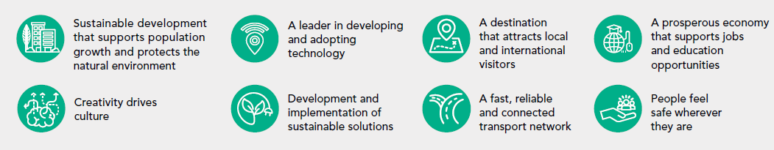
Links to Community’s Aspirations



